16 April, 2025

**PRESS RELEASE**

**ADULT EDUCATION SURVEY, 2022**

According to the results of the Adult Education Survey 2022, the proportion of the population aged 18-69 participating in Formal or Non-Formal education and training, was 46,9%. The respective proportion for men was 53,9% and for women was 40,3%. The corresponding percentages for EU-27 were 47,5% for the total population, 47,0% for men and 48,0% for women.

Comparing the participation rates of the population in learning activities in Formal or Non-Formal Education among the 27 EU countries, Cyprus is in the 15th place.

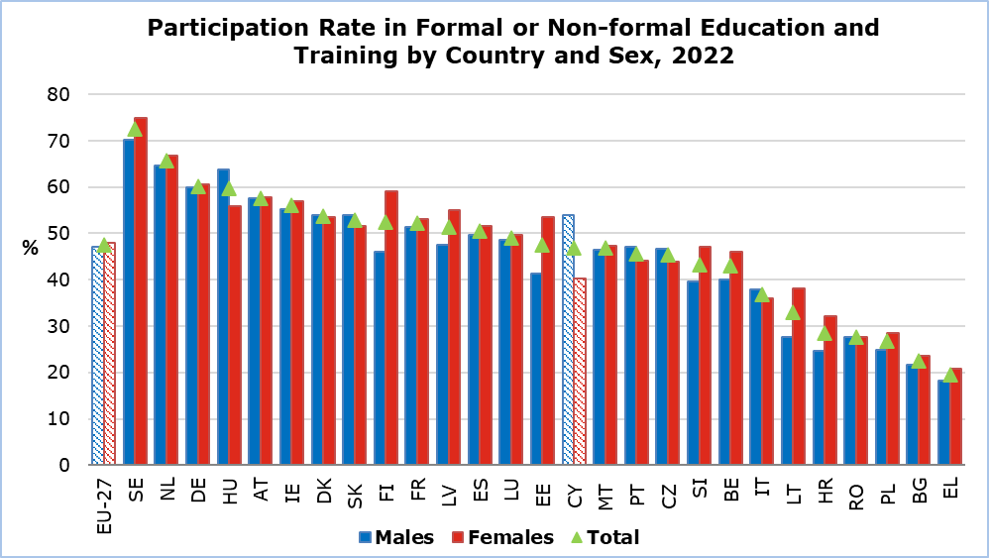

**Formal Education** refers to learning activities that are part of the formal education system of a country. This includes all educational institutions of primary, secondary and tertiary education. **Non-Formal Education** refers to learning activities that take place outside the formal education system but are organized and institutionalised. These activities include seminars, conferences, courses, training courses, tutorials etc.

**Formal Education**

The participation rate of the population aged 18-69 in Formal Education, was 12,0%. The participation rate for men was 11,8% and for women was 12,2%. The corresponding percentages for the EU were 12,2% for the total population, 11,5% for men and 13,0% for women.

The highest participation in Formal Education, as expected, was among the population aged 18–24, with a percentage of 61,6% (EU - 64,3%) and the population with upper secondary/post-secondary education.

**Non-Formal Education**

The participation rate of the population aged 18-69 in Non-Formal Education was 39,2%. The participation rate among men was 46,1% and was much higher than the respective rate of women which was 32,8%. The corresponding percentages for the EU were 41,8% for the total population, 41,6% for men and 42,0% for women.

Additionally, in Non-Formal Education, the highest participation rates were recorded among the population aged 25-54, among employees and the population with tertiary education. Similar trends are observed in the rest of the EU countries.

In general, the participation rates in **Non-Formal Education** are higher than those in **Formal Education** (39,2% and 12,0%, respectively).

|  |  |  |  |  |  |
| --- | --- | --- | --- | --- | --- |
| **Table** |  |  |  |  |  |
| **Participation in Educational Activities of People Aged 18-69 in 2022** | | | **Formal or Non-Formal Education (%)** | **Formal Education (%)** | **Non-Formal Education (%)** |
| Total | | Cyprus | 46,9 | 12,0 | 39,2 |
| EU-27 | 47,5 | 12,2 | 41,8 |
| Sex | Men | Cyprus | 53,9 | 11,8 | 46,1 |
|  | EU-27 | 47,0 | 11,5 | 41,6 |
|  | Women | Cyprus | 40,3 | 12,2 | 32,8 |
|  | EU-27 | 48,0 | 13,0 | 42,0 |
| Age | 18-24 | Cyprus | 76,6 | 61,6 | 34,6 |
|  | EU-27 | 79,8 | 64,3 | 47,6 |
|  | 25-34 | Cyprus | 56,0 | 10,6 | 49,5 |
|  | EU-27 | 56,5 | 16,0 | 49,7 |
|  | 35-54 | Cyprus | 47,1 | 2,6 | 46,3 |
|  | EU-27 | 48,0 | 4,6 | 46,2 |
|  | 55-69 | Cyprus | 20,4 | u | 20,2 |
|  | EU-27 | 29,4 | 1,2 | 28,8 |
| Employment Status | Employed | Cyprus | 50,7 | 5,3 | 48,2 |
| EU-27 | 54,4 | 7,0 | 51,8 |
| Unemployed | Cyprus | 35,0 | 6,2 | 30,4 |
| EU-27 | 31,6 | 8,9 | 26,3 |
| Inactive | Cyprus | 39,0 | 32,5 | 16,0 |
| EU-27 | 36,5 | 24,8 | 23,9 |
| Education Level | Less than upper secondary | Cyprus | 16,9 | 3,1 | 15,2 |
| EU-27 | 28,3 | 9,0 | 23,6 |
| Upper secondary and post-secondary | Cyprus | 46,4 | 18,2 | 33,8 |
| EU-27 | 44,7 | 13,7 | 37,9 |
| Tertiary | Cyprus | 57,0 | 9,1 | 52,1 |
| EU-27 | 64,8 | 12,2 | 60,0 |
| u: Data with low reliability | | | | | |

**METHODOLOGICAL INFORMATION**

**Purpose and Coverage of the Adult Education Survey**

The Adult Education Survey (AES) is conducted every five years from 2006 to 2016 and every six years from 2022 and thereafter, in all member states of the European Union based on the Commission Implementing Regulation (EU) 2021/861, in accordance with Regulation (EU) No. 2019/1700 of the European Parliament and of the Council. It focuses on the participation in any educational activity, which is carried out with the intention of learning, whether it concerns Formal Education, Non-Formal Education, or Informal Learning and the analysis of these data in terms of demographic and other characteristics of the population.

Furthermore, the AES collects data on the reasons that did not allow respondents to participate as much as they would like in educational activities, as well as their knowledge of languages ​​other than their mother tongue.

The AES covered a representative sample of 4.500 households in the Government controlled areas of Cyprus, both in urban and rural areas.

**Reference period**

The data collection period was from November 2022 to March 2023.

The reference period of the survey was the last 12 months from the date of the interview.

**Sources of Data**

The data collection was carried out with personal and telephone interviews at the households using

electronic questionnaires.

**Definitions**

**Adult Education**

Adult Educationencompasses all learning activities undertaken throughout the life of adult population (aged 18 and over) with the aim of improving knowledge, skills and competences, within personal, civic, social or employment-related perspectives. The intention or aim to learn is the critical point that distinguishes these activities from non-learning activities, such as cultural or sporting activities.

**Learning Activities**

Learning Activities are defined as any activities of an individual organised with the intention to improve his/her knowledge, skills and competence. The two fundamental criteria to distinguish learning activities from non-learning activities are:

* the activity must be intentional (as opposed to random learning), so the act has a predetermined purpose;
* the activity must be organized in some way, either by another person or an organized body, or by the learner himself/herself; it typically involves the transfer of information in a broader sense.

**Formal Education**

It refers to learning activities that are part of the formal education system of a country. This includes all educational institutions, public and private (schools, colleges, universities) which offer organized, predefined and systematic education which results in the award of a high school diploma or degree or certificate recognized by the Ministry of Education, Sports and Youth.

**Non-Formal Education**

It refers to learning activities that take place outside the formal education system but are organized and based on instruction. They can be short or long-term and usually require registration to attend. These activities include seminars, conferences, courses, training courses, tutorials or private lessons as well as the "apprenticeship system" and the "afternoon and evening classes of Technical Schools".

**Employment Status**

Employment Status is determined by the following categories:

* **Employee**: A person who works part-time or full-time as an employee or self-employed. This category includes people who work unpaid in a family business as well as paid apprentices and trainees.
* **Unemployed**: A person who was not working at the time of the interview and is actively looking for a job.
* **Inactive**: A person who is neither employed nor unemployed. This category includes pupils, students, unpaid apprentices, people who are in regular or early retirement, people who are chronically ill or disabled or unable to work, soldiers serving their Military Service, housewives, and other economically inactive people.

**Education Level**

The level of education completed by an individual is divided into the following 3 categories:

* **Less than upper secondary:** It includes people who have never attended school, people who attended primary school but did not complete it, people who completed primary school, people who attended lower secondary school but did not complete it, and people who completed lower secondary school.
* **Upper secondary and post-secondary:** It includes individuals who completed Upper Secondary, Technical or Vocational School, Evening Upper Secondary or Evening Technical School as well as individuals who completed Post-Secondary Non-Tertiary Education of usually less than 2 years duration.
* **Tertiary:** It includes individuals who completed short-term Tertiary Education (2-3 years), individuals who completed a Bachelor's Degree (3-4 years) or a Long Degree (5+ years), individuals who completed a Master's Degree and individuals who completed a Doctorate.

***For further information:***

Statistical Service (CYSTAT) Website, subtheme [Education](https://www.cystat.gov.cy/en/SubthemeStatistics?id=33)

[Methodological Information](https://www.cystat.gov.cy/en/MethodologicalDetails?m=2334)

[Publications](https://www.cystat.gov.cy/en/PublicationList?s=33)

*Contact*

Loukia Nicolaou: Tel.: +35722602147, Email: [lnicolaou@cystat.mof.gov.cy](mailto:lnicolaou@cystat.mof.gov.cy)