29 June, 2023

**PRESS RELEASE**

###### AVERAGE MONTHLY EARNINGS OF EMPLOYEES: 1st QUARTER 2023

**Annual Change 7,2%**

Based on provisional data, the average gross monthly earnings of employees during the first quarter of 2023, amounted to €2.217 compared to €2.068 during the first quarter of 2022, i.e. an increase of 7,2% is observed.

The average gross monthly earnings during the first quarter of 2023, seasonally adjusted, are estimated at €2.289 and compared to the fourth quarter of 2022 they are increased by 2,5%.

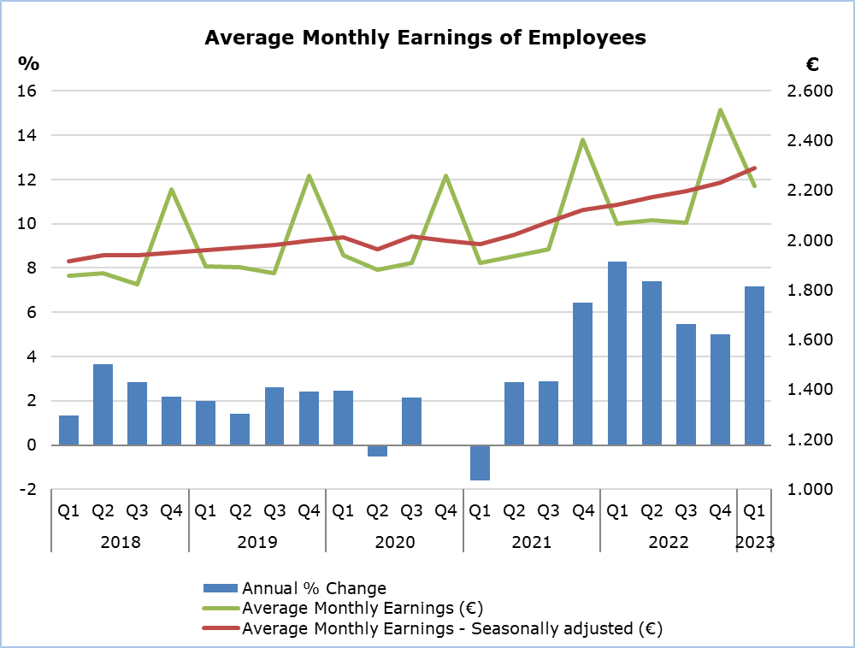

Note: From the 1st quarter of 2022 onwards, data are provisional.

The average gross monthly earnings of male employees during the first quarter of 2023 are estimated at €2.376 and of female employees at €2.016. Compared to the first quarter of 2022, the average gross monthly earnings of male and female employees recorded an increase of 7,3% and 6,7% respectively.

|  |  |  |  |  |  |  |  |  |  |  |
| --- | --- | --- | --- | --- | --- | --- | --- | --- | --- | --- |
| **Table** |  | |  | |  | |  | |  | |
| **Gender** | | **Average monthly earnings (€)** | | | |  | | **Percentage Change (%)** | | | |
| Unadjusted | | Seasonally adjusted | |  | | To the same quarter of the previous year (unadjusted earnings) | | To the previous quarter (seasonally adjusted earnings) | |
| **Total** | |  | |  | |  | |  | |  | |
| 1st Quarter 2023 | | 2.217 | | 2.289 | |  | | 7,2 | | 2,5 | |
| 4th Quarter 2022 | | 2.524 | | 2.233 | |  | | 5,0 | | 1,6 | |
| 1st Quarter 2022 | | 2.068 | | 2.143 | |  | | 8,3 | | 0,9 | |
| **Males** | |  | |  | |  | |  | |  | |
| 1st Quarter 2023 | | 2.376 | | 2.455 | |  | | 7,3 | | 2,6 | |
| 4th Quarter 2022 | | 2.693 | | 2.393 | |  | | 5,0 | | 1,6 | |
| 1st Quarter 2022 | | 2.214 | | 2.296 | |  | | 7,2 | | 0,9 | |
| **Females** | |  | |  | |  | |  | |  | |
| 1st Quarter 2023 | | 2.016 | | 2.080 | |  | | 6,7 | | 2,2 | |
| 4th Quarter 2022 | | 2.315 | | 2.034 | |  | | 4,8 | | 1,6 | |
| 1st Quarter 2022 | | 1.889 | | 1.954 | |  | | 9,8 | | 0,9 | |

Note: Due to the rounding of earnings, the calculation of the change may differ from the percentage change presented in the table.

**METHODOLOGICAL INFORMATION**

**Identity**

The Average Monthly Earnings of employees are calculated by dividing the total gross earnings before any deductions for compulsory social security contributions, by the total number of employees who received remuneration. The data source is the records of the Social Insurance Services. The results are published on a quarterly basis. The calculation of the average monthly earnings of the reference quarter is based on the first two months of the quarter.

**Data Coverage**

All sectors of economic activities according to the Statistical Classification of Economic Activities in the European Community (NACE Rev.2) are covered, except Section T: Activities of households as employers and Section U: Activities of extraterritorial organisations and bodies.

All employees recorded at the Social Insurance Services’ Records are covered. Persons with remuneration indicating that no regular work has been performed during the reference period are excluded from the data (e.g. persons who received arrear payments only, persons who worked for a limited number of hours, etc.). The minimum amount of earnings acceptable in order to be included in the data is revised every year, based on the level of the minimum wage according to the Minimum Wage Order.

**Exceptional Methodological Adjustment**

Included in the calculations are, regardless of the amount of their earnings, employees who participated in the Special Schemes under the Employees’ Support Schemes to deal with the pandemic of the Ministry of Labour and Social Insurance, from April 2020 until October 2021.

**Definitions**

**Average Monthly Earnings** of employees include the basic salary, the cost of living allowance, earnings for overtime, the Holiday Fund, any other allowances received by employees during the reference period and payments in arrears.

The temporary contributions of employees of the private sector (2012-2016) and officials and employees of the central government and the broad public sector (1/9/2011-31/12/2016) and the deductions in earnings of officials and employees of the central government and the broad public sector (since 01/12/2012), do not affect the gross salary of employees but only their net income. Consequently, they are not reflected in the figures above.

It is clarified that, as regards the employees who participated in the Special Schemes under the Employees’ Support Schemes to deal with the pandemic of the Ministry of Labour and Social Insurance, the amount taken into account is the earnings paid by the employer and does not include any amount paid as an allowance by the Ministry of Labour and Social Insurance.

**Seasonally Adjusted Average Monthly Earnings** are the average monthly earnings of employees, after removing the seasonal effect from the data. The removal of the seasonal component from the data is performed, using appropriate statistical techniques. Seasonally adjusted data are used in the comparison of data of a specific time period, with other periods, such as the previous quarter, where the seasonal factor affects the data.

The **Percentage Change - Compared to the same quarter of the previous year** is the percentage change of average monthly earnings, comparing data of a specific quarter, with the corresponding quarter of the previous year. The comparison is made between corresponding time periods of different years. Therefore, there is no need to use the seasonally adjusted data, since the seasonal component is the same for the two periods.

The **Percentage Change - Compared to the previous quarter (Seasonally Adjusted Earnings)** is the percentage change of average monthly earnings, comparing data of a specific quarter, with the previous quarter. Due to the fact that the seasonal component is different between two consecutive quarters, it is necessary to use seasonally adjusted data for this comparison.

**Data Availability**

The data is published on CYSTAT's online database CYSTAT-DB. Data is available from the first quarter of 2003.

***For more information:***

CYSTAT Portal, subtheme [Labour Cost and Earnings](https://www.cystat.gov.cy/en/SubthemeStatistics?s=42)

[CYSTAT-DB](https://cystatdb.cystat.gov.cy/pxweb/en/8.CYSTAT-DB/8.CYSTAT-DB__Labour%20Cost%20and%20Earnings__) (Online Database)

[Predefined Tables](https://www.cystat.gov.cy/en/KeyFiguresList?s=42) (Excel)

[Methodological Information](https://www.cystat.gov.cy/en/MethodologicalDetails?m=2096)

**The data included in the Predefined Tables in Excel format are available up to the 4th Quarter 2021. Data from the 1st Quarter 2022 onwards are available only in the CYSTAT-DB Online Database.**

*Contact*

Phani Lagou: Tel: +35722602115, Email: [plagou@cystat.mof.gov.cy](mailto:plagou@cystat.mof.gov.cy)