26 October, 2026

PRESS RELEASE

AVERAGE MONTHLY EARNINGS OF EMPLOYEES: 2nd QUARTER 2026

Annual Change 3,0%

Based on provisional data, the average gross monthly earnings of employees during the second quarter of 2026, amounted to €2.548 compared to €2.475 during the second quarter of 2025, recording an increase of 3,0%. For the second quarter of 2026, there is an increase in seasonally adjusted average gross monthly earnings compared to the first quarter of 2026, of 0,6%. (Figure)

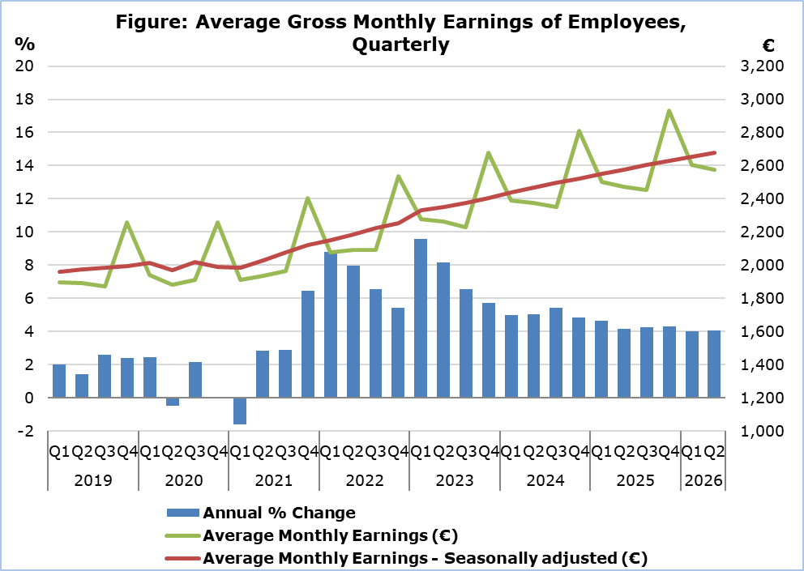
Note: From the 1st quarter of 2026 onwards, data are provisional.

The average gross monthly earnings of male employees during the second quarter of 2026 are estimated at €2.708 and of female employees at €2.345. Compared to the second quarter of 2025, the average gross monthly earnings of male and female employees recorded an increase of 2,1% and 4,1% respectively. (Table 1)

The largest proportion of employees (41,4%) is recorded in the gross monthly earnings category of €1.500–€2.999. The distribution varies by nationality, with Cypriots being concentrated mainly in the €1.500–€2.999 category (45,5%), while non-Cypriots show a higher concentration in the category below €1.500 (46,3%). (Table 2)

Table 1
Sex/ Quarter | Average Gross Monthly Earnings (€) |  |  | Percentage Change (%)
Sex/ Quarter | Unadjusted | Seasonally adjusted |  | To the same quarter of the previous year (unadjusted earnings) | To the previous quarter (seasonally adjusted earnings)
Total
2nd Quarter 2026 | 2.548 | 2.663 |  | 3,0 | 0,6
1st Quarter 2026 | 2.604 | 2.648 |  | 4,0 | 0,8
2nd Quarter 2025 | 2.475 | 2.578 |  | 4,2 | 1,1
Males
2nd Quarter 2026 | 2.708 | 2.825 |  | 2,1 | 0,3
1st Quarter 2026 | 2.779 | 2.816 |  | 3,7 | 0,6
2nd Quarter 2025 | 2.653 | 2.754 |  | 3,7 | 1,1
Females
2nd Quarter 2026 | 2.345 | 2.458 |  | 4,1 | 1,0
1st Quarter 2026 | 2.380 | 2.434 |  | 4,3 | 1,0
2nd Quarter 2025 | 2.252 | 2.359 |  | 4,8 | 1,1
Notes: 1. Due to the rounding of earnings, the calculation of the change may differ from the percentage change presented in the table.
2. From the 1st quarter of 2026 onwards, data are provisional.

Table 2
Gross Monthly Earnings by Sex | Distribution of Employees (%)
Gross Monthly Earnings by Sex | Total | Cypriots | Non-Cypriots
Total
<€1.500 | 33,6 | 27,0 | 46,3
€1.500-€2.999 | 41,4 | 45,5 | 33,6
€3.000-€4.499 | 13,1 | 16,0 | 7,4
€4.500-€5.999 | 6,3 | 7,2 | 4,7
>=€6.000 | 5,6 | 4,3 | 8,1
Males
<€1.500 | 30,8 | 22,4 | 44,1
€1.500-€2.999 | 42,7 | 48,1 | 34,1
€3.000-€4.499 | 13,2 | 16,9 | 7,1
€4.500-€5.999 | 6,3 | 7,2 | 4,8
>=€6.000 | 7,1 | 5,4 | 9,9
Females
<€1.500 | 37,2 | 31,9 | 49,9
€1.500-€2.999 | 39,7 | 42,6 | 32,7
€3.000-€4.499 | 12,9 | 15,0 | 7,8
€4.500-€5.999 | 6,5 | 7,3 | 4,5
>=€6.000 | 3,7 | 3,2 | 5,1
Notes: 1. Due to rounding, the sum of the individual percentages may not equal 100%.
2. From the 1st quarter of 2026 onwards, data are provisional.

METHODOLOGICAL INFORMATION

Identity

The Average Monthly Earnings of employees are calculated by dividing the total gross earnings by the total number of employees who received remuneration. The data source is the records of the Social Insurance Services.

Data Coverage

All sectors of economic activities according to the Statistical Classification of Economic Activities in the European Community (NACE Rev.2) are covered, except Section T: Activities of households as employers and Section U: Activities of extraterritorial organisations and bodies.

All employees recorded at the Social Insurance Services’ Records are covered. Persons with remuneration indicating that no regular work has been performed during the reference period are excluded from the data (e.g. persons who received arrear payments only, persons who worked for a limited number of hours, etc.). The minimum amount of earnings acceptable in order to be included in the data is revised every year, based on the level of the minimum wage according to the Minimum Wage Order until 2022 and in accordance with the Minimum Wage Law from 2023.

Definitions

Average Monthly Earnings of employees include the basic salary, the cost of living allowance, earnings for overtime, the Holiday Fund, any other allowances received by employees during the reference period and payments in arrears. Allowances include both regular and irregular payments (13th salary, 14th salary, bonuses etc.)

Gross earnings refer to the total amount earned before any deductions, including income tax and deductions for compulsory schemes such as the Social Insurance Fund and the General Healthcare Scheme.

The temporary contributions of employees of the private sector (2012-2016) and officials and employees of the central government and the broad public sector (1/9/2011-31/12/2016) and the deductions in earnings of officials and employees of the central government and the broad public sector (from 01/12/2012 to 31/12/2022), do not affect the gross salary of employees but only their net income. Consequently, they are not reflected in the figures above.

It is clarified that, as regards the employees who participated in the Special Schemes under the Employees’ Support Schemes to deal with the pandemic of the Ministry of Labour and Social Insurance, the amount taken into account is the earnings paid by the employer and does not include any amount paid as an allowance by the Ministry of Labour and Social Insurance.

Seasonally Adjusted Average Monthly Earnings are the average monthly earnings of employees, after removing the seasonal effect from the data. The removal of the seasonal component from the data is performed, using appropriate statistical techniques. Seasonally adjusted data are used in the comparison of data of a specific time period, with other periods, such as the previous quarter, where the seasonal factor affects the data.

The Percentage Change - Compared to the same quarter of the previous year is the percentage change of average monthly earnings, comparing data of a specific quarter, with the corresponding quarter of the previous year. The comparison is made between corresponding time periods of different years. Therefore, there is no need to use the seasonally adjusted data, since the seasonal component is the same for the two periods.

The Percentage Change - Compared to the previous quarter (Seasonally Adjusted Earnings) is the percentage change of average monthly earnings, comparing data of a specific quarter, with the previous quarter. Due to the fact that the seasonal component is different between two consecutive quarters, it is necessary to use seasonally adjusted data for this comparison.

Data Availability

The data is published on CYSTAT's online database CYSTAT-DB. Data is available from the first quarter of 2003.

For more information:
CYSTAT Portal, subtheme Labour Cost and Earnings
CYSTAT-DB (Online Database)
Methodological Information

Contact
Phani Lagou: Tel: +35722602115, Email: plagou@cystat.mof.gov.cy

