28 January, 2026

PRESS RELEASE

AVERAGE MONTHLY EARNINGS OF EMPLOYEES: 3rd QUARTER 2025

Annual Change 4,3%

Based on provisional data, the average gross monthly earnings of employees during the third quarter of 2025, amounted to €2.452 compared to €2.352 during the third quarter of 2024, i.e. an increase of 4,3% is observed. For the third quarter of 2025, there is an increase of 0,7% in seasonally adjusted average gross monthly earnings compared to the second quarter of 2025. (Table 1)

The average gross monthly earnings of male employees during the third quarter of 2025 are estimated at €2.622 and of female employees at €2.238. Compared to the third quarter of 2024, the average gross monthly earnings of male and female employees recorded an increase of 3,8% and 4,9% respectively. (Table 1)

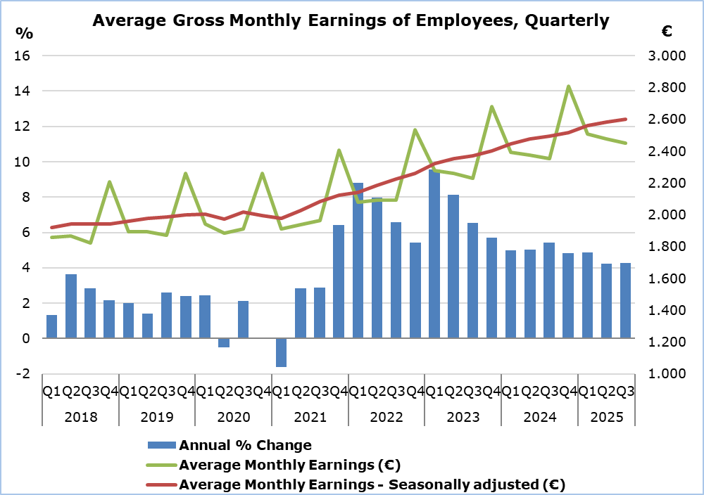
Note: From the 1st quarter of 2025 onwards, data are provisional.

According to the distribution of employees by earnings brackets, the largest share of male employees (41,3%) earns between €1.500 and €2.999, whereas the largest share of female employees (40,5%) is recorded in the earnings bracket below €1.500 (Table 2).

With regard to citizenship, the highest proportion of Cypriot employees (43,9%) is found in the €1.500–€2.999 earnings bracket, whereas among non-Cypriot employees, the largest proportion (49,1%) earns less than €1.500. Employees in the highest earnings bracket (≥ €6.000) account for 3,8% of Cypriots, compared with 7,6% among non-Cypriot employees (Table 2).

Table 1
Sex/ Quarter | Average Gross Monthly Earnings (€) |  |  | Percentage Change (%)
Sex/ Quarter | Unadjusted | Seasonally adjusted |  | To the same quarter of the previous year (unadjusted earnings) | To the previous quarter (seasonally adjusted earnings)
Total
3rd Quarter 2025 | 2.452 | 2.602 |  | 4,3 | 0,7
2nd Quarter 2025 | 2.476 | 2.582 |  | 4,2 | 0,9
3rd Quarter 2024 | 2.352 | 2.493 |  | 5,4 | 0,7
Males
3rd Quarter 2025 | 2.622 | 2.770 |  | 3,8 | 0,3
2nd Quarter 2025 | 2.656 | 2.761 |  | 3,8 | 0,8
3rd Quarter 2024 | 2.526 | 2.666 |  | 5,4 | 0,4
Females
3rd Quarter 2025 | 2.238 | 2.388 |  | 4,9 | 1,2
2nd Quarter 2025 | 2.251 | 2.359 |  | 4,7 | 1,1
3rd Quarter 2024 | 2.134 | 2.277 |  | 5,5 | 1,2
Note: Due to the rounding of earnings, the calculation of the change may differ from the percentage change presented in the table.

Table 2
Gross Monthly Earnings by Sex | Distribution of Employees (%)
Gross Monthly Earnings by Sex | Total | Cypriots | Non-Cypriots
Total
<€1.500 | 36,5 | 30,2 | 49,1
€1.500-€2.999 | 39,7 | 43,9 | 31,5
€3.000-€4.499 | 12,7 | 15,5 | 7,1
€4.500-€5.999 | 6,0 | 6,7 | 4,7
≥€6.000 | 5,0 | 3,8 | 7,6
Males
<€1.500 | 33,3 | 25,5 | 46,5
€1.500-€2.999 | 41,3 | 46,7 | 32,2
€3.000-€4.499 | 12,8 | 16,3 | 6,8
€4.500-€5.999 | 6,1 | 6,7 | 4,9
≥€6.000 | 6,5 | 4,8 | 9,5
Females
<€1.500 | 40,5 | 35,3 | 53,4
€1.500-€2.999 | 37,8 | 40,8 | 30,4
€3.000-€4.499 | 12,5 | 14,6 | 7,4
€4.500-€5.999 | 6,0 | 6,6 | 4,3
≥€6.000 | 3,2 | 2,7 | 4,4

METHODOLOGICAL INFORMATION

Identity

The Average Monthly Earnings of employees are calculated by dividing the total gross earnings before any deductions for compulsory social security contributions, by the total number of employees who received remuneration. The data source is the records of the Social Insurance Services. The results of the current publication are published both on a quarterly and on an annual basis.

Data Coverage

All sectors of economic activities according to the Statistical Classification of Economic Activities in the European Community (NACE Rev.2) are covered, except Section T: Activities of households as employers and Section U: Activities of extraterritorial organisations and bodies.

All employees recorded at the Social Insurance Services’ Records are covered. Persons with remuneration indicating that no regular work has been performed during the reference period are excluded from the data (e.g. persons who received arrear payments only, persons who worked for a limited number of hours, etc.). The minimum amount of earnings acceptable in order to be included in the data is revised every year, based on the level of the minimum wage according to the Minimum Wage Order until 2022 and in accordance with the Minimum Wage Law from 2023.

Definitions

Average Monthly Earnings of employees include the basic salary, the cost of living allowance, earnings for overtime, the Holiday Fund, any other allowances received by employees during the reference period and payments in arrears. Allowances include both regular and irregular payments (13th salary, 14th salary, bonuses etc.)

The temporary contributions of employees of the private sector (2012-2016) and officials and employees of the central government and the broad public sector (1/9/2011-31/12/2016) and the deductions in earnings of officials and employees of the central government and the broad public sector (from 01/12/2012 to 31/12/2022), do not affect the gross salary of employees but only their net income. Consequently, they are not reflected in the figures above.

It is clarified that, as regards the employees who participated in the Special Schemes under the Employees’ Support Schemes to deal with the pandemic of the Ministry of Labour and Social Insurance, the amount taken into account is the earnings paid by the employer and does not include any amount paid as an allowance by the Ministry of Labour and Social Insurance.

Seasonally Adjusted Average Monthly Earnings are the average monthly earnings of employees, after removing the seasonal effect from the data. The removal of the seasonal component from the data is performed, using appropriate statistical techniques. Seasonally adjusted data are used in the comparison of data of a specific time period, with other periods, such as the previous quarter, where the seasonal factor affects the data.

The Percentage Change - Compared to the same quarter of the previous year is the percentage change of average monthly earnings, comparing data of a specific quarter, with the corresponding quarter of the previous year. The comparison is made between corresponding time periods of different years. Therefore, there is no need to use the seasonally adjusted data, since the seasonal component is the same for the two periods.

The Percentage Change - Compared to the previous quarter (Seasonally Adjusted Earnings) is the percentage change of average monthly earnings, comparing data of a specific quarter, with the previous quarter. Due to the fact that the seasonal component is different between two consecutive quarters, it is necessary to use seasonally adjusted data for this comparison.

Data Availability

The data is published on CYSTAT's online database CYSTAT-DB. Data is available from the first quarter of 2003.

Data Revision

The data for each quarter are regarded as preliminary at the time of publication and are subsequently revised based on the final records received from the administrative source (Social Insurance Services). Final data covering all quarters of a given year are published in October of the following year.
For more information:
CYSTAT Portal, subtheme Labour Cost and Earnings
CYSTAT-DB (Online Database)
Methodological Information

Contact
Phani Lagou: Tel.: +357-22602115, Email: plagou@cystat.mof.gov.cy

