7 November, 2023

**PRESS RELEASE**

BUILDING PERMITS: **AUGUST 2023**

**Increase both in Area (2,5%) and in Value (14,9%)**

The Statistical Service announces that the number of building permits authorized by the municipal authorities and the district administration offices during August 2023 stood at 450. The total value of these permits reached €191,3 million and the total area 148,6 thousand square metres. These building permits provide for the construction of 734 dwelling units.

During the period January – August 2023, 4.662 building permits were issued compared to 5.031 in the corresponding period of the previous year, recording a decrease of 7,3%. The total value of these permits increased by 14,9% and the total area by 2,5%. The number of dwelling units recorded an increase of 5,5%.

Building permits constitute a leading indicator of future activity in the construction sector.

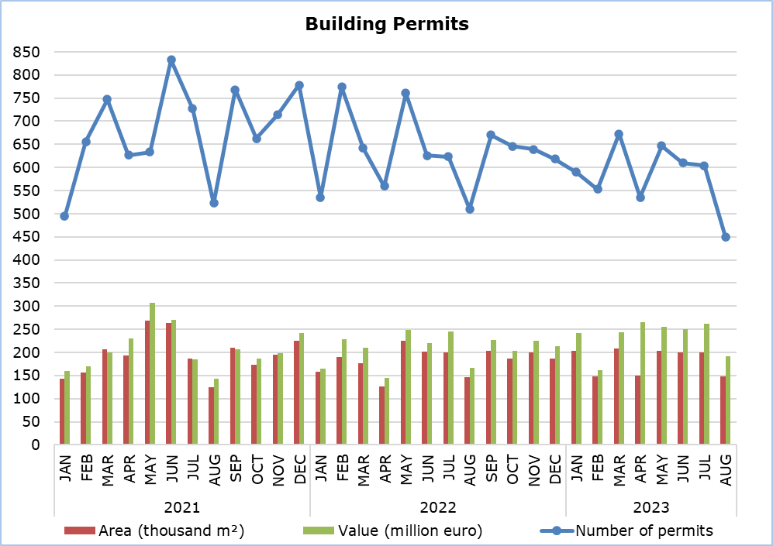

|  |  |  |  |  |  |
| --- | --- | --- | --- | --- | --- |
| **Table 1** |  |  |  |  |  |
| **Type of Project** | **Number of Permits** | | |  | **Percentage Change (%)** |
| **Aug 2023** | **Jan-Aug**  **2023** | **Jan-Aug 2022** |  | **Jan-Aug 2023/**  **Jan-Aug 2022** |
| Residential Buildings | 325 | 3.198 | 3.443 |  | -7,1 |
| Non-residential Buildings | 58 | 679 | 780 |  | -12,9 |
| Civil Engineering Projects | 29 | 269 | 344 |  | -21,8 |
| Division of Plots | 33 | 369 | 346 |  | 6,6 |
| Road Construction | 5 | 147 | 118 |  | 24,6 |
| **Total** | **450** | **4.662** | **5.031** |  | **-7,3** |

|  |  |  |  |  |  |
| --- | --- | --- | --- | --- | --- |
| **Table 2** |  |  |  |  |  |
| **Type of Project** | **Area (m²)** | | |  | **Percentage Change (%)** |
| **Aug 2023** | **Jan-Aug**  **2023** | **Jan-Aug 2022** |  | **Jan-Aug 2023/**  **Jan-Aug 2022** |
| Residential Buildings | 123.330 | 1.245.953 | 1.201.088 |  | 3,7 |
| Non-residential Buildings | 24.605 | 206.581 | 214.733 |  | -3,8 |
| Civil Engineering Projects | 682 | 6.418 | 7.636 |  | -16,0 |
| **Total** | **148.617** | **1.458.952** | **1.423.457** |  | **2,5** |

|  |  |  |  |  |  |
| --- | --- | --- | --- | --- | --- |
| **Table 3** |  |  |  |  |  |
| **Type of Project** | **Value (€000’s)** | | |  | **Percentage Change (%)** |
| **Aug 2023** | **Jan-Aug**  **2023** | **Jan-Aug 2022** |  | **Jan-Aug 2023/**  **Jan-Aug 2022** |
| Residential Buildings | 145.460 | 1.505.999 | 1.252.607 |  | 20,2 |
| Non-residential Buildings | 31.074 | 234.667 | 266.279 |  | -11,9 |
| Civil Engineering Projects | 11.693 | 84.014 | 66.951 |  | 25,5 |
| Division of Plots | 2.814 | 33.192 | 32.104 |  | 3,4 |
| Road Construction | 263 | 12.210 | 10.224 |  | 19,4 |
| **Total** | **191.304** | **1.870.082** | **1.628.165** |  | **14,9** |

|  |  |  |  |  |  |
| --- | --- | --- | --- | --- | --- |
| **Table 4** |  |  |  |  |  |
| **Residential Buildings** | **Number of Dwelling Units** | | |  | **Percentage Change (%)** |
| **Aug 2023** | **Jan-Aug**  **2023** | **Jan-Aug 2022** |  | **Jan-Aug 2023/**  **Jan-Aug 2022** |
| Single houses | 165 | 1.874 | 2.093 |  | -10,5 |
| Buildings with two housing units | 77 | 523 | 613 |  | -14,7 |
| Residential apartment blocks | 417 | 4.335 | 3.622 |  | 19,7 |
| Residential/commercial apartment blocks | 75 | 237 | 278 |  | -14,7 |
| **Total** | **734** | **6.969** | **6.606** |  | **5,5** |

**METHODOLOGICAL INFORMATION**

**Scope and Coverage**

The purpose is the collection of basic data concerning residential and non-residential buildings as well as other construction activities such as civil engineering projects, division of plots and road construction, by district (both urban and rural areas). For each type of project, information is compiled on the number of permits authorized, the area and the value of the project and the number of dwelling units that are expected to be built.

Data cover all building permits authorized by local authorities, namely the municipalities, the district administration offices of the Ministry of Interior and the Agios Tychonas Community Board.

**Data Collection**

The Statistical Service receives on a monthly basis from all local authorities copies of all the building permits issued. The information contained in these forms is appropriately coded by the Statistical Service in order to produce the statistics. The EU Classification of Types of Construction (CC) is used to categorize the various construction projects.

***For more information*:**

CYSTAT Portal, subtheme [Construction](https://www.cystat.gov.cy/en/SubthemeStatistics?s=31)

[CYSTAT-DB](https://cystatdb.cystat.gov.cy/pxweb/en/8.CYSTAT-DB/8.CYSTAT-DB__Construction__) (Online Database)

[Predefined Tables](https://www.cystat.gov.cy/en/KeyFiguresList?s=31) (Excel)

**The** [**Predefined Tables**](https://www.cystat.gov.cy/en/KeyFiguresList?s=31)**, available in Excel format, include data up to December 2022. Data from January 2023 onwards are available only in the CYSTAT-DB Online Database.**

*Contact*  
Achilleas Moustakas: Tel.: 22602156, E-mail: amoustakas@cystat.mof.gov.cy