9 March, 2023

**PRESS RELEASE**

BUILDING PERMITS: **DECEMBER 2022**

**Decrease in Area (-6,3%), No Change in Value (0,0%)**

The Statistical Service announces that the number of building permits authorized by the municipal authorities and the district administration offices during December 2022 stood at 618. The total value of these permits reached €213,2 million and the total area 187,1 thousand square metres. These building permits provide for the construction of 863 dwelling units.

During the period January – December 2022, 7.604 building permits were issued compared to 8.164 in the corresponding period of the previous year, recording a decrease of 6,9%. The total value of these permits remained at the level of the preceding year, while the total area declined by 6,3%. The number of dwelling units recorded a decrease of 6,3%.

Building permits constitute a leading indicator of future activity in the construction sector.

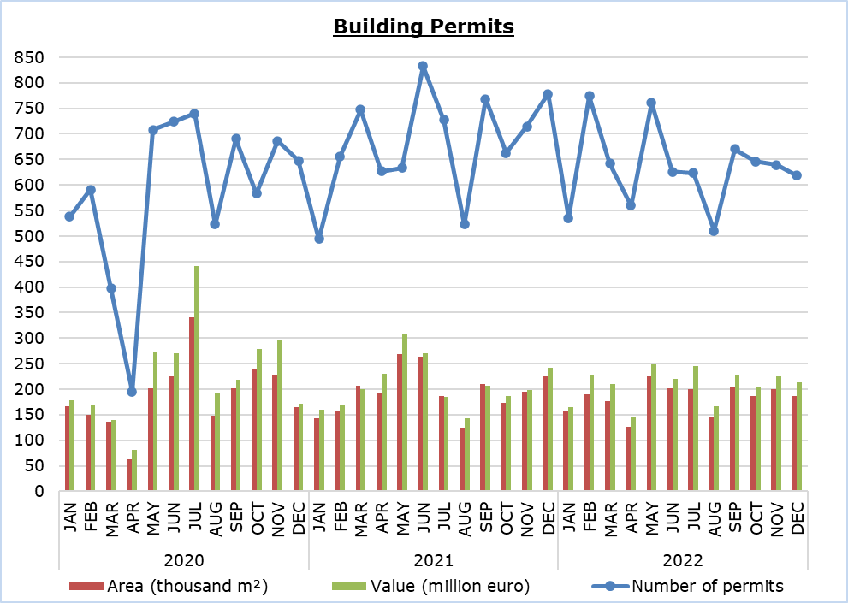

|  |  |  |  |  |  |
| --- | --- | --- | --- | --- | --- |
| **Table 1** |  |  |  |  |  |
| **Type of Project** | **Number of Permits** | | |  | **Percentage Change (%)** |
| **Dec 2022** | **Jan-Dec**  **2022** | **Jan-Dec 2021** |  | **Jan-Dec 2022/**  **Jan-Dec 2021** |
| Residential Buildings | 443 | 5.210 | 5.753 |  | -9,4 |
| Non-residential Buildings | 72 | 1.160 | 1.254 |  | -7,5 |
| Civil Engineering Projects | 40 | 515 | 443 |  | 16,3 |
| Division of Plots | 48 | 529 | 547 |  | -3,3 |
| Road Construction | 15 | 190 | 167 |  | 13,8 |
| **Total** | **618** | **7.604** | **8.164** |  | **-6,9** |

|  |  |  |  |  |  |
| --- | --- | --- | --- | --- | --- |
| **Table 2** |  |  |  |  |  |
| **Type of Project** | **Area (m²)** | | |  | **Percentage Change (%)** |
| **Dec 2022** | **Jan-Dec**  **2022** | **Jan-Dec 2021** |  | **Jan-Dec 2022/**  **Jan-Dec 2021** |
| Residential Buildings | 161.166 | 1.806.617 | 1.999.466 |  | -9,6 |
| Non-residential Buildings | 24.596 | 382.732 | 338.522 |  | 13,1 |
| Civil Engineering Projects | 1.322 | 9.893 | 8.194 |  | 20,7 |
| **Total** | **187.084** | **2.199.242** | **2.346.182** |  | **-6,3** |

|  |  |  |  |  |  |
| --- | --- | --- | --- | --- | --- |
| **Table 3** |  |  |  |  |  |
| **Type of Project** | **Value (€000’s)** | | |  | **Percentage Change (%)** |
| **Dec 2022** | **Jan-Dec**  **2022** | **Jan-Dec 2021** |  | **Jan-Dec 2022/**  **Jan-Dec 2021** |
| Residential Buildings | 177.683 | 1.896.653 | 2.033.958 |  | -6,8 |
| Non-residential Buildings | 22.535 | 442.101 | 321.334 |  | 37,6 |
| Civil Engineering Projects | 7.381 | 92.640 | 88.743 |  | 4,4 |
| Division of Plots | 4.310 | 48.504 | 42.975 |  | 12,9 |
| Road Construction | 1.244 | 16.740 | 10.757 |  | 55,6 |
| **Total** | **213.153** | **2.496.638** | **2.497.767** |  | **0,0** |

|  |  |  |  |  |  |
| --- | --- | --- | --- | --- | --- |
| **Table 4** |  |  |  |  |  |
| **Residential Buildings** | **Number of Dwelling Units** | | |  | **Percentage Change (%)** |
| **Dec 2022** | **Jan-Dec**  **2022** | **Jan-Dec 2021** |  | **Jan-Dec 2022/**  **Jan-Dec 2021** |
| Single houses | 272 | 3.157 | 3.553 |  | -11,1 |
| Buildings with two housing units | 134 | 950 | 930 |  | 2,2 |
| Residential apartment blocks | 433 | 5.341 | 5.590 |  | -4,5 |
| Residential/commercial apartment blocks | 24 | 394 | 433 |  | -9,0 |
| **Total** | **863** | **9.842** | **10.506** |  | **-6,3** |

**METHODOLOGICAL INFORMATION**

**Scope and coverage**

The purpose is the collection of basic data concerning residential and non-residential buildings as well as other construction activities such as civil engineering projects, division of plots and road construction, by district (both urban and rural areas). For each type of project, information is compiled on the number of permits authorized, the area and the value of the project and the number of dwelling units that are expected to be built.

Data cover all building permits authorized by local authorities, namely the municipalities, the district administration offices of the Ministry of Interior and the Agios Tychonas Community Board.

**Data collection**

The Statistical Service receives on a monthly basis from all local authorities copies of all the building permits issued. The information contained in these forms is appropriately coded by the Statistical Service in order to produce the statistics. The EU Classification of Types of Construction (CC) is used to categorize the various construction projects.

***For more information*:**

CYSTAT Portal, subtheme [Construction](https://www.cystat.gov.cy/en/SubthemeStatistics?s=31)

[CYSTAT-DB](https://cystatdb.cystat.gov.cy/pxweb/en/8.CYSTAT-DB/8.CYSTAT-DB__Construction__) (Online Database)

[Predefined Tables](https://www.cystat.gov.cy/en/KeyFiguresList?s=31) (Excel)

*Contact*  
Achilleas Moustakas: Tel.: 22602156, E-mail: amoustakas@cystat.mof.gov.cy