19 June 2025

**PRESS RELEASE**

BUILDING PERMITS: **FEBRUARY 2025**

**Reduction of 20,4% in the Number of Building Permits Issued**

The Statistical Service announces that the number of building permits authorized during February 2025 stood at 562 compared to 706 in February 2024, registering a decrease of 20,4%. The total value of these permits reached €296,3 million and the total area 237,2 thousand square metres. These building permits provide for the construction of 1.094 dwelling units.

During the period January – February 2025, 1.008 building permits were issued compared to 1.293 in the corresponding period of the previous year, recording a decrease of 22,0%. The total value of these permits increased by 12,1% and the total area by 6,6%. The number of dwelling units recorded an increase of 10,2%.

It is noted that as from the 1st July 2024, the authority of issuing building permits was transferred from the municipalities and the district administration offices to the newly founded Local Government Organisations (LGOs) and the licensing process is performed through the new integrated information system “Ippodamos”.

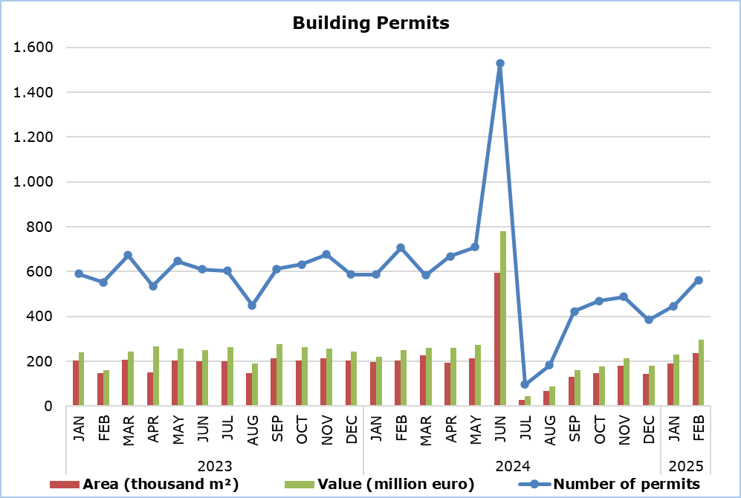

|  |  |  |  |  |  |
| --- | --- | --- | --- | --- | --- |
| **Table 1** |  |  |  |  |  |
| **Type of Project** | **Number of Permits** | | |  | **Percentage Change (%)** |
| **Feb 2025** | **Jan-Feb 2025** | **Jan-Feb 2024** |  | **Jan-Feb**  **2025/2024** |
| Residential Buildings | 415 | 723 | 859 |  | -15,8 |
| Non-residential Buildings | 59 | 127 | 217 |  | -41,5 |
| Civil Engineering Projects | 41 | 69 | 89 |  | -22,5 |
| Division of Plots | 43 | 82 | 88 |  | -6,8 |
| Road Construction | 4 | 7 | 40 |  | -82,5 |
| **Total** | **562** | **1.008** | **1.293** |  | **-22,0** |

|  |  |  |  |  |  |
| --- | --- | --- | --- | --- | --- |
| **Table 2** |  |  |  |  |  |
| **Type of Project** | **Area (m²)** | | |  | **Percentage Change (%)** |
| **Feb 2025** | **Jan-Feb 2025** | **Jan-Feb 2024** |  | **Jan-Feb**  **2025/2024** |
| Residential Buildings | 179.643 | 321.930 | 314.936 |  | 2,2 |
| Non-residential Buildings | 56.932 | 104.274 | 84.463 |  | 23,5 |
| Civil Engineering Projects | 585 | 901 | 1.351 |  | -33,3 |
| **Total** | **237.160** | **427.105** | **400.750** |  | **6,6** |

|  |  |  |  |  |  |
| --- | --- | --- | --- | --- | --- |
| **Table 3** |  |  |  |  |  |
| **Type of Project** | **Value (€000’s)** | | |  | **Percentage Change (%)** |
| **Feb 2025** | **Jan-Feb 2025** | **Jan-Feb 2024** |  | **Jan-Feb**  **2025/2024** |
| Residential Buildings | 206.399 | 363.743 | 371.978 |  | -2,2 |
| Non-residential Buildings | 68.166 | 126.955 | 76.670 |  | 65,6 |
| Civil Engineering Projects | 18.845 | 31.361 | 10.785 |  | 190,8 |
| Division of Plots | 2.648 | 4.539 | 7.398 |  | -38,6 |
| Road Construction | 235 | 507 | 3.362 |  | -84,9 |
| **Total** | **296.293** | **527.105** | **470.193** |  | **12,1** |

|  |  |  |  |  |  |
| --- | --- | --- | --- | --- | --- |
| **Table 4** |  |  |  |  |  |
| **Residential Buildings** | **Number of Dwelling Units** | | |  | **Percentage Change (%)** |
| **Feb 2025** | **Jan-Feb 2025** | **Jan-Feb 2024** |  | **Jan-Feb**  **2025/2024** |
| Single houses | 270 | 435 | 502 |  | -13,3 |
| Buildings with two housing units | 93 | 213 | 151 |  | 41,1 |
| Residential apartment blocks | 663 | 1.192 | 973 |  | 22,5 |
| Residential/commercial apartment blocks | 68 | 92 | 127 |  | -27,6 |
| **Total** | **1.094** | **1.932** | **1.753** |  | **10,2** |

**METHODOLOGICAL INFORMATION**

**Scope and Coverage**

The purpose is the collection of basic data concerning residential and non-residential buildings as well as other construction activities such as civil engineering projects, division of plots and road construction, by district (both urban and rural areas). For each type of project, information is compiled on the number of permits authorized, the area and the value of the project and the number of dwelling units that are expected to be built. For the categorization of the various construction projects, the EU Classification of Types of Construction (CC) is being used.

Data cover all building permits authorized, including those for demolitions and permits being re-issued. However, permit renewals and permits for the division of buildings are not included.

**Data Collection**

The Statistical Service traditionally received on a monthly basis from all the local administration authorities, namely the municipalities, the district administration offices of the Ministry of Interior and the Agios Tychonas Community Board, copies of all the building permits they issued. The information contained in these forms was appropriately coded by the Statistical Service in order to produce the statistics.

As part of the administrative reform, the authority of issuing building permits was transferred as from the 1st July 2024 from the local administration authorities to the newly founded Local Government Organisations (LGOs). At the same time, the integrated information system "Ippodamos" was put into operation and all applications are now processed by the LGOs electronically, including a large volume of older applications that were apparently submitted in printed form before the 1st July 2024. In the first months of the reform, the operation of "Ippodamos" was accompanied by a series of technical and procedural weaknesses and delays that had a serious impact on the production of statistics in a timely, accurate and reliable manner.

The Statistical Service remains in touch with the Ministry of the Interior and the LGOs, as well as with the Deputy Ministry of Research, Innovation and Digital Policy, in order to achieve the smooth recording by the LGOs of the necessary data in the "Ippodamos" system and the seamless production of statistics.

***For more information*:**

CYSTAT Portal, subtheme [Construction](https://www.cystat.gov.cy/en/SubthemeStatistics?s=31)

[CYSTAT-DB](https://cystatdb.cystat.gov.cy/pxweb/en/8.CYSTAT-DB/8.CYSTAT-DB__Construction__) (Online Database)

[Predefined Tables](https://www.cystat.gov.cy/en/KeyFiguresList?s=31) (Excel)

**The** [**Predefined Tables**](https://www.cystat.gov.cy/en/KeyFiguresList?s=31)**, available in Excel format, include data up to December 2022. Data from January 2023 onwards are available only in the CYSTAT-DB Online Database.**

*Contact*  
Achilleas Moustakas: Tel.: 22602156, E-mail: amoustakas@cystat.mof.gov.cy