19 September, 2024

PRESS RELEASE

BUILDING PERMITS: JUNE 2024

The Statistical Service announces that the number of building permits authorized by the municipal authorities and the district administration offices during June 2024 stood at 1.528. The total value of these permits reached €781,6 million and the total area 594,9 thousand square metres. These building permits provide for the construction of 2.772 dwelling units.

During the period January – June 2024, 4.782 building permits were issued compared to 3.608 in the corresponding period of the previous year, recording an increase of 32,5%. The total value of these permits increased by 44,4% and the total area by 46,5%. The number of dwelling units recorded an increase of 44,4%.

The noteworthy increase in the number of building permits issued in June 2024 is to a large extent the result of the efforts made by the issuing authorities to process a large part of the backlog of applications, in view of the transfer as from the 1st July 2024 of the authority of issuing building permits from the municipalities and the district administration offices to the newly founded Local Government Organisations.

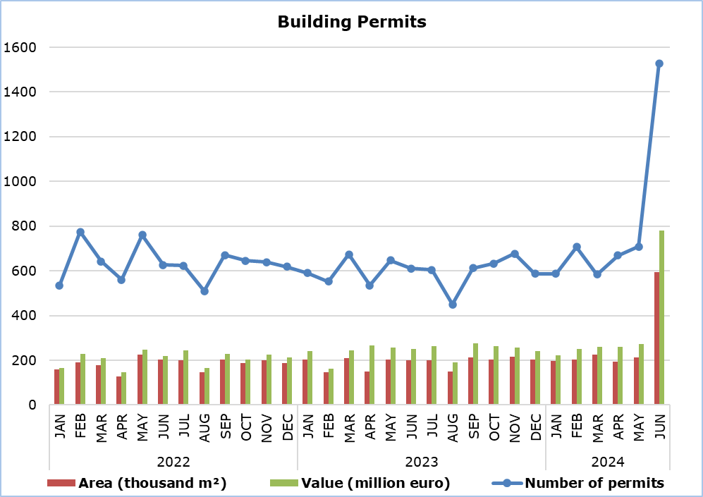

Table 1
Type of Project | Number of Permits |  |  |  | Percentage Change (%)
Type of Project | June 2024 | Jan-June  2024 | Jan-June 2023 |  | Jan-June  2024/2023
Residential Buildings | 1.008 | 3.171 | 2.455 |  | 29,2
Non-residential Buildings | 304 | 838 | 548 |  | 52,9
Civil Engineering Projects | 73 | 288 | 206 |  | 39,8
Division of Plots | 90 | 326 | 278 |  | 17,3
Road Construction | 53 | 159 | 121 |  | 31,4
Total | 1.528 | 4.782 | 3.608 |  | 32,5

Table 2
Type of Project | Area (m²) |  |  |  | Percentage Change (%)
Type of Project | June 2024 | Jan-June  2024 | Jan-June 2023 |  | Jan-June  2024/2023
Residential Buildings | 450.614 | 1.261.953 | 947.239 |  | 33,2
Non-residential Buildings | 140.101 | 358.796 | 158.093 |  | 127,0
Civil Engineering Projects | 4.151 | 6.710 | 5.561 |  | 20,7
Total | 594.866 | 1.627.459 | 1.110.893 |  | 46,5

Table 3
Type of Project | Value (€000’s) |  |  |  | Percentage Change (%)
Type of Project | June 2024 | Jan-June  2024 | Jan-June 2023 |  | Jan-June  2024/2023
Residential Buildings | 540.985 | 1.496.322 | 1.136.391 |  | 31,7
Non-residential Buildings | 163.783 | 399.632 | 174.625 |  | 128,9
Civil Engineering Projects | 66.246 | 110.718 | 70.337 |  | 57,4
Division of Plots | 6.072 | 26.190 | 24.491 |  | 6,9
Road Construction | 4.517 | 11.876 | 10.638 |  | 11,6
Total | 781.603 | 2.044.738 | 1.416.482 |  | 44,4

Table 4
Residential Buildings | Number of Dwelling Units |  |  |  | Percentage Change (%)
Residential Buildings | June 2024 | Jan-June  2024 | Jan-June 2023 |  | Jan-June  2024/2023
Single houses | 496 | 1.685 | 1.454 |  | 15,9
Buildings with two housing units | 152 | 579 | 370 |  | 56,5
Residential apartment blocks | 1.841 | 4.832 | 3.314 |  | 45,8
Residential/commercial apartment blocks | 283 | 520 | 138 |  | 276,8
Total | 2.772 | 7.616 | 5.276 |  | 44,4

METHODOLOGICAL INFORMATION

Scope and Coverage

The purpose is the collection of basic data concerning residential and non-residential buildings as well as other construction activities such as civil engineering projects, division of plots and road construction, by district (both urban and rural areas). For each type of project, information is compiled on the number of permits authorized, the area and the value of the project and the number of dwelling units that are expected to be built.

Data cover all building permits authorized by local authorities, namely the municipalities, the district administration offices of the Ministry of Interior and the Agios Tychonas Community Board.

Data Collection

The Statistical Service receives on a monthly basis from all local authorities copies of all the building permits issued. The information contained in these forms is appropriately coded by the Statistical Service in order to produce the statistics. The EU Classification of Types of Construction (CC) is used to categorize the various construction projects.

For more information:
CYSTAT Portal, subtheme Construction
CYSTAT-DB (Online Database)
Predefined Tables (Excel)

The Predefined Tables, available in Excel format, include data up to December 2022. Data from January 2023 onwards are available only in the CYSTAT-DB Online Database.

Contact
Achilleas Moustakas: Tel.: 22602156, E-mail: amoustakas@cystat.mof.gov.cy

