13 March 2026

PRESS RELEASE

BUILDING PERMITS: NOVEMBER 2025

Increase of 13,9% in the Number of Building Permits
Issued during the period Jan – Nov 2025

The Statistical Service announces that the number of building permits authorized during November 2025 stood at 850. The total value of these permits reached €382,9 million and the total area 333,4 thousand square metres. These building permits provide for the construction of 1.631 dwelling units.

During the period January – November 2025, 7.340 building permits were issued compared to 6.442 in the corresponding period of the previous year, recording an increase of 13,9%. The total value of these permits increased by 31,8% and the total area by 35,3%. The number of dwelling units recorded an increase of 36,1%.

It is noted that as from the 1st July 2024, the authority of issuing building permits was transferred from the municipalities and the district administration offices to the newly founded Local Government Organisations (LGOs) and the licensing process is performed through the new integrated information system “Ippodamos”.

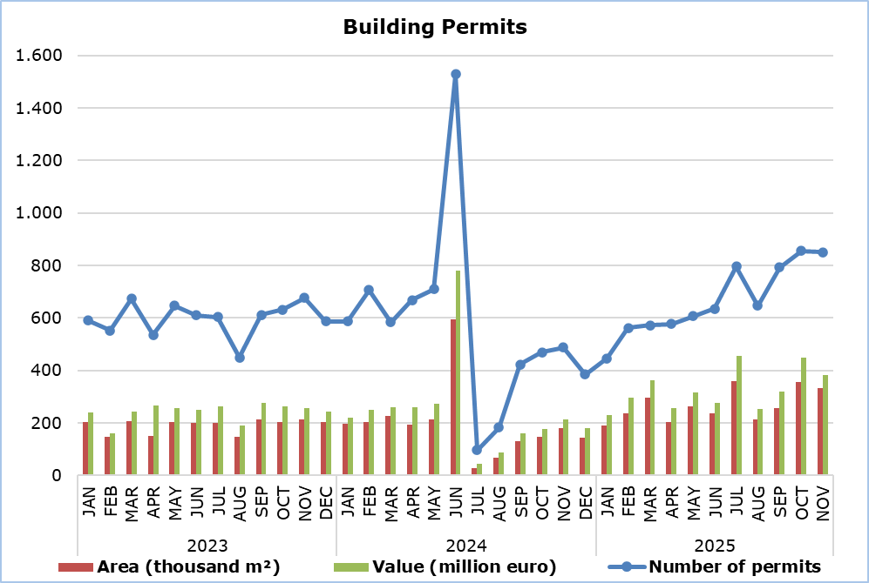

Table 1
Type of Project | Number of Permits |  |  |  | Percentage Change (%)
Type of Project | Nov 2025 | Jan-Nov 2025 | Jan-Nov 2024 |  | Jan-Nov  2025/2024
Residential Buildings | 640 | 5.472 | 4.416 |  | 23,9
Non-residential Buildings | 84 | 768 | 1.015 |  | -24,3
Civil Engineering Projects | 54 | 445 | 370 |  | 20,3
Division of Plots | 55 | 543 | 473 |  | 14,8
Road Construction | 17 | 112 | 168 |  | -33,3
Total | 850 | 7.340 | 6.442 |  | 13,9

Table 2
Type of Project | Area (m²) |  |  |  | Percentage Change (%)
Type of Project | Nov 2025 | Jan-Nov 2025 | Jan-Nov 2024 |  | Jan-Nov  2025/2024
Residential Buildings | 272.398 | 2.448.273 | 1.772.437 |  | 38,1
Non-residential Buildings | 57.740 | 481.867 | 396.486 |  | 21,5
Civil Engineering Projects | 3.298 | 15.268 | 7.996 |  | 90,9
Total | 333.436 | 2.945.408 | 2.176.919 |  | 35,3

Table 3
Type of Project | Value (€000’s) |  |  |  | Percentage Change (%)
Type of Project | Nov 2025 | Jan-Nov 2025 | Jan-Nov 2024 |  | Jan-Nov  2025/2024
Residential Buildings | 318.707 | 2.823.384 | 2.095.611 |  | 34,7
Non-residential Buildings | 49.253 | 567.805 | 433.635 |  | 30,9
Civil Engineering Projects | 8.717 | 157.044 | 145.468 |  | 8,0
Division of Plots | 4.483 | 34.282 | 38.676 |  | -11,4
Road Construction | 1.759 | 9.212 | 12.540 |  | -26,5
Total | 382.919 | 3.591.727 | 2.725.930 |  | 31,8

Table 4
Residential Buildings | Number of Dwelling Units |  |  |  | Percentage Change (%)
Residential Buildings | Nov 2025 | Jan-Nov 2025 | Jan-Nov 2024 |  | Jan-Nov  2025/2024
Single houses | 435 | 3.507 | 2.593 |  | 35,2
Buildings with two housing units | 120 | 1.069 | 753 |  | 42,0
Residential apartment blocks | 1.067 | 9.586 | 6.654 |  | 44,1
Residential/commercial apartment blocks | 9 | 239 | 584 |  | -59,1
Total | 1.631 | 14.401 | 10.584 |  | 36,1

METHODOLOGICAL INFORMATION

Scope and Coverage

The purpose is the collection of basic data concerning residential and non-residential buildings as well as other construction activities such as civil engineering projects, division of plots and road construction, by district (both urban and rural areas). For each type of project, information is compiled on the number of permits authorized, the area and the value of the project and the number of dwelling units that are expected to be built. For the categorization of the various construction projects, the EU Classification of Types of Construction (CC) is being used.

Data cover all building permits authorized, including those for demolitions and permits being re-issued. However, permit renewals and permits for the division of buildings are not included.

Data Collection

The Statistical Service traditionally received on a monthly basis from all the local administration authorities, namely the municipalities, the district administration offices of the Ministry of Interior and the Agios Tychonas Community Board, copies of all the building permits they issued. The information contained in these forms was appropriately coded by the Statistical Service in order to produce the statistics.
As part of the administrative reform, the authority of issuing building permits was transferred as from the 1st July 2024 from the local administration authorities to the newly founded Local Government Organisations (LGOs). At the same time, the integrated information system "Ippodamos" was put into operation and all applications are now processed by the LGOs electronically, including a large volume of older applications that were apparently submitted in printed form before the 1st July 2024. In the first months of the reform, the operation of "Ippodamos" was accompanied by a series of technical and procedural weaknesses and delays that had a serious impact on the production of statistics in a timely, accurate and reliable manner.

For more information:
CYSTAT Portal, subtheme Construction
CYSTAT-DB (Online Database)
Predefined Tables (Excel)

The Predefined Tables, available in Excel format, include data up to December 2022. Data from January 2023 onwards are available only in the CYSTAT-DB Online Database.

Contact
Achilleas Moustakas: Tel.: 22602156, E-mail: amoustakas@cystat.mof.gov.cy

