22 December, 2021

PRESS RELEASE

BUSINESS REGISTER: 2020

Annual Change 2,0%

In 2020 the number of enterprises reached 109.220 compared to 107.062 in 2019, recording an increase of 2,0%.

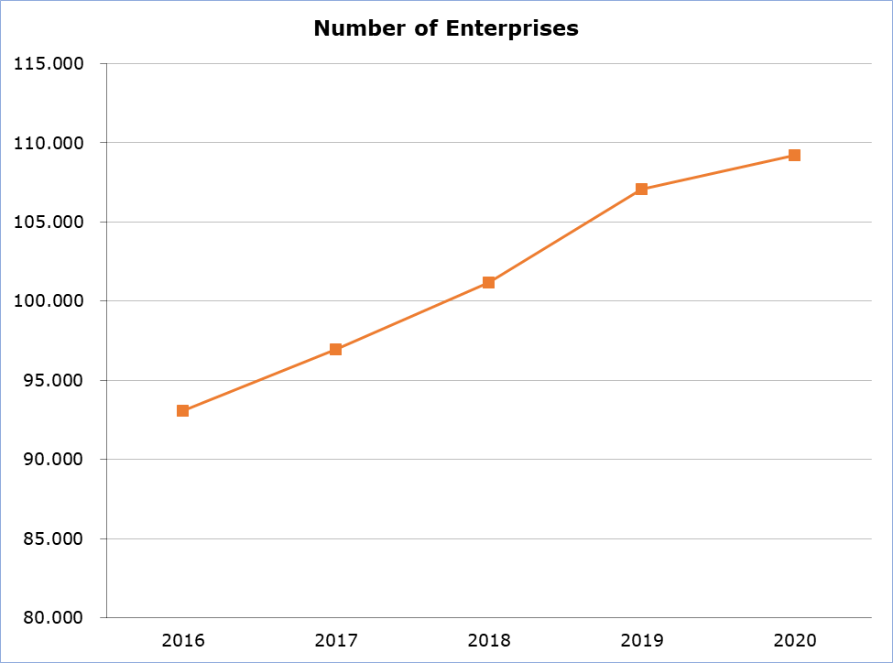

Since 2016 an annual increase in the number of enterprises is being recorded (Table 1).

In 2020, 95,1% of the enterprises were employing less than 10 persons (Table 2). The biggest productive sector in terms of the number of enterprises was “Wholesale and Retail Trade; Repair of Motor Vehicles and Motorcycles”, followed by “Professional, Scientific and Technical Activities” and “Construction”, while the smallest productive sector was “Mining and Quarrying” (Table 3).

Table 1
Year | Annual change (%)  (Comparison with Previous Year)
Year | Number of Enterprises
2016 | 3,2
2017 | 4,2
2018 | 4,3
2019 | 5,8
2020 | 2,0

Table 2
Size (No of Persons Employed) | Number of Enterprises | Share (%)
0-9 | 103.836 | 95,1
10-49 | 4.550 | 4,2
50-249 | 714 | 0,6
250+ | 120 | 0,1
Total | 109.220 | 100

Table 3
Nace Rev.2 | Economic Activity | Number of Enterprises
Α | Agriculture, Forestry and Fishing | 3.550
B | Mining and Quarrying | 47
C | Manufacturing | 5.011
D | Electricity, Gas, Steam and Air Conditioning Supply | 92
E | Water Supply, Sewerage, Waste Management and Remediation Activities | 224
F | Construction | 9.334
G | Wholesale and Retail Trade, Repair of Motor Vehicles and Motorcycles | 16.942
H | Transportation and Storage | 3.142
I | Accommodation and Food Service Activities | 5.990
J | Information and Communication | 2.537
K | Financial and Insurance Activities | 3.613
L | Real Estate Activities | 1.350
M | Professional, Scientific and Technical Activities | 10.415
N | Administrative and Support Service Activities | 3.933
O | Public Administration and Defence, Compulsory Social Security | 511
P | Education | 3.804
Q | Human Health and Social Work Activities | 5.384
R | Arts, Entertainment and Recreation | 2.376
S | Other Service Activities | 6.068
T | Activities of Households as Employers; Undifferentiated Goods- and Services-Producing Activities of Households for Own Use | 24.897
 | Total | 109.220
* Data refer to the Government controlled area of Cyprus.

METHODOLOGICAL INFORMATION

Background Information

The Statistical Business Register is updated on an annual basis, according to the Regulation (EU) 2019/2152, using administrative sources and surveys conducted by the Statistical Service of Cyprus. The administrative sources used are registers from the Social Insurance Services, from the Tax Department (V.A.T.) and from the Department of Registrar of Companies and Intellectual Property.

Coverage

The Statistical Business Register covers the following statistical units:
• Legal Unit
• Enterprise
• Local Unit (Establishment)
• Enterprise Group

The classification system used is the Statistical Classification of Economic Activities NACE Rev. 2, of the European Union. Data is disseminated for the statistical unit “Enterprise”.

Definitions

Enterprise is defined, in the Statistical Units Council Regulation (EEC) No 696/93, as “the smallest combination of legal units that is an organizational unit producing goods or services which benefits from a certain degree of autonomy in decision-making, especially for the allocation of its current recourses. An enterprise carries out one or more activities at one or more locations. The enterprise corresponds either to a legal unit or to a combination of legal units, provided that the result is an organizational unit with a certain degree of autonomy”.

For more information:
CYSTAT Portal, subtheme Business Register
CYSTAT-DB (Online Database)

Contact
Thomas Gregoriou: Tel:+35722602126, Email: tgregoriou@cystat.mof.gov.cy

