11 September, 2025

PRESS RELEASE

BUSINESS REGISTER: 2023

Annual Change in the Number of Enterprises 4,5%

In 2023 the number of enterprises in Cyprus reached 125.152 compared to 119.816 in 2022, recording an increase of 4,5% (Table 1).

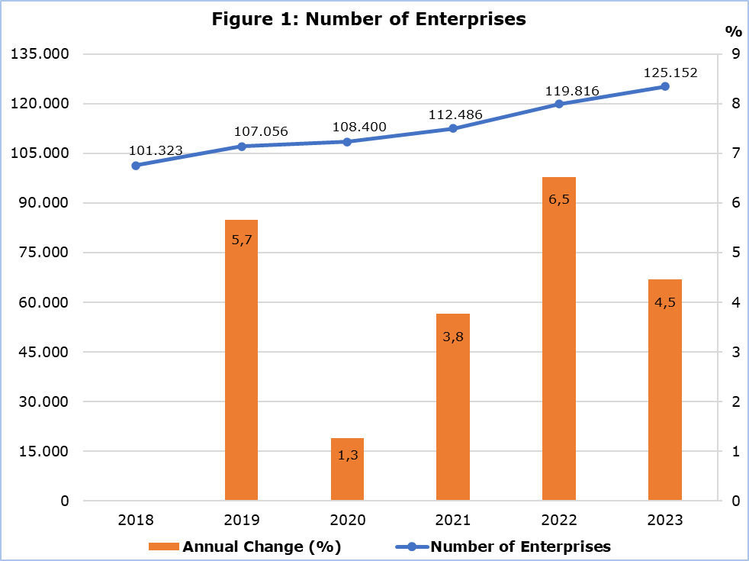

In 2023, 94,8% of the enterprises were employing less than 10 persons (Table 2). Only 156 enterprises or 0,1% of the total employed 250 persons and over.

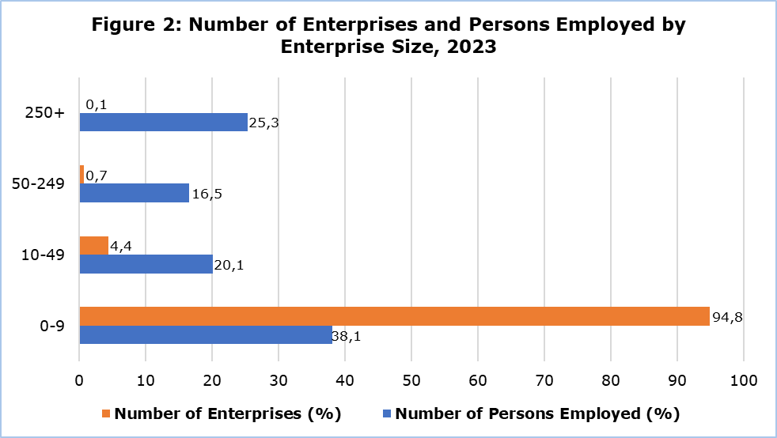

The number of persons employed in enterprises shows in general an upward trend, with the exception of 2020 where a decrease of 3,3% was observed (Table 3). In 2023, the enterprises in the size group 0-9 were employing 38,1% of the total number of persons employed, while the enterprises in the size group 250+ were employing 25,3% of the total (Table 4).

The biggest productive sector in terms of the number of enterprises was the sector of “Wholesale and Retail Trade; Repair of Motor Vehicles and Motorcycles” (16.672), followed by the sectors of “Professional, Scientific and Technical Activities” (13.235) and “Construction” (10.311), while the smallest productive sector was “Mining and Quarrying” with only 46 enterprises (Table 5).

As far as the number of persons employed is concerned, the sector of “Wholesale and Retail Trade; Repair of Motor Vehicles and Motorcycles” is again the biggest sector with 77.046 persons employed, followed by the sectors of “Accommodation and Food Service Activities” with 57.041 persons employed and “Public Administration and Defence, Compulsory Social Security” with 55.067 persons employed (Table 5).

Table 1
Year | Annual change (%)  (Comparison with Previous Year) | Number of Enterprises
2018 | n.a. | 101.323
2019 | 5,7 | 107.056
2020 | 1,3 | 108.400
2021 | 3,8 | 112.486
2022 | 6,5 | 119.816
2023 | 4,5 | 125.152
n.a.: Not applicable

Table 2
Enterprise Size (Number of Persons Employed) | Number of Enterprises in 2023 | Share (%)
0-9 | 118.697 | 94,8
10-49 | 5.443 | 4,4
50-249 | 856 | 0,7
250+ | 156 | 0,1
Total | 125.152 | 100

Table 3
Year | Annual change (%)  (Comparison with Previous Year) | Number of Persons Employed
2018 | n.a. | 415.335
2019 | 6,5 | 442.530
2020 | -3,3 | 427.735
2021 | 3,9 | 444.296
2022 | 6,4 | 472.688
2023 | 5,5 | 498.916
n.a.: Not applicable

Table 4
Enterprise Size (Number of Persons Employed) | Number of Persons Employed in 2023 | Share (%)
0-9 | 190.095 | 38,1
10-49 | 100.492 | 20,1
50-249 | 82.313 | 16,5
250+ | 126.016 | 25,3
Total | 498.916 | 100

Table 5
NACE Rev.2 | Economic Activity | Number of Enterprises 2023 | Number of Persons Employed 2023
Α | Agriculture, Forestry and Fishing | 3.511 | 9.302
B | Mining and Quarrying | 46 | 580
C | Manufacturing | 5.028 | 37.078
D | Electricity, Gas, Steam and Air Conditioning Supply | 123 | 2.368
E | Water Supply, Sewerage, Waste Management and Remediation Activities | 244 | 2.226
F | Construction | 10.311 | 39.078
G | Wholesale and Retail Trade, Repair of Motor Vehicles and Motorcycles | 16.672 | 77.046
H | Transportation and Storage | 5.069 | 22.330
I | Accommodation and Food Service Activities | 6.396 | 57.041
J | Information and Communication | 4.185 | 26.654
K | Financial and Insurance Activities | 5.017 | 23.015
L | Real Estate Activities | 1.769 | 4.346
M | Professional, Scientific and Technical Activities | 13.235 | 42.187
N | Administrative and Support Service Activities | 4.414 | 20.020
O | Public Administration and Defence, Compulsory Social Security | 519 | 55.067
P | Education | 3.641 | 16.445
Q | Human Health and Social Work Activities | 6.359 | 18.021
R | Arts, Entertainment and Recreation | 2.696 | 9.382
S | Other Service Activities | 6.750 | 12.523
T | Activities of Households as Employers; Undifferentiated Goods- and Services-Producing Activities of Households for Own Use | 29.167 | 24.207
 | Total | 125.152 | 498.916

METHODOLOGICAL INFORMATION

Background Information

The Statistical Business Register is updated on an annual basis, according to the Regulation (EU) 2019/2152 on European business statistics, using administrative sources and surveys carried out by the Statistical Service. The administrative sources used are registers from the Social Insurance Services, from the Tax Department and from the Department of Registrar of Companies and Intellectual Property.

Definitions

The Enterprise, as defined in the Council Regulation (EEC) No 696/93 on the statistical units, is “the smallest combination of legal units that is an organizational unit producing goods or services which benefits from a certain degree of autonomy in decision-making, especially for the allocation of its current recourses. An enterprise carries out one or more activities at one or more locations”.

The Establishment (Local Unit), as defined in the Council Regulation (EEC) No 696/93, “is an enterprise or part thereof (e. g. a workshop, factory, warehouse, office, mine, or depot) situated in a geographically identified place. At or from this place economic activity is carried out for which — save for certain exceptions — one or more persons work (even if only part-time) for one and the same enterprise”. An enterprise may have one or more establishments.

For more information:
CYSTAT Portal, subtheme Business Register
CYSTAT-DB (Online Database)
Predefined Tables (excel)
Methodological Information

Contact
Thomas Gregoriou: Tel:+35722602126, Email: tgregoriou@cystat.mof.gov.cy
Loukia Epiphaniou: Tel:+35722602117, Email: lepiphaniou@cystat.mof.gov.cy

