12 May, 2026

PRESS RELEASE

CIVIL UNIONS 2016-2024

The Statistical Service announces the first publication of statistical data concerning Civil Unions in Cyprus. The compilation of these statistics forms part of the qualitative upgrading and the enhancement of completeness of statistical indicators and aims to provide a more comprehensive picture of the demographic characteristics of the population.

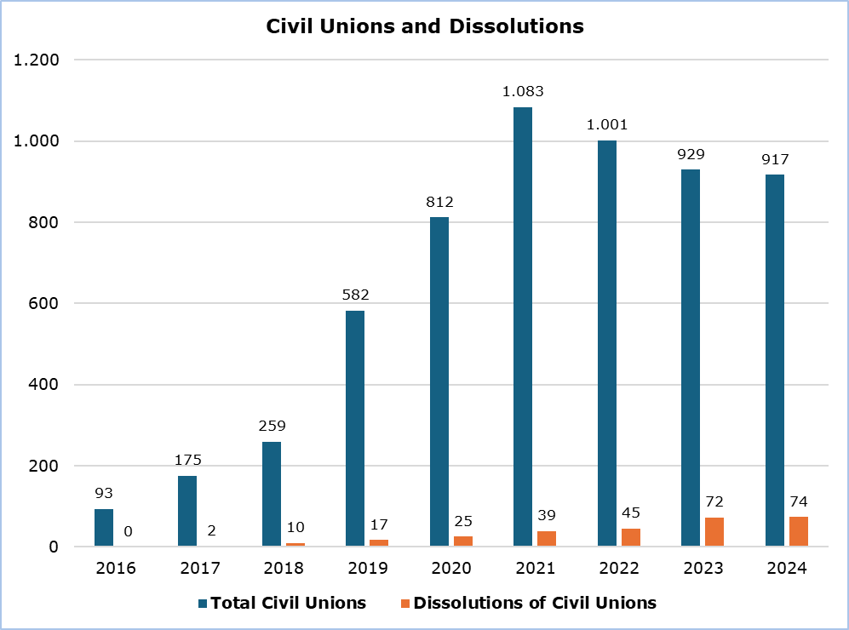

The first civil unions were concluded in 2016, totalling 93 during that year. Since then, a gradual increase has been recorded. In 2024 917 civil unions were concluded, remaining at the same level as the previous year (929). At the same time, a total of 74 dissolutions of civil unions were recorded in 2024. (Figure)

Civil unions account for 8,2% of all legally recognized unions in 2024. (Table 1)

Table 1
Year | Marriages |  | Civil Unions |  | Total
Year | Number | % | Number | % | Number | %
2016 | 13.588 | 99,3 | 93 | 0,7 | 13.681 | 100,0
2017 | 13.062 | 98,7 | 175 | 1,3 | 13.237 | 100,0
2018 | 13.783 | 98,2 | 259 | 1,8 | 14.042 | 100,0
2019 | 14.854 | 96,2 | 582 | 3,8 | 15.436 | 100,0
2020 | 4.028 | 83,2 | 812 | 16,8 | 4.840 | 100,0
2021 | 8.578 | 88,8 | 1.083 | 11,2 | 9.661 | 100,0
2022 | 13.350 | 93,0 | 1.001 | 7,0 | 14.351 | 100,0
2023 | 11.766 | 92,7 | 929 | 7,3 | 12.695 | 100,0
2024 | 10.334 | 91,8 | 917 | 8,2 | 11.251 | 100,0

A percentage of 96,2% (882) of the unions concluded in 2024, concerned residents of Cyprus, while the remaining percentage involved persons residing abroad. Of the 882 unions concluded between Cyprus residents in 2024, 839 concerned opposite-sex couples and 43 concerned same-sex couples. (Table 2)

Table 2
Civil Unions Between Residents of Cyprus | 2024
Civil Unions Between Residents of Cyprus | Number | Percentage (%)
Total | 882 | 100,0
Opposite-sex Couples | 839 | 95,1
Same-sex Couples | 43 | 4,9

The average age at the time of concluding the union for opposite-sex couples was 33,5 years for men and 30,8 years for women. Among same-sex couples, the average age was 40,6 years overall.

For more information:
CYSTAT Portal, subtheme Population
CYSTAT-DB (Database)
Methodological Information

Contact
Andri Christofi: Tel: +35722602234, Email: achristofi@cystat.mof.gov.cy

