7 October, 2025

**PRESS RELEASE**

INDEX OF PRODUCTION AND INDEX OF OUTPUT PRICES IN CONSTRUCTION: **2nd QUARTER 2025**

**Annual Change** **+4,6% in Production and +5,4% in Output Prices**

The Index of Production in Construction during the second quarter of 2025 reached 131,38 units (base year 2021=100,00), recording an increase of 4,6% over the second quarter of 2024.

The Output Prices Index in Construction for the second quarter of 2025 reached 126,32 units (base year 2021=100,00), recording an increase of 2,1% relative to the first quarter of 2025. Compared to the same quarter of the previous year, the Index increased by 5,4%.

During the period January-June 2025, increases relative to the corresponding period of 2024 were observed in the Index of Production in Construction (3,7%) and in the Output Prices Index in Construction (4,9%).

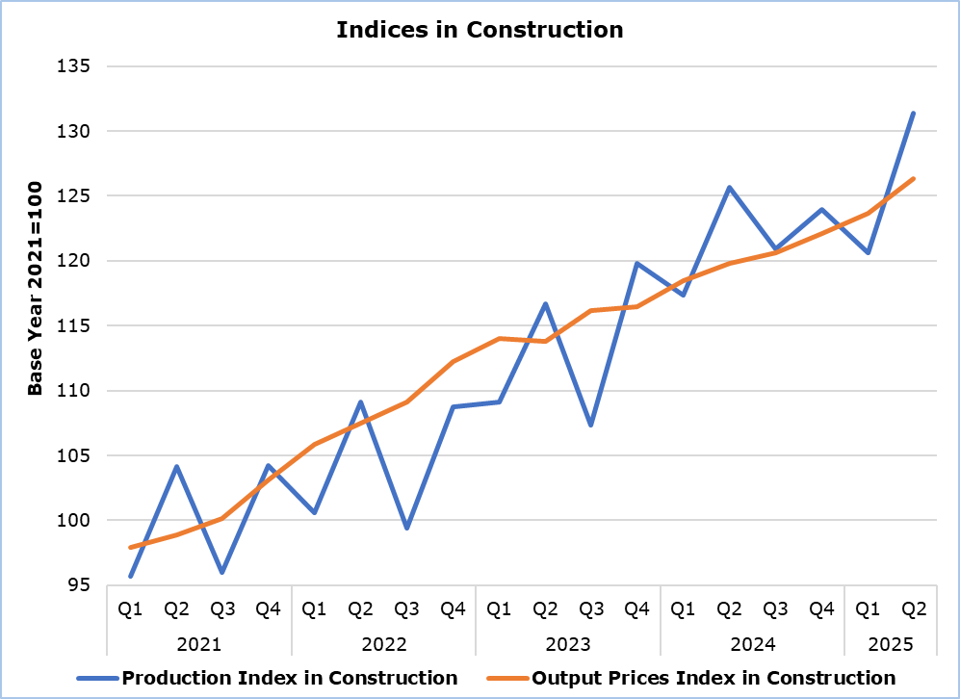

|  |  |  |  |  |  |  |
| --- | --- | --- | --- | --- | --- | --- |
| **Table** |  | | | | | |
|  | | **Index**  **(2021=100)** | |  | **Percentage Change (%)** | |
| **Apr-June 2024** | **Apr-June 2025** |  | **Apr-June 2025/2024** | **Jan-June**  **2025/2024** |
| Index of Production in Construction | | 125,64 | 131,38 |  | 4,6 | 3,7 |
| Output Prices Index in Construction | | 119,82 | 126,32 |  | 5,4 | 4,9 |

**METHODOLOGICAL INFORMATION**

**Scope**

The quarterly Index of Production in Construction serves as a tool for monitoring short-term developments in construction activity. It is a volume index that approximates the changes in value added at constant prices. It can, therefore, be considered as an indication of the growth rate of construction relevant to a specific reference year, the base year.

The quarterly Output Prices Index measures the changes in unit prices charged to clients of construction work. Consequently, it shows the change in the overall cost of construction work incurred to the client, including costs coming from the materials used, from labour, energy, transport, etc, as well as the profit made by the contractors. It can be seen as an indication of the level of price inflation in construction compared to a specific reference year, the base year.

**Collection of Data**

The Statistical Service collects data by telephone enquiries or e-mail on a quarterly basis, from a sample of enterprises that are active in the construction sector. Moreover, information from administrative and other sources is used.

**Compilation Method**

The base year for the Index of Production in Construction is 2021. This means that the index shows the current evolution of production in relation to its average value in the year 2021. In the base year, the average of the production index for the four quarters is set to 100,0. For example, an index of 115,8 implies that production has gone up by 15,8% in relation to the average production of 2021.

The compilation of the Index of Production in Construction follows the provisions of Regulation (EU) 2019/2152 on European business statistics. At national level, the index is published unadjusted (gross), i.e. no working day or seasonal adjustment is performed. In addition to the unadjusted index, a working day and a seasonally adjusted index is transmitted on a quarterly basis to the Statistical Office of the European Union (Eurostat).

Respectively, the base year for the Output Prices Index is also 2021, thus showing the changes in unit prices in relation to their average values in the year 2021.

For the compilation of the Output Prices Index, unit prices are collected for a number of basic construction tasks that are necessary from the foundation to the completion of a project. These tasks are aggregated on the basis of weights that reflect the share of cost corresponding to each task. The Output Prices Index is also used as deflator for the calculation of the Production Index in Construction.

***For more information:***

CYSTAT Portal, subtheme [Construction](https://www.cystat.gov.cy/en/SubthemeStatistics?s=31)

[CYSTAT-DB](https://cystatdb23px.cystat.gov.cy/pxweb/en/8.CYSTAT-DB/8.CYSTAT-DB__Construction__) (Online Database)

[Predefined Tables](https://www.cystat.gov.cy/en/KeyFiguresList?s=31) (Excel)

**Data for base year 2021=100 are available only in the CYSTAT-DB Online Database.**

*Contact*  
Evi Kalogirou Demetriou: Tel: +357 22602168, Email: [ekalogirou@cystat.mof.gov.cy](mailto:ekalogirou@cystat.mof.gov.cy)