22 July, 2026

PRESS RELEASE

RESULTS OF THE CONSTRUCTION AND LAND DEVELOPMENT SURVEY: 2024

Increase in Value Added in the Construction Sector by 10,7%

According to the results of the Construction and Land Development Survey, the main aggregates of the construction sector in 2024 registered a positive growth rate compared to 2023.

In particular, production value in the broad construction sector increased in 2024 by 7,4% to €6.696,5 million compared to €6.232,6 million in 2023. Value added at current prices increased by 10,7% to €1.747,5 million in 2024 compared to €1.578,7 million in 2023.

New construction in 2024 reached €3.823,8 million, registering an increase by 6,4% compared to 2023. More specifically, residential buildings increased in 2024 by 8,6%, non-residential buildings by 2,6% and civil engineering projects by 2,0% compared to 2023.

Employment in the construction sector increased in 2024 by 1,9% to 39,7 thousand compared to 38,9 thousand persons in 2023.

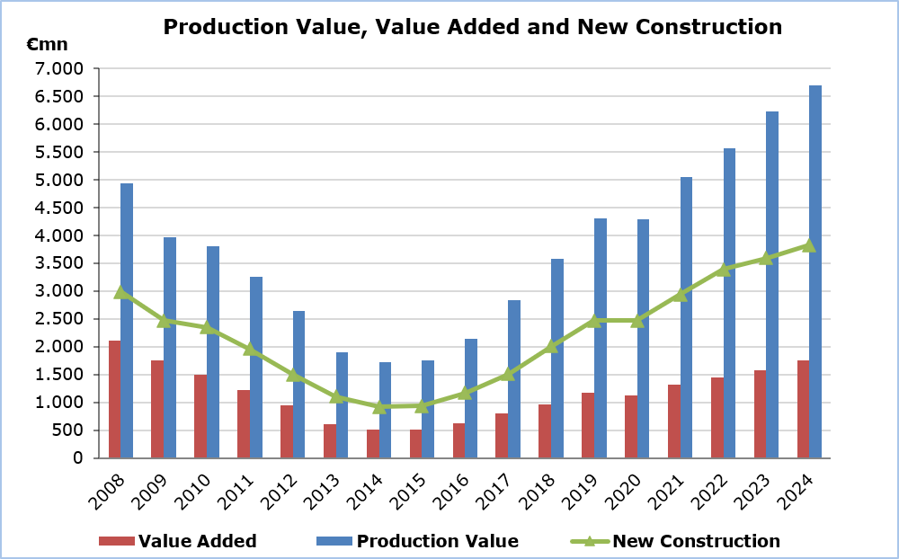

Table
Main Indicators | 2024 | 2023 |  |  | Percentage Change  (%)
Production value (€mn) | 6.696,5 | 6.232,6 |  |  | 7,4
Value added at market prices (€mn) | 1.747,5 | 1.578,7 |  |  | 10,7
Employment | 39.686 | 38.937 |  |  | 1,9
New construction (€mn) | 3.823,8 | 3.592,6 |  |  | 6,4
Residential buildings (€mn) | 2.576,2 | 2.373,1 |  |  | 8,6
Non-residential buildings (€mn) | 711,2 | 693,4 |  |  | 2,6
Civil engineering projects (€mn) | 536,4 | 526,1 |  |  | 2,0

METHODOLOGICAL INFORMATION

Definitions

Production Value – Derived by adding on turnover other income and changes in the value of stocks at the end of the year and deducting the cost of goods and property purchased for resale.

Value Added at current prices - Derived by deducting from the production value the total cost of production expenses, administrative expenses and rents paid for buildings and machinery.

Employment – The average number of employees and self-employed persons during the year, in full time equivalent terms.

Coverage and collection of data

The Construction and Land Development Survey covers a sample of around 1.400 enterprises with main activity falling under section F of the classification system of economic activities NACE Rev. 2 of the European Union, in particular divisions 41 (construction of buildings), 42 (civil engineering) and 43 (specialized construction activities).

The collection of data by the Statistical Service is done by email, using administrative sources, by personal interviews and by phone interviews.

For more information:
CYSTAT Portal, subtheme Construction
Predefined Tables (Excel)
Methodological Information

Contact
Panagiota Christodoulou, Tel: +35722602172, Email: pchristodoulou@cystat.mof.gov.cy

