7 May, 2026

PRESS RELEASE

CONSUMER PRICE INDEX (CPI): APRIL 2026

Inflation 2,8%

Consumer Price Index in April 2026 increased by 1,73 points, reaching 102,80 units compared to 101,07 units in March 2026. Inflation in April 2026 increased at a rate of 2,8%. (Table 1)

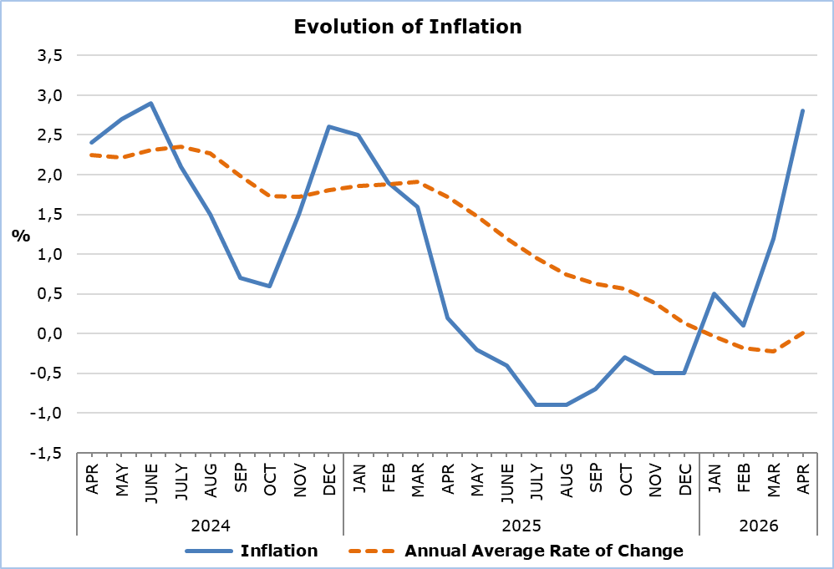

The largest increases compared with April 2025 were recorded in the economic categories Petroleum Products (18,3%) and Agricultural Goods (9,6%), while the largest decrease was observed in Electricity and Water (-7,9%). Compared with March 2026, the largest increase was recorded in Petroleum Products (12,6%). (Table 2)

Analysis of Percentage Changes
Compared with April 2025, the largest changes were observed in the categories Transport (8,2%), Clothing and Footwear (-5,3%), Food and Non-Alcoholic Beverages (4,8%), Recreation, Sports and Culture (4,2%) and Educational Services (3,7%). (Table 1)

In relation to March 2026, the largest changes were recorded in the categories Transport (8,3%), Clothing and Footwear (5,2%) and Housing, Water, Electricity, Natural Gas and Other Fuels (1,4%). (Table 1)

Analysis of Effects in Units
The largest positive contribution to the change in the CPI of April 2026 compared with April 2025 was recorded in the categories Restaurants and Accommodation Services (3,11), Recreation, Sports and Culture (2,82) and Alcoholic Beverages and Tobacco (1,85), while the largest negative contribution to the CPI change of April 2026 compared with April 2025 was observed in the categories Health (-2,61), Information and Communication (-1,61) and Clothing and Footwear (-1,14). (Table 3)

The largest impact on the month-to-month changes in the CPI in April 2026 compared with March 2026 was recorded in the categories Transport (1,23), Clothing and Footwear (0,32), Housing, Water, Electricity, Natural Gas and Other Fuels (0,17) and Food and Non-Alcoholic Beverages (-0,11). (Table 3)

The largest positive contribution to the change in the CPI of April 2026 compared with April 2025 was attributed to Recreation Services (2,88), while the largest negative contribution was attributed to Mobile Communication Services (-1,50). (Table 4)

Fuels and Lubricants (0,72) had the largest positive impact on the change in the CPI of April 2026 compared with the corresponding index of March 2026, while Vegetables (-0,20) had the largest negative impact. (Table 5)

Table 1
Categories of Goods  and Services | CPI (2025=100) |  |  | Change (%)
Categories of Goods  and Services | March  2026 | April  2026 |  | Apr 26 /  Apr 25 |  | Apr 26 /  Mar 26 | Jan - Apr 26 / Jan - Apr 25
Food and Non-Alcoholic  Beverages | 105,24 | 104,62 |  | 4,76 |  | -0,59 | 4,07
Alcoholic Beverages and Tobacco | 100,62 | 100,46 |  | 0,81 |  | -0,16 | 0,83
Clothing and Footwear | 93,85 | 98,76 |  | -5,29 |  | 5,23 | -6,19
Housing, Water, Electricity, Natural Gas and Other Fuels | 100,23 | 101,64 |  | 2,65 |  | 1,41 | -0,35
Furnishings and Home Decoration, Household Equipment, and Routine Home Maintenance | 99,97 | 99,86 |  | -0,26 |  | -0,11 | 0,16
Health | 100,86 | 100,93 |  | 1,11 |  | 0,07 | 0,78
Transport | 100,56 | 108,87 |  | 8,17 |  | 8,26 | 0,47
Information and Communication | 97,71 | 97,42 |  | -1,99 |  | -0,30 | -1,89
Recreation, Sports and Culture | 101,61 | 102,74 |  | 4,15 |  | 1,11 | 3,17
Educational Services | 102,58 | 102,58 |  | 3,71 |  | 0,00 | 3,71
Restaurants and Accommodation Services | 102,15 | 102,60 |  | 3,27 |  | 0,44 | 4,01
Insurance and Financial Services | 100,05 | 100,05 |  | 0,03 |  | 0,00 | 0,10
Personal Care, Social Protection, and Miscellaneous Goods and Services | 100,34 | 100,60 |  | 0,89 |  | 0,26 | 1,47
General Consumer Price Index | 101,07 | 102,80 |  | 2,83 |  | 1,71 | 1,14

Table 2
Economic Origin | Weights | Change (%)
Economic Origin | Weights | Apr 26/ Apr 25 | Apr 26/ Mar 26
Agricultural Goods | 648 | 9,57 | -1,81
Industrial Goods  (excl. Petroleum Products) | 4111 | -0,68 | 0,82
Electricity and Water | 393 | -7,89 | -2,15
Petroleum Products | 708 | 18,29 | 12,61
Services | 4140 | 3,54 | 1,57
General Index | 10000 | 2,83 | 1,71

Table 3
Categories of Goods and Services | Weights 2025 | Weights 2026 | Effect (units)
Categories of Goods and Services | Weights 2025 | Weights 2026 | Apr 26 / Apr 25 | Apr 26/ Mar 26
Food and Non-Alcoholic  Beverages | 1906 | 1762 | -0,60 | -0,11
Alcoholic Beverages and Tobacco | 347 | 528 | 1,85 | -0,01
Clothing and Footwear | 721 | 646 | -1,14 | 0,32
Housing, Water, Electricity, Natural Gas and Other Fuels | 1122 | 1187 | 0,95 | 0,17
Furnishings and Home Decoration, Household Equipment, and Routine Home Maintenance | 641 | 619 | -0,24 | -0,01
Health | 637 | 371 | -2,61 | 0,00
Transport | 1538 | 1481 | 0,64 | 1,23
Information and Communication | 569 | 415 | -1,61 | -0,01
Recreation, Sports and Culture | 437 | 694 | 2,82 | 0,08
Educational Services | 392 | 376 | -0,02 | 0,00
Restaurants and Accommodation Services | 836 | 1113 | 3,11 | 0,05
Insurance and Financial Services | 326 | 236 | -0,90 | 0,00
Personal Care, Social Protection, and Miscellaneous Goods and Services | 528 | 572 | 0,49 | 0,01
General Consumer Price Index | 10000 | 10000 | 2,83 | 1,73
Note: The totals are calculated based on the individual impacts using infinite-precision decimals and are published rounded to two decimal places. Any discrepancies in the totals are due to rounding effects as well as the change in the base year.

Table 4
Goods/Services | Effect (units)
Goods/Services | Apr 26/ Apr 25
Positive Effect
Recreation Services | 2,88
Catering Services (Food and Beverage Services) | 2,74
Rents | 1,53
Negative Effect
Mobile Communication Services | -1,50
Insurance | -1,13
Medicines and Health Products | -0,99
Various Other Goods and Services | -0,70
TOTAL | 2,83

Table 5
Goods/Services | Effect (units)
Goods/Services | Apr 26/ Mar 26
Positive Effect
Fuels and Lubricants | 0,72
Passenger Transport | 0,54
Clothing | 0,24
Various Other Goods and Services | 0,66
Negative Effect
Vegetables | -0,20
Meat | -0,15
Electricity | -0,08
TOTAL | 1,73

METHODOLOGICAL INFORMATION

Definitions

The Consumer Price Index (CPI) is compiled to measure the changes of prices over time of consumer goods and services acquired, used or paid by households. Specifically, the national CPI of Cyprus covers the consumption expenses of specific goods and services (shopping basket of goods and services), of the resident households and of the households that intend to live in Cyprus for at least one year. CPI is the official index for the estimation of inflation.

The Inflation shows the change of the CPI when compared with the index of the corresponding month of the previous year.

The Effect represents the amount of the overall change in the General Index which is accounted for by any given category/product/service.

Price Collection

The price collection is carried out only in urban districts of Nicosia, Larnaca, Limassol and Paphos. For each city, the fluctuations in the product and services prices for each month, are weighted according to their population. Specifically, the weights for the four districts are: Nicosia 40%, Limassol 30%, Larnaca 18% and Paphos 12%.

The prices of 850 goods and services, which are included in the CPI, are recorded once every month, except for some seasonal products (e.g., vegetables and fruit), meat and fuels, for which prices are collected every week (every Thursday).

Base Year

From January 2026 onwards, the base year is 2025=100. The index reference period was 2015=100 for the period between January 2016 and December 2025.

Classification

Until December 2025, ECOICOP classification was used for the calculation and the dissemination of the CPI. From January 2026 onwards, CYSTAT adopts the ECOICOP ver.2 classification. The lowest level of detail for the classification used in CPI is five digits level of analysis.

Products/Services and Weights

From January 2026 onwards, the products and services included in the CPI as well as their corresponding weights have been revised. The revision was based on the results of the Household Budget Survey 2023.

For more information:
CYSTAT Portal, subtheme Price Indices
CYSTAT-DB (Online Database)
CPI Revision January 2026

Contact
Sofronis Vikis: Tel: +35722602206, Email: svikis@cystat.mof.gov.cy
Kyriakos Voutouris: Tel: +35722605132, Email: kvoutouris@cystat.mof.gov.cy
Filippos Kakoutsis: Tel: +35722605149, Email: fkakoutsis@cystat.mof.gov.cy

