8 January, 2026

PRESS RELEASE

CONSUMER PRICE INDEX (CPI): DECEMBER 2025

Inflation -0,5%

The Consumer Price Index (CPI) in December 2025 increased by 0,10 points, reaching 117,67 units compared to 117,57 units in November 2025. Inflation in December 2025 decreased at a rate of 0,5%. (Table 1)

For the period January – December 2025, the CPI recorded an increase of 0,1% compared to the corresponding period of the previous year. (Table 1)

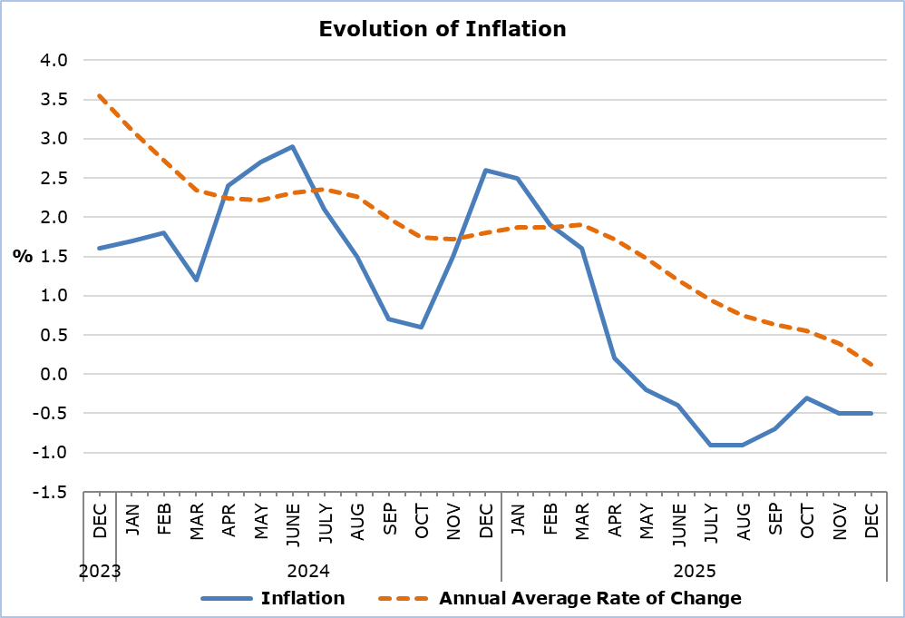

The largest positive change in the economic categories compared with December 2024 was recorded in Services (3,1%), while the largest negative changes were observed in Electricity (-9,4%) and Agricultural Products (-5,8%). Compared with November 2025, the largest change was recorded in Agricultural Products (3,0%). (Table 2)

Analysis of Percentage Changes

Compared to December 2024, the largest changes were recorded in the categories Clothing and Footwear (-7,9%), Restaurants and Hotels (4,9%), Education (3,5%) and Food and Non-Alcoholic Beverages (-2,9%). (Table 1)

Compared to November 2025, the largest changes were recorded in the categories Food and Non-Alcoholic Beverages (0,8%) and Transport (-0,4%). (Table 1)

For the period January – December 2025, compared with the corresponding period of the previous year, the largest changes were recorded in the categories Clothing and Footwear (-6,5%), Restaurants and Hotels (4,7%), Education (3,7%) and Recreation and Culture (3,1%). (Table 1)

Analysis of Effects in Units

The largest positive impact on the change of the CPI in December 2025 compared to December 2024 was recorded in the categories Restaurants and Hotels (0,54), Education (0,16) and Recreation and Culture (0,15), while the largest negative impact on the change of the CPI in December 2025 compared to December 2024 was recorded in the categories Food and Non-Alcoholic Beverages (-0,70) and Clothing and Footwear (-0,61). (Table 3)

The largest impact on the change of the CPI in December 2025 compared to November 2025 was recorded in the category Food and Non-Alcoholic Beverages (0,19). (Table 3)

The largest positive impact on the change of the CPI in December 2025 compared to the index of December 2024 was recorded in Catering Services (0,53), while the largest negative impact was recorded in Electricity (-0,53) and Fresh Vegetables (-0,51). (Table 4)

Fresh Vegetables (0,33) had the largest positive impact on the change of the CPI in December 2025 compared to the corresponding index of November 2025, while Airfares (-0,06) and Electricity (-0,06) had the largest negative impact. (Table 5)

Table 1
Categories of Goods  and Services | CPI (2015=100) |  |  | Change (%)
Categories of Goods  and Services | November  2025 | December  2025 |  | Dec 25 / Dec 24 | Dec 25 /  Nov 25 | Jan – Dec 25 /  Jan – Dec 24
Food and Non-Alcoholic  Beverages | 121,10 | 122,11 |  | -2,93 | 0,83 | -0,41
Alcoholic Beverages and Tobacco | 104,32 | 104,44 |  | 1,04 | 0,12 | 0,91
Clothing and Footwear | 98,94 | 98,63 |  | -7,93 | -0,31 | -6,48
Housing, Water, Electricity, Gas and Other Fuels | 144,37 | 143,98 |  | -1,65 | -0,27 | -0,66
Furnishings, Household Equipment and Routine Maintenance of the House | 104,32 | 104,36 |  | -0,23 | 0,04 | -0,70
Health | 108,23 | 108,23 |  | 1,12 | 0,00 | 1,53
Transport | 113,30 | 112,88 |  | -0,85 | -0,37 | -1,38
Communication | 92,09 | 92,02 |  | 0,54 | -0,08 | 0,31
Recreation and Culture | 119,02 | 119,01 |  | 2,20 | -0,01 | 3,10
Education | 120,01 | 120,19 |  | 3,45 | 0,15 | 3,65
Restaurants and Hotels | 136,22 | 136,38 |  | 4,92 | 0,12 | 4,72
Miscellaneous Goods  and Services | 113,09 | 113,26 |  | 1,41 | 0,15 | 1,08
General Consumer Price Index | 117,57 | 117,67 |  | -0,54 | 0,09 | 0,13

Table 2
Economic Origin | Weights | Change (%)
Economic Origin | Weights | Dec 25/ Dec 24 | Dec 25/ Nov 25
Agricultural Goods | 749 | -5,81 | 3,01
Industrial Goods  (excl. Petroleum Products) | 4021 | -1,56 | -0,22
Electricity | 316 | -9,37 | -1,13
Petroleum Products | 871 | -2,82 | -0,11
Water | 72 | 0,00 | 0,00
Services | 3971 | 3,12 | -0,03
General Index | 10000 | -0,54 | 0,09

Table 3
Categories of Goods and Services | Weights | Effect (units)
Categories of Goods and Services | Weights | Dec 25/ Dec 24 | Dec 25/ Nov 25
Food and non-Alcoholic Beverages | 1906 | -0,70 | 0,19
Alcoholic Beverages, Tobacco | 347 | 0,04 | 0,00
Clothing and Footwear | 721 | -0,61 | -0,02
Housing, Water, Electricity, Gas and Other Fuels | 1119 | -0,27 | -0,04
Furnishings, Household Equipment and Routine Maintenance of the House | 644 | -0,02 | 0,00
Health | 637 | 0,08 | 0,00
Transport | 1524 | -0,15 | -0,06
Communication | 439 | 0,02 | 0,00
Recreation and Culture | 575 | 0,15 | 0,00
Education | 392 | 0,16 | 0,01
Restaurants and Hotels | 836 | 0,54 | 0,01
Miscellaneous Goods and Services | 860 | 0,14 | 0,01
General Consumer Price Index | 10000 | -0,64 | 0,10
Note: Totals are calculated on the basis of the effects of the categories with infinite decimal figures and rounded up to two decimals when published. Figures may not add to totals due to rounding error.

Table 4
Goods/Services | Effect (units)
Goods/Services | Dec 25/ Dec 24
Positive Effect
Catering Services | 0,53
Home Maintenance Services | 0,19
Fresh Fruits | 0,16
Actual Rent for Primary Residence | 0,10
Various Other Goods and Services | 0,24
Negative Effect
Electricity | -0,53
Fresh Vegetables | -0,51
Clothing | -0,50
Petroleum Products | -0,32
TOTAL | -0,64

Table 5
Goods/Services | Effect (units)
Goods/Services | Dec 25/ Nov 25
Positive Effect
Fresh Vegetables | 0,33
Catering Services | 0,02
Home Maintenance Services | 0,02
Footwears | 0,02
Various Other Goods and Services | -0,13
Negative Effect
Airfares | -0,06
Electricity | -0,06
Clothing | -0,04
TOTAL | 0,10

METHODOLOGICAL INFORMATION

Definitions

The Consumer Price Index (CPI) is compiled to measure the changes of prices over time of consumer goods and services acquired, used or paid by households. Specifically, the national CPI of Cyprus covers the consumption expenses of specific goods and services (shopping basket of goods and services), of the resident households and of the households that intend to live in Cyprus for at least one year. CPI is the official index for the estimation of inflation.

The Inflation shows the change of the CPI when compared with the index of the corresponding month of the previous year.

The Effect represents the amount of the overall change in the General Index which is accounted for by any given category/product/service.

Price Collection

The price collection is carried out only in urban districts of Nicosia, Larnaca, Limassol and Paphos. For each city, the fluctuations in the product and services prices for each month, are weighted according to their population. Specifically, the weights for the four districts are: Nicosia 42%, Limassol 30%, Larnaca 18% and Paphos 10%.

The prices of 805 goods and services, which are included in the CPI, are recorded once every month, except for some seasonal products (e.g., vegetables and fruit), meat and fuels, for which prices are collected every week (every Thursday).

Base Year

The index reference period was 2005=100 for the period between January 2006 and December 2015. From January 2016 and onwards, the base year is 2015=100.

Classification

Until December 2015, COICOP 4 classification up to four digits level of analysis, was used for the calculation and the dissemination of the CPI. From January 2016 and onwards, CYSTAT is adopting the ECOICOP classification satisfying relevant European Union Regulation. Consequently, the lowest level of detail for the classification used in CPI is COICOP 5-digits level of analysis.

Products/Services and Weights

From January 2018 and onwards, the products included in the CPI as well as their corresponding weights have been revised. The revision was based on the results of the Household Budget Survey 2015/2016.

For more information:
CYSTAT Portal, subtheme Price Indices
CYSTAT-DB (Online Database)
Methodological Information

Contact
Sofronis Vikis: Tel.: +357-22602206, Email: svikis@cystat.mof.gov.cy
Kyriakos Voutouris: Tel.: +357-22605132, Email: kvoutouris@cystat.mof.gov.cy
Filippos Kakoutsis: Tel.: +357-22605149, Email: fkakoutsis@cystat.mof.gov.cy

