6 March, 2025

**PRESS RELEASE**

CONSUMER PRICE INDEX (CPI): **February 2025**

**Inflation 1,9%**

The Consumer Price Index (CPI) in February 2025 increased by 0,38 points, reaching 117,11 units compared to 116,73 units in January 2025. Inflation in February 2025 increased at a rate of 1,9%.

(Table 1)

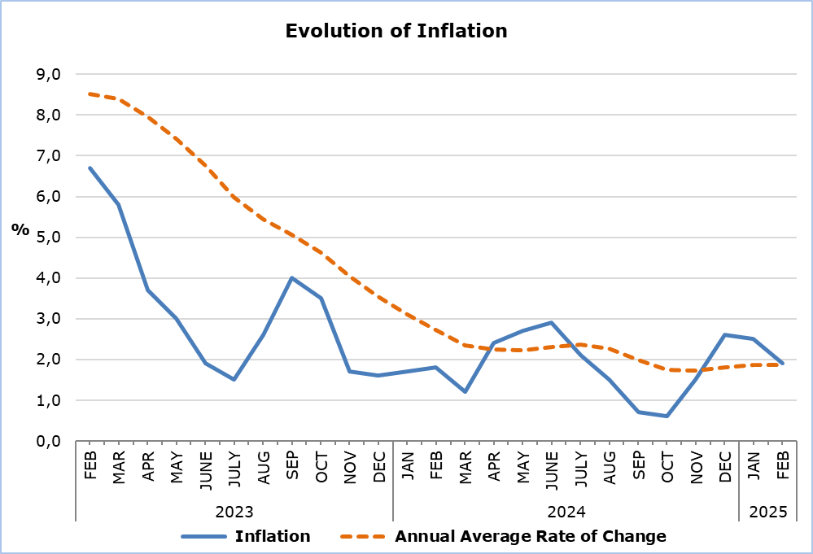

The largest change in economic categories compared to February 2024 and the previous month was recorded in *Agricultural Goods*, with percentages of 7,0% and 2,7%, respectively. (Table 2)

**Analysis of Percentage Changes**

Compared to February 2024, the largest changes were observed in the categories of *Clothing and Footwear* (-5,1%), *Education* (3,7%), *Transport* (3,7%), and *Restaurants and Hotels* (3,5%). (Table 1)

Compared to January 2025, the largest change was recorded in the *Transport* category (1,3%). (Table 1)

For the period January – February 2025, compared to the same period of the previous year, the largest changes were observed in the categories of *Clothing and Footwear* (-3,9%), Restaurants and Hotels (3,8%), *Education* (3,7%), *Food and Non-Alcoholic Beverages* (3,5%), and *Transport* (3,5%). (Table 1)

**Analysis of Effects in Units**

The largest positive impact on the change in the Consumer Price Index (CPI) for February 2025 compared to February 2024 was observed in the categories of *Transport* (0,62) and *Food and Non-Alcoholic Beverages* (0,52). On the other hand, the category of *Clothing and Footwear* had the largest negative impact (-0,36). (Table 3)

The category with the greatest impact on the change in the CPI compared to the previous month was *Transport* (0,23). (Table 3)

The largest positive impact on the change in the CPI for February 2025 compared to February 2024 was recorded in the *Petroleum Products* (0,40) and *Catering Services* (0,37), while the largest negative impact came from *Clothing Items* (-0,23). (Table 4)

*Fresh Vegetables* had the most significant positive impact on the CPI change for February 2025 compared to the previous month (0,25), while the largest negative impact was observed in *Potatoes* (-0.06).

(Table 5)

|  |  |  |  |  |  |  |
| --- | --- | --- | --- | --- | --- | --- |
| **Table 1** | | | | | | |
| **Categories of Goods**  **and Services** | **CPI (2015=100)** | |  | **Change (%)** | | |
| **January**  **2025** | **February**  **2025** |  | **Feb 25/**  **Feb 24** | **Feb 25/ Jan 25** | **Jan- Feb 25/**  **Jan- Feb 24** |
| Food and Non-Alcoholic  Beverages | 122,73 | 122,97 |  | 2,25 | 0,20 | 3,51 |
| Alcoholic Beverages and Tobacco | 103,51 | 103,57 |  | 1,41 | 0,06 | 1,69 |
| Clothing and Footwear | 93,22 | 93,71 |  | -5,12 | 0,53 | -3,92 |
| Housing, Water, Electricity, Gas and Other Fuels | 145,91 | 146,59 |  | 2,82 | 0,47 | 2,29 |
| Furnishings, Household Equipment and Routine Maintenance of the House | 103,68 | 103,55 |  | -0,53 | -0,13 | -0,54 |
| Health | 107,64 | 108,03 |  | 1,82 | 0,36 | 1,73 |
| Transport | 114,17 | 115,66 |  | 3,67 | 1,31 | 3,50 |
| Communication | 91,51 | 91,50 |  | 0,18 | -0,01 | 0,16 |
| Recreation and Culture | 116,51 | 116,50 |  | 2,65 | -0,01 | 2,73 |
| Education | 116,08 | 116,08 |  | 3,73 | 0,00 | 3,73 |
| Restaurants and Hotels | 130,23 | 130,38 |  | 3,49 | 0,12 | 3,78 |
| Miscellaneous Goods  and Services | 111,69 | 111,35 |  | 1,08 | -0,30 | 1,45 |
| **General Consumer Price Index** | **116,73** | **117,11** |  | **1,90** | **0,33** | **2,18** |

|  |  |  |  |
| --- | --- | --- | --- |
| **Table 2** | | | |
| **Economic Origin** | **Weights** | **Change (%)** | |
| **Feb 25/ Feb 24** | **Feb 25/ Jan 25** |
| Agricultural goods | 749 | 6,97 | 2,66 |
| Industrial goods (excl. petroleum products) | 4021 | -0,84 | -0,43 |
| Electricity | 316 | 1,45 | 0,53 |
| Petroleum products | 871 | 4,58 | 1,63 |
| Water | 72 | 0,00 | 0,00 |
| Services | 3971 | 2,97 | 0,25 |
| **General Index** | **10000** | **1,90** | **0,33** |

|  |  |  |  |
| --- | --- | --- | --- |
| **Table 3** | | | |
| **Categories of Goods and Services** | **Weights** | **Effect (units)** | |
| **Feb 25/ Feb 24** | **Feb 25/ Jan 25** |
| Food and non-Alcoholic Beverages | 1906 | 0,52 | 0,05 |
| Alcoholic Beverages, Tobacco | 347 | 0,05 | 0,00 |
| Clothing and Footwear | 721 | -0,36 | 0,04 |
| Housing, Water, Electricity, Gas and Other Fuels | 1119 | 0,45 | 0,08 |
| Furnishings, Household Equipment and Routine Maintenance of the House | 644 | -0,04 | -0,01 |
| Health | 637 | 0,12 | 0,03 |
| Transport | 1524 | 0,62 | 0,23 |
| Communication | 439 | 0,01 | 0,00 |
| Recreation and Culture | 575 | 0,17 | 0,00 |
| Education | 392 | 0,16 | 0,00 |
| Restaurants and Hotels | 836 | 0,37 | 0,01 |
| Miscellaneous Goods and Services | 860 | 0,10 | -0,03 |
| **General Consumer Price Index** | **10000** | **2,18** | **0,38** |
| Note: Totals are calculated on the basis of the effects of the categories with infinite decimal figures and rounded up to two decimals when published. Figures may not add to totals due to rounding error. | | | |

|  |  |
| --- | --- |
| **Table 4** | |
| **Goods/Services** | **Effect (units)** |
| **Feb 25/ Feb 24** |
| ***Positive Effect*** |  |
| Petroleum Products | 0,40 |
| Catering Services | 0,37 |
| Fresh Vegetables | 0,31 |
| Meat | 0,18 |
| Services for Regular Household Maintenance | 0,15 |
| Fresh Fruits | 0,12 |
| Various Other Products and Services | 1,45 |
| ***Negative Effect*** |  |
| Clothing Items | -0,23 |
| Oils and Fats | -0,02 |
| Potatoes | -0,01 |
| **TOTAL** | **2,18** |

|  |  |
| --- | --- |
| **Table 5** | |
| **Goods/Services** | **Effect (units)** |
| **Feb 25/ Jan 25** |
| ***Positive Effect*** |  |
| Fresh Vegetables | 0,25 |
| Petroleum Products | 0,16 |
| Fresh Fruits | 0,06 |
| Clothing Items | 0,05 |
| Electricity | 0,03 |
| ***Negative Effect*** |  |
| Potatoes | -0,06 |
| Meat | -0,03 |
| Footwear | -0,02 |
| Various Other Products and Services | -0,07 |
| **TOTAL** | **0,38** |

**METHODOLOGICAL INFORMATION**

**Definitions**

The **Consumer Price Index (CPI)** is compiled to measure the changes of prices over time of consumer goods and services acquired, used or paid by households. Specifically, the national CPI of Cyprus covers the consumption expenses of specific goods and services (shopping basket of goods and services), of the resident households and of the households that intend to live in Cyprus for at least one year. CPI is the official index for the estimation of inflation.

The **Inflation** shows the change of the CPI when compared with the index of the corresponding month of the previous year.

The **Effect** represents the amount of the overall change in the General Index which is accounted for by any given category/product/service.

**Price Collection**

The price collection is carried out only in urban districts of Nicosia, Larnaca, Limassol and Paphos. For each city, the fluctuations in the product and services prices for each month, are weighted according to their population. Specifically, the weights for the four districts are: Nicosia 42%, Limassol 30%, Larnaca 18% and Paphos 10%.

The prices of 805 goods and services, which are included in the CPI, are recorded once every month, except for some seasonal products (e.g vegetables and fruit), meat and fuels, for which prices are collected every week (every Thursday).

**Base Year**

The index reference period was 2005=100 for the period between January 2006 and December 2015. From January 2016 and onwards, the base year is 2015=100.

**Classification**

Until December 2015, COICOP 4 classification up to four digits level of analysis, was used for the calculation and the dissemination of the CPI. From January 2016 and onwards, CYSTAT is adopting the ECOICOP classification satisfying relevant European Union Regulation. Consequently, the lowest level of detail for the classification used in CPI is COICOP 5-digits level of analysis.

**Products/Services and Weights**

From January 2018 and onwards, the products included in the CPI as well as their corresponding weights have been revised. The revision was based on the results of the Household Budget Survey 2015/2016.

***For more information:***

CYSTAT Portal, subtheme [Price Indices](https://www.cystat.gov.cy/en/SubthemeStatistics?s=47)

[CYSTAT-DB](https://cystatdb.cystat.gov.cy/pxweb/en/8.CYSTAT-DB/8.CYSTAT-DB__Price%20Indices__) (Online Database)

[Predefined Tables](https://www.cystat.gov.cy/en/KeyFiguresList?s=47) (Excel)

[Methodological Information](https://www.cystat.gov.cy/en/MethodologicalDetails?m=2090)

**The Predefined Tables, available in Excel format, are updated up to and including December 2021. More recent data are published only on the CYSTAT-DB Online Database.**

*Contact*

Sofronis Vikis: Tel: +35722602206, Email: [svikis@cystat.mof.gov.cy](mailto:svikis@cystat.mof.gov.cy)

Kyriakos Voutouris: Tel: +35722605132, Email: [kvoutouris@cystat.mof.gov.cy](mailto:kvoutouris@cystat.mof.gov.cy)

Filippos Kakoutsis: Tel: +35722605149, Email: [fkakoutsis@cystat.mof.gov.cy](mailto:fkakoutsis@cystat.mof.gov.cy)