5 March, 2026

PRESS RELEASE

CONSUMER PRICE INDEX (CPI): February 2026

Inflation 0,1%

Consumer Price Index in February 2026 decreased by 0,12 points, reaching 99,86 units compared to 99,98 units in January 2026. Inflation in February 2026 increased at a rate of 0.1%. (Table 1)

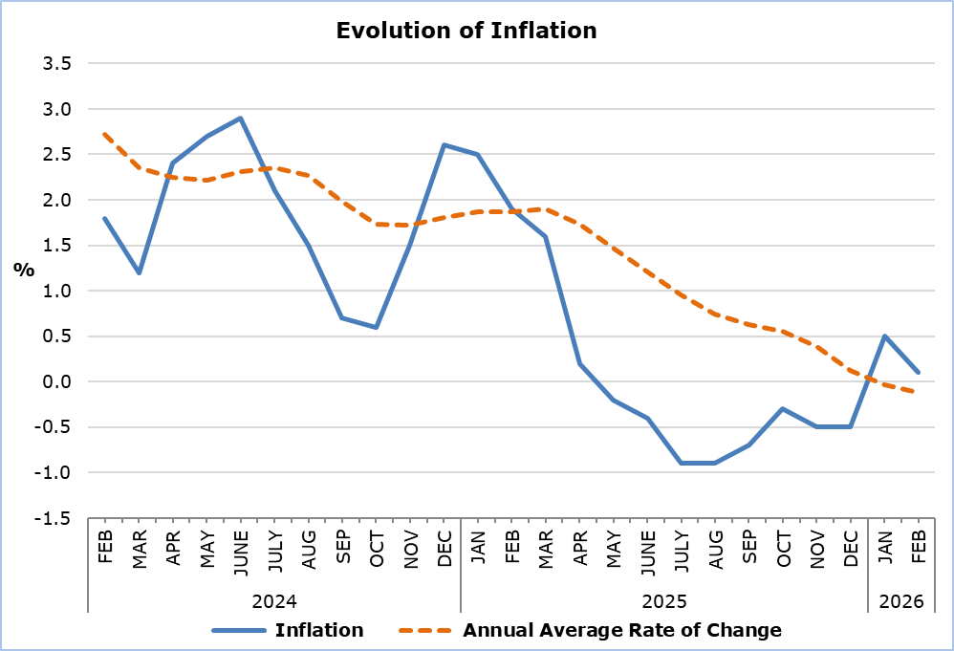

The largest positive change among the economic categories compared with February 2025 was recorded in Agricultural Products (4,2%), while the largest negative changes was observed in Electricity and Water (-9,3%). Compared with January 2026, the biggest change was in Electricity and Water(-2,5%).(Table 2)

Analysis of Percentage Changes
Compared with February 2025, the largest changes were observed in the categories Clothing and Footwear (-6,8%), Restaurants and Accommodation Services (4,7%), Educational Services (3,7%), and Transport (-3,7%). (Table 1)

In relation to January 2026, the largest changes were recorded in the categories Clothing and Footwear (0,8%), Recreation, Sports and Culture (-0,5%), and Food and Non-Alcoholic Beverages (-0,4%). (Table 1)

Analysis of Effects in Units
The largest positive contribution to the change in the CPI of February 2026 compared with February 2025 was recorded in the categories Restaurants and Accommodation Services (3,21), Recreation, Sports and Culture (2,70), and Alcoholic Beverages and Tobacco (1,86), while the largest negative contribution to the CPI change of February 2026 compared with February 2025 was observed in the categories Health (-2,64), Information and Communication (-1,60), and Clothing and Footwear (-1,15). (Table 3)

The largest impact on the month-to-month changes in the CPI in February 2026 compared with January 2026 was recorded in the categories Food and Non-Alcoholic Beverages (-0,08), Clothing and Footwear (0,05), Housing, Water, Electricity, Gas and Other Fuels (-0,04), and Recreation, Sports and Culture (-0,04). (Table 3)

The largest positive contribution to the change in the CPI of February 2026 compared with February 2025 was attributed to Catering Services (2,82), while the largest negative contribution was attributed to Petrol (-2,28). (Table 4)

Clothing (0,06) had the largest positive impact on the change in the CPI of February 2026 compared with the corresponding index of January 2026, while Vegetables (-0,19) had the largest negative impact. (Table 5)

Table 1
Categories of Goods  and Services | CPI (2025=100) |  |  | Change (%)
Categories of Goods  and Services | January  2026 | February  2026 |  | Feb 26 /  Feb 25 |  | Feb 26 /  Jan 26 | Jan – Feb 26 / Jan – Feb 25
Food and Non-Alcoholic  Beverages | 103,11 | 102,67 |  | 2,36 |  | -0,43 | 2,68
Alcoholic Beverages and Tobacco | 100,42 | 100,68 |  | 0,96 |  | 0,26 | 0,86
Clothing and Footwear | 89,63 | 90,34 |  | -6,77 |  | 0,79 | -6,89
Housing, Water, Electricity, Natural Gas and Other Fuels | 100,66 | 100,36 |  | -1,41 |  | -0,30 | -1,03
Furnishings and Home Decoration, Household Equipment, and Routine Home Maintenance | 99,83 | 99,52 |  | 0,24 |  | -0,31 | 0,32
Health | 100,38 | 100,47 |  | 0,51 |  | 0,09 | 0,65
Transport | 97,72 | 97,71 |  | -3,71 |  | -0,01 | -3,08
Information and Communication | 97,61 | 97,62 |  | -1,75 |  | 0,01 | -1,86
Recreation, Sports and Culture | 101,43 | 100,89 |  | 2,43 |  | -0,53 | 2,79
Educational Services | 102,58 | 102,58 |  | 3,71 |  | 0,00 | 3,71
Restaurants and Accommodation Services | 101,72 | 101,80 |  | 4,74 |  | 0,08 | 4,76
Insurance and Financial Services | 100,05 | 100,05 |  | 0,12 |  | 0,00 | 0,12
Personal Care, Social Protection, and Miscellaneous Goods and Services | 100,71 | 100,45 |  | 2,03 |  | -0,26 | 1,90
General Consumer Price Index | 99,98 | 99,86 |  | 0,06 |  | -0,12 | 0,29

Table 2
Economic Origin | Weights | Change (%)
Economic Origin | Weights | Feb 26/ Feb 25 | Feb 26/ Jan 26
Agricultural Goods | 648 | 4,24 | -1,19
Industrial Goods  (excl. Petroleum Products) | 4111 | -0,86 | 0,00
Electricity and Water | 393 | -9,29 | -2,52
Petroleum Products | 708 | -7,42 | 0,18
Services | 4140 | 3,15 | 0,13
General Index | 10000 | 0,06 | -0,12

Table 3
Categories of Goods and Services | Weights 2025 | Weights 2026 | Effect (units)
Categories of Goods and Services | Weights 2025 | Weights 2026 | Feb 26 / Feb 25 | Feb 26/ Jan 26
Food and Non-Alcoholic  Beverages | 1906 | 1762 | -1,03 | -0,08
Alcoholic Beverages and Tobacco | 347 | 528 | 1,86 | 0,01
Clothing and Footwear | 721 | 646 | -1,15 | 0,05
Housing, Water, Electricity, Natural Gas and Other Fuels | 1122 | 1187 | 0,49 | -0,04
Furnishings and home decoration, Household Equipment, and Routine Home Maintenance | 641 | 619 | -0,20 | -0,02
Health | 637 | 371 | -2,64 | 0,00
Transport | 1538 | 1481 | -1,14 | 0,00
Information and Communication | 569 | 415 | -1,60 | 0,00
Recreation, Sports and Culture | 437 | 694 | 2,70 | -0,04
Educational Services | 392 | 376 | -0,02 | 0,00
Restaurants and Accommodation Services | 836 | 1113 | 3,21 | 0,01
Insurance and Financial Services | 326 | 236 | -0,90 | 0,00
Personal Care, Social Protection, and miscellaneous Goods and Services | 528 | 572 | 0,55 | -0,01
General Consumer Price Index | 10000 | 10000 | 0,06 | -0,12
Note: The totals are calculated based on the individual impacts using infinite-precision decimals and are published rounded to two decimal places. Any discrepancies in the totals are due to rounding effects as well as the change in the base year.

Table 4
Goods/Services | Effect (units)
Goods/Services | Feb 26/ Feb 25
Positive Effect
Catering Services (food and beverage services) | 2,82
Recreation Services | 2,79
Rents | 1,42
Negative Effect
Petrol | -2,28
Mobile Communication Services | -1,50
Insurance | -1,13
Various Other Goods and Services | -2,06
TOTAL | 0,06

Table 5
Goods/Services | Effect (units)
Goods/Services | Feb 26/ Jan 26
Positive Effect
Clothing | 0,06
Rents | 0,05
Fruits | 0,03
Negative Effect
Vegetables | -0,19
Electricity | -0,10
Petrol | -0,03
Various Other Goods and Services | -0,05
TOTAL | -0,12

METHODOLOGICAL INFORMATION

Definitions

The Consumer Price Index (CPI) is compiled to measure the changes of prices over time of consumer goods and services acquired, used or paid by households. Specifically, the national CPI of Cyprus covers the consumption expenses of specific goods and services (shopping basket of goods and services), of the resident households and of the households that intend to live in Cyprus for at least one year. CPI is the official index for the estimation of inflation.

The Inflation shows the change of the CPI when compared with the index of the corresponding month of the previous year.

The Effect represents the amount of the overall change in the General Index which is accounted for by any given category/product/service.

Price Collection

The price collection is carried out only in urban districts of Nicosia, Larnaca, Limassol and Paphos. For each city, the fluctuations in the product and services prices for each month, are weighted according to their population. Specifically, the weights for the four districts are: Nicosia 40%, Limassol 30%, Larnaca 18% and Paphos 12%.

The prices of 850 goods and services, which are included in the CPI, are recorded once every month, except for some seasonal products (e.g., vegetables and fruit), meat and fuels, for which prices are collected every week (every Thursday).

Base Year

From January 2026 onwards, the base year is 2025=100.The index reference period was 2015=100 for the period between January 2016 and December 2025.

Classification

Until December 2025, ECOICOP classification was used for the calculation and the dissemination of the CPI. From January 2026 onwards, CYSTAT adopts the ECOICOP ver.2 classification. The lowest level of detail for the classification used in CPI is COICOP 5-digits level of analysis.

Products/Services and Weights

From January 2026 onwards, the products included in the CPI as well as their corresponding weights have been revised. The revision was based on the results of the Household Budget Survey 2023.

For more information:
CYSTAT Portal, subtheme Price Indices
CYSTAT-DB (Online Database)
Methodological Information
CPI Revision January 2026

Contact
Sofronis Vikis: Tel.: +357-22602206, Email: svikis@cystat.mof.gov.cy
Kyriakos Voutouris: Tel.: +357-22605132, Email: kvoutouris@cystat.mof.gov.cy
Filippos Kakoutsis: Tel.: +357-22605149, Email: fkakoutsis@cystat.mof.gov.cy

