6 February, 2025

**PRESS RELEASE**

CONSUMER PRICE INDEX (CPI): **January 2025**

**Inflation 2,5%**

The Consumer Price Index (CPI) in January 2025 decreased by 1,58 points, reaching 116,73 units compared to 118,31 units in December 2024. Inflation in January 2025 increased at a rate of 2,5%. (Table 1)

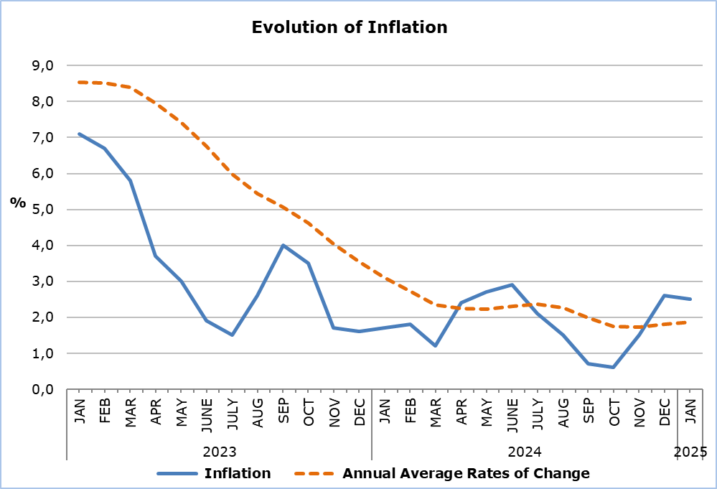

The largest change in economic categories compared to January 2024 and the previous month was recorded in *Agricultural Goods*, with percentages of 10,0% and -6,1%, respectively. (Table 2)

**Analysis of Percentage Changes**

Compared to January 2024, the largest changes were observed in the categories of *Food and Non-Alcoholic Beverages* (4,8%) and *Restaurants and Hotels* (4,1%). (Table 1)

In relation to December 2024, the most significant change was recorded in the category of *Clothing and Footwear* (-13,0%). (Table 1)

**Analysis of Effects in Units**

The largest positive impact on the change in the Consumer Price Index (CPI) of January 2025 compared to January 2024 was observed in the categories of *Food and Non-Alcoholic Beverages* (1,07) and *Transport* (0,56). (Table 3)

The largest negative impact on the change in the CPI of January 2025 compared to January 2024 was recorded in the category of *Clothing and Footwear* (-0,18). (Table 3)

The most significant impact on the change in the CPI compared to the previous month was in the category of *Clothing and Footwear* (-1,00). (Table 3)

The biggest positive impact on the change in the CPI of January 2025 compared to the index of January 2024 was observed in the categories of *Catering Services* (0,48), *Fresh Vegetables* (0,36), and *Meat* (0,24), while the most significant negative impact was recorded in the category of *Clothing Items* (-0,81). (Table 4)

*Petroleum Products* had the most significant positive impact on the change in the CPI of January 2025 compared to the corresponding index of the previous month (0,15), while the most significant negative impact was recorded in the category of *Clothing Items* (-0,71). (Table 5)

|  |  |  |  |  |  |
| --- | --- | --- | --- | --- | --- |
| **Table 1** | | | | | |
| **Categories of Goods**  **and Services** | **CPI (2015=100)** | |  | **Change (%)** | |
| **December**  **2024** | **January**  **2025** |  | **Jan 25/**  **Jan 24** | **Jan 25/ Dec 24** |
| Food and Non-Alcoholic  Beverages | 125,79 | 122,73 |  | 4,81 | -2,43 |
| Alcoholic Beverages and Tobacco | 103,37 | 103,51 |  | 1,98 | 0,14 |
| Clothing and Footwear | 107,13 | 93,22 |  | -2,67 | -12,98 |
| Housing, Water, Electricity, Gas and Other Fuels | 146,40 | 145,91 |  | 1,78 | -0,33 |
| Furnishings, Household Equipment and Routine Maintenance of the House | 104,60 | 103,68 |  | -0,56 | -0,88 |
| Health | 107,03 | 107,64 |  | 1,62 | 0,57 |
| Transport | 113,85 | 114,17 |  | 3,33 | 0,28 |
| Communication | 91,53 | 91,51 |  | 0,15 | -0,02 |
| Recreation and Culture | 116,45 | 116,51 |  | 2,81 | 0,05 |
| Education | 116,18 | 116,08 |  | 3,73 | -0,09 |
| Restaurants and Hotels | 129,98 | 130,23 |  | 4,08 | 0,19 |
| Miscellaneous Goods  and Services | 111,69 | 111,69 |  | 1,82 | 0,00 |
| **General Consumer Price Index** | **118,31** | **116,73** |  | **2,48** | **-1,34** |

|  |  |  |  |
| --- | --- | --- | --- |
| **Table 2** | | | |
| **Economic Origin** | **Weights** | **Change (%)** | |
| **Jan 25/ Jan 24** | **Jan 25/ Dec 24** |
| Agricultural goods | 749 | 10,04 | -6,13 |
| Industrial goods (excl. petroleum products) | 4021 | 0,40 | -2,26 |
| Electricity | 316 | -1,21 | -2,02 |
| Petroleum products | 871 | 4,56 | 1,68 |
| Water | 72 | 0,00 | 0,00 |
| Services | 3971 | 3,04 | -0,03 |
| **General Index** | **10000** | **2,48** | **-1,34** |

|  |  |  |  |
| --- | --- | --- | --- |
| **Table 3** | | | |
| **Categories of Goods and Services** | **Weights** | **Effect (units)** | |
| **Jan 25/ Jan 24** | **Jan 25/ Dec 24** |
| Food and non-Alcoholic Beverages | 1906 | 1,07 | -0,58 |
| Alcoholic Beverages, Tobacco | 347 | 0,07 | 0,01 |
| Clothing and Footwear | 721 | -0,18 | -1,00 |
| Housing, Water, Electricity, Gas and Other Fuels | 1119 | 0,29 | -0,05 |
| Furnishings, Household Equipment and Routine Maintenance of the House | 644 | -0,04 | -0,06 |
| Health | 637 | 0,11 | 0,04 |
| Transport | 1524 | 0,56 | 0,05 |
| Communication | 439 | 0,01 | 0,00 |
| Recreation and Culture | 575 | 0,18 | 0,00 |
| Education | 392 | 0,16 | 0,00 |
| Restaurants and Hotels | 836 | 0,43 | 0,02 |
| Miscellaneous Goods and Services | 860 | 0,17 | 0,00 |
| **General Consumer Price Index** | **10000** | **2,83** | **-1,58** |
| Note: Totals are calculated on the basis of the effects of the categories with infinite decimal figures and rounded up to two decimals when published. Figures may not add to totals due to rounding error. | | | |

|  |  |
| --- | --- |
| **Table 4** | |
| **Goods/Services** | **Effect (units)** |
| **Jan 25/ Jan 24** |
| ***Positive effect*** |  |
| Catering Services | 0,48 |
| Fresh Vegetables | 0,36 |
| Meat | 0,24 |
| Services for Regular Maintenance of Dwellings | 0,16 |
| Petroleum Products | 0,15 |
| Various Other Goods and Services | 2,45 |
| ***Negative effect*** |  |
| Clothing Items | -0,81 |
| Electricity | -0,15 |
| Airfares | -0,05 |
| **TOTAL** | **2,83** |

|  |  |
| --- | --- |
| **Table 5** | |
| **Goods/Services** | **Effect (units)** |
| **Jan 25/ Dec 24** |
| ***Positive effect*** |  |
| Petroleum Products | 0,15 |
| Fresh Fruits | 0,06 |
| Catering Services | 0,03 |
| ***Negative effect*** |  |
| Clothing Items | -0,71 |
| Fresh Vegetables | -0,55 |
| Shoes | -0,29 |
| Potatoes | -0,14 |
| Various Other Goods and Services | -0,13 |
| **TOTAL** | **-1,58** |

**METHODOLOGICAL INFORMATION**

**Definitions**

The **Consumer Price Index (CPI)** is compiled to measure the changes of prices over time of consumer goods and services acquired, used or paid by households. Specifically, the national CPI of Cyprus covers the consumption expenses of specific goods and services (shopping basket of goods and services), of the resident households and of the households that intend to live in Cyprus for at least one year. CPI is the official index for the estimation of inflation.

The **Inflation** shows the change of the CPI when compared with the index of the corresponding month of the previous year.

The **Effect** represents the amount of the overall change in the General Index which is accounted for by any given category.

**Collection**

The price collection is carried out only in urban districts of Nicosia, Larnaca, Limassol and Paphos. For each city, the fluctuations in the product prices each month, are weighted according to their population. Specifically, the weights for the four districts are: Nicosia 42%, Limassol 30%, Larnaca 18% and Paphos 10%.

The prices of 805 goods and services are recorded once every month, except for some seasonal products (e.g vegetables and fruit), meat and fuels, whose prices are collected every week (every Thursday).

**Base Year**

The index reference period was 2005=100 for the period between January 2006 and December 2015. From January 2016 and onwards, the base year is 2015=100.

**Classification**

Until December 2015, COICOP 4 classification was used for the calculation and the dissemination of the CPI. From January 2016 and onwards, CYSTAT is adopting the ECOICOP classification satisfying relevant Eurostat’s Regulation. In other words, the lowest level of detail for the classification used in CPI is COICOP 5-digits.

**Products/Services and Weights**

From January 2018 and onwards, the products included in the CPI as well as their corresponding weights have been revised. The revision was based on the results of the Household Budget Survey 2015/2016.

***For more information:***

CYSTAT Portal, subtheme [Price Indices](https://www.cystat.gov.cy/en/SubthemeStatistics?s=47)

[CYSTAT-DB](https://cystatdb.cystat.gov.cy/pxweb/en/8.CYSTAT-DB/8.CYSTAT-DB__Price%20Indices__) (Online Database)

[Predefined Tables](https://www.cystat.gov.cy/en/KeyFiguresList?s=47) (Excel)

[Methodological Information](https://www.cystat.gov.cy/en/MethodologicalDetails?m=2090)

**The Predefined Tables, available in Excel format, are updated up to and including December 2021. More recent data are published only on the CYSTAT-DB Online Database.**

*Contact*

Sofronis Vikis: Tel:+35722602206, Email: [svikis@cystat.mof.gov.cy](mailto:svikis@cystat.mof.gov.cy)

Kyriakos Voutouris: Tel:+35722605132, Email: [kvoutouris@cystat.mof.gov.cy](mailto:kvoutouris@cystat.mof.gov.cy)

Filippos Kakoutsis: Tel:+35722605149, Email: [fkakoutsis@cystat.mof.gov.cy](mailto:fkakoutsis@cystat.mof.gov.cy)