5 February, 2026

PRESS RELEASE

CONSUMER PRICE INDEX (CPI): January 2026

Inflation 0,5%

Consumer Price Index in January 2026 decreased by 0,30 points, reaching 99,98 units compared to 100,28 units in December 2025. Inflation in January 2026 increased at a rate of 0,5%. (Table 1)

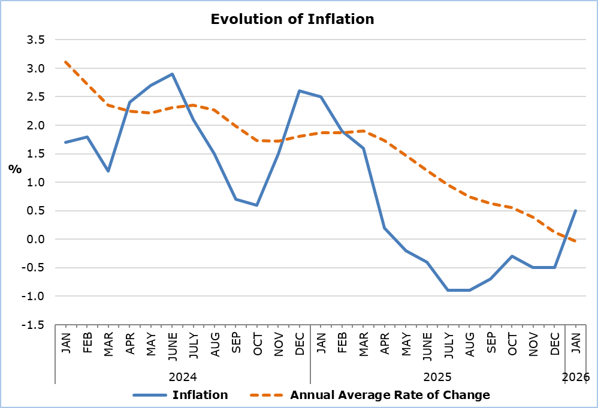

The largest positive change among the economic categories compared with January 2025 was recorded in Agricultural Products (8,2%), while the largest negative changes were observed in Electricity and Water (-6,5%) and Petroleum Products (-6,1%). Compared with December 2025, the biggest change was again in Agricultural Products (7,9%). (Table 2)

Analysis of Percentage Changes

Compared with January 2025, the largest changes were observed in the categories Clothing and Footwear (-7,0%), Restaurants and Accommodation Services (4,8%), Educational Services (3,7%), and Recreation, Sports and Culture (3,2%). (Table 1)

Compared with December 2025, the largest changes were recorded in Clothing and Footwear (-12,1%) and Food and Non-Alcoholic Beverages (3,5%). (Table 1)

Analysis of Effects in Units

The largest positive contribution to the change in the CPI in January 2026 compared with January 2025 came from the categories Food and Non-Alcoholic Beverages (0,53), Restaurants and Accommodation Services (0,52), and Recreation, Sports and Culture (0,22), while the largest negative contribution came from Clothing and Footwear (-0,44) and Transport (-0,36). (Table 3)

The categories Clothing and Footwear (-0,80) and Food and Non-Alcoholic Beverages (0,62) had the greatest impact on the change in the CPI in January 2026 compared with December 2025. (Table 3)

Catering Services (0,49) had the largest positive contribution to the change in the CPI in January 2026 compared with January 2025, while Petroleum Products (-0,45) had the largest negative contribution. (Table 4)

Fresh Vegetables (0,50) had the largest positive contribution to the change in the CPI in January 2026 compared with December 2025, while Clothing Items (-0,58) had the largest negative contribution. (Table 5)

Table 1
Categories of Goods  and Services | CPI (2015=100) |  |  | Change (%)
Categories of Goods  and Services | December 2025 | January  2026 |  | Jan 26 /  Jan 25 | Jan26 /  Dec 25
Food and Non-Alcoholic  Beverages | 99,59 | 103,11 |  | 3,01 | 3,53
Alcoholic Beverages and Tobacco | 100,56 | 100,42 |  | 0,75 | -0,14
Clothing and Footwear | 101,99 | 89,63 |  | -7,02 | -12,12
Housing, Water, Electricity, Natural Gas and Other Fuels | 99,96 | 100,66 |  | -0,65 | 0,70
Furnishings and Home Decoration, Household Equipment, and Routine Home Maintenance | 100,12 | 99,83 |  | 0,40 | -0,29
Health | 100,14 | 100,38 |  | 0,79 | 0,24
Transport | 99,04 | 97,72 |  | -2,45 | -1,33
Information and Communication | 99,27 | 97,61 |  | -1,97 | -1,67
Recreation, Sports and Culture | 101,72 | 101,43 |  | 3,17 | -0,29
Educational Services | 102,41 | 102,58 |  | 3,71 | 0,17
Restaurants and Accommodation Services | 101,66 | 101,72 |  | 4,79 | 0,06
Insurance and Financial Services | 100,02 | 100,05 |  | 0,11 | 0,02
Personal Care, Social Protection, and Miscellaneous Goods and Services | 101,21 | 100,71 |  | 1,78 | -0,50
General Consumer Price Index | 100,28 | 99,98 |  | 0,51 | -0,30

Table 2
Economic Origin | Weights | Change (%)
Economic Origin | Weights | Jan 26/ Jan 25 | Jan 26/ Dec 25
Agricultural Goods | 648 | 8,21 | 7,93
Industrial Goods  (excl. Petroleum Products) | 4111 | -1,27 | -2,02
Electricity and Water | 393 | -6,51 | 0,14
Petroleum Products | 708 | -6,07 | -1,72
Services | 4140 | 3,27 | 0,12
General Index | 10000 | 0,51 | -0,30

Table 3
Categories of Goods and Services | Weights | Effect (units)
Categories of Goods and Services | Weights | Jan 26 / Jan 25 | Jan 26/ Dec 25
Food and Non-Alcoholic  Beverages | 1762 | 0,53 | 0,62
Alcoholic Beverages and Tobacco | 528 | 0,04 | -0,01
Clothing and Footwear | 646 | -0,44 | -0,80
Housing, Water, Electricity, Natural Gas and Other Fuels | 1187 | -0,08 | 0,08
Furnishings and home decoration, Household Equipment, and Routine Home Maintenance | 619 | 0,02 | -0,02
Health | 371 | 0,03 | 0,01
Transport | 1481 | -0,36 | -0,20
Information and Communication | 415 | -0,08 | -0,07
Recreation, Sports and Culture | 694 | 0,22 | -0,02
Educational Services | 376 | 0,14 | 0,01
Restaurants and Accommodation Services | 1113 | 0,52 | 0,01
Insurance and Financial Services | 236 | 0,00 | 0,00
Personal Care, Social Protection, and miscellaneous Goods and Services | 572 | 0,10 | -0,03
General Consumer Price Index | 10000 | 0,51 | -0,30
Note: Totals are calculated on the basis of the effects of the categories with infinite decimal figures and rounded up to two decimals when published. Figures may not add to totals due to rounding error.

Table 4
Goods/Services | Effect (units)
Goods/Services | Jan 26/ Jan 25
Positive Effect
Catering Services | 0,49
Fresh Vegetables | 0,46
Home Maintenance Services | 0,14
Actual Rents for Primary Residence | 0,11
Various Other Goods and Services | 0,60
Negative Effect
Petroleum Products | -0,45
Electricity | -0,37
Clothing | -0,26
Transport | -0,21
TOTAL | 0,51

Table 5
Goods/Services | Effect (units)
Goods/Services | Jan 26/ Dec 25
Positive Effect
Fresh Vegetables | 0,50
Home Maintenance Services | 0,05
Bakery Products | 0,04
Meat | 0,03
Various Other Goods and Services | 0,01
Negative Effect
Clothing | -0,58
Footwear | -0,21
Petroleum Products | -0,14
TOTAL | -0,30

METHODOLOGICAL INFORMATION

Definitions

The Consumer Price Index (CPI) is compiled to measure the changes of prices over time of consumer goods and services acquired, used or paid by households. Specifically, the national CPI of Cyprus covers the consumption expenses of specific goods and services (shopping basket of goods and services), of the resident households and of the households that intend to live in Cyprus for at least one year. CPI is the official index for the estimation of inflation.

The Inflation shows the change of the CPI when compared with the index of the corresponding month of the previous year.

The Effect represents the amount of the overall change in the General Index which is accounted for by any given category/product/service.

Price Collection

The price collection is carried out only in urban districts of Nicosia, Larnaca, Limassol and Paphos. For each city, the fluctuations in the product and services prices for each month, are weighted according to their population. Specifically, the weights for the four districts are: Nicosia 40%, Limassol 30%, Larnaca 18% and Paphos 12%.

The prices of 850 goods and services, which are included in the CPI, are recorded once every month, except for some seasonal products (e.g., vegetables and fruit), meat and fuels, for which prices are collected every week (every Thursday).

Base Year

From January 2026 onwards, the base year is 2025=100.The index reference period was 2015=100 for the period between January 2016 and December 2025.

Classification

Until December 2025, ECOICOP classification was used for the calculation and the dissemination of the CPI. From January 2026 onwards, CYSTAT adopts the ECOICOP ver.2 classification. The lowest level of detail for the classification used in CPI is COICOP 5-digits level of analysis.

Products/Services and Weights

From January 2026 onwards, the products included in the CPI as well as their corresponding weights have been revised. The revision was based on the results of the Household Budget Survey 2023.

For more information:
CYSTAT Portal, subtheme Price Indices
CYSTAT-DB (Online Database)
Methodological Information
CPI Revision January 2026

Contact
Sofronis Vikis: Tel: +35722602206, Email: svikis@cystat.mof.gov.cy
Kyriakos Voutouris: Tel: +35722605132, Email: kvoutouris@cystat.mof.gov.cy
Filippos Kakoutsis: Tel: +35722605149, Email: fkakoutsis@cystat.mof.gov.cy

