7 August, 2025

**PRESS RELEASE**

CONSUMER PRICE INDEX (CPI): **July 2025**

**Inflation -0,9%**

The Consumer Price Index (CPI) in July 2025 decreased by 0,63 points, reaching 116,65 units compared to 117,28 units in June 2025. Inflation in July 2025 decreased at a rate of 0,9%. (Table 1)

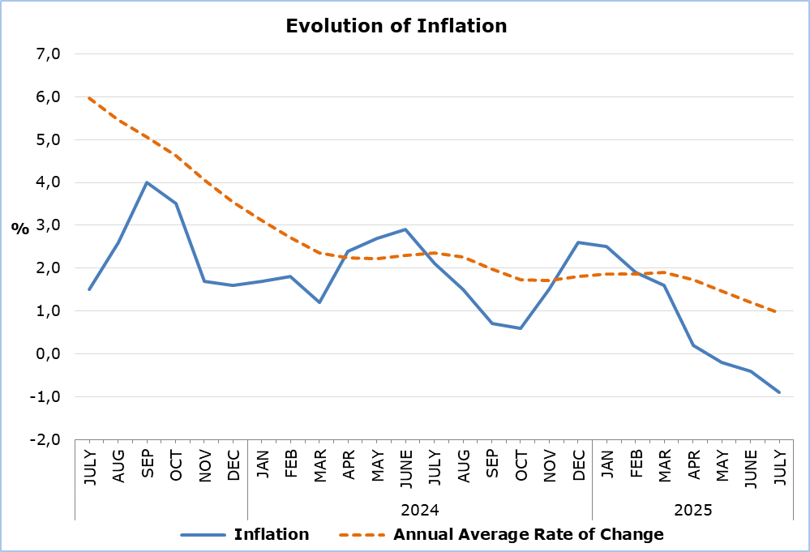

The largest positive change among the economic categories compared with July 2024 was recorded in *Services* (3,7%), while the largest negative changes were observed in *Electricity* (-12,2%) and *Petroleum Products* (-8,1%). In comparison with June 2025, the largest change was recorded in *Industrial Goods (excl. Petroleum Products)* (-2,0%). (Table 2)

**Analysis of Percentage Changes**

Compared to July 2024, the largest changes were recorded in the categories *Clothing and Footwear* (-7,3%), *Restaurants and Hotels* (5,0%), and *Recreation and Culture* (4,1%). (Table 1)

Compared to June 2025, the most significant changes were observed in the categories *Clothing and Footwear* (-12,4%) and *Transport* (2,1%). (Table 1)

For the period January – July 2025, in comparison with the corresponding period of the previous year, the largest changes were noted in the categories *Clothing and Footwear* (-5,8%), *Restaurants and Hotels* (4,8%), and *Education* (3,8%). (Table 1)

**Analysis of Effects in Units**

The largest positive impact on the change of the CPI in July 2025 compared to July 2024 was recorded in the categories *Restaurants and Hotels* (0,54) and *Recreation and Culture* (0,27), while the largest negative impact was observed in the category *Food and Non-Alcoholic Beverages* (-0,72). (Table 3)

The greatest impact on the change of the CPI in July 2025 compared to June 2025 was recorded in the category *Clothing and Footwear* (-0,92). (Table 3)

The largest positive contribution to the change of the CPI in July 2025 compared to July 2024 was made by *Catering Services* (0,57), while the largest negative contribution was made by *Petroleum Products* (-0,94). (Table 4)

*Petroleum Products (0,16)* had the largest positive impact on the change of the CPI in July 2025 compared to June 2025, while *Clothing Items* had the largest negative impact (-0,71). (Table 5)

|  |  |  |  |  |  |  |
| --- | --- | --- | --- | --- | --- | --- |
| **Table 1** | | | | | | |
| **Categories of Goods**  **and Services** | **CPI (2015=100)** | |  | **Change (%)** | | |
| **June**  **2025** | **July**  **2025** |  | **July 25/**  **July 24** | **July 25/**  **June 25** | **Jan- July 25/**  **Jan- July 24** |
| Food and Non-Alcoholic  Beverages | 121,12 | 120,67 |  | -3,02 | -0,37 | 1,38 |
| Alcoholic Beverages and Tobacco | 103,73 | 103,94 |  | 1,24 | 0,20 | 1,25 |
| Clothing and Footwear | 103,14 | 90,38 |  | -7,30 | -12,37 | -5,79 |
| Housing, Water, Electricity, Gas and Other Fuels | 142,69 | 142,27 |  | -2,66 | -0,29 | 0,11 |
| Furnishings, Household Equipment and Routine Maintenance of the House | 104,75 | 104,34 |  | -0,61 | -0,39 | -0,67 |
| Health | 107,97 | 108,13 |  | 1,68 | 0,15 | 1,70 |
| Transport | 112,83 | 115,15 |  | -3,40 | 2,06 | -1,51 |
| Communication | 92,11 | 92,12 |  | 0,52 | 0,01 | 0,14 |
| Recreation and Culture | 118,33 | 119,33 |  | 4,07 | 0,85 | 3,39 |
| Education | 116,08 | 116,30 |  | 3,92 | 0,19 | 3,75 |
| Restaurants and Hotels | 134,97 | 135,34 |  | 5,00 | 0,27 | 4,76 |
| Miscellaneous Goods  and Services | 112,64 | 112,44 |  | 0,82 | -0,18 | 1,12 |
| **General Consumer Price Index** | **117,28** | **116,65** |  | **-0,92** | **-0,54** | **0,65** |

|  |  |  |  |
| --- | --- | --- | --- |
| **Table 2** | | | |
| **Economic Origin** | **Weights** | **Change (%)** | |
| **July 25/ July 24** | **July 25/ June 25** |
| Agricultural Goods | 749 | -5,18 | -1,29 |
| Industrial Goods  (excl. Petroleum Products) | 4021 | -1,63 | -1,97 |
| Electricity | 316 | -12,17 | -1,75 |
| Petroleum Products | 871 | -8,13 | 1,87 |
| Water | 72 | 0,00 | 0,00 |
| Services | 3971 | 3,73 | 0,56 |
| **General Index** | **10000** | **-0,92** | **-0,54** |

|  |  |  |  |
| --- | --- | --- | --- |
| **Table 3** | | | |
| **Categories of Goods and Services** | **Weights** | **Effect (units)** | |
| **July 25/ July 24** | **July 25/ June 25** |
| Food and non-Alcoholic Beverages | 1906 | -0,72 | -0,09 |
| Alcoholic Beverages, Tobacco | 347 | 0,04 | 0,01 |
| Clothing and Footwear | 721 | -0,51 | -0,92 |
| Housing, Water, Electricity, Gas and Other Fuels | 1119 | -0,44 | -0,05 |
| Furnishings, Household Equipment and Routine Maintenance of the House | 644 | -0,04 | -0,03 |
| Health | 637 | 0,11 | 0,01 |
| Transport | 1524 | -0,62 | 0,35 |
| Communication | 439 | 0,02 | 0,00 |
| Recreation and Culture | 575 | 0,27 | 0,06 |
| Education | 392 | 0,17 | 0,01 |
| Restaurants and Hotels | 836 | 0,54 | 0,03 |
| Miscellaneous Goods and Services | 860 | 0,08 | -0,02 |
| **General Consumer Price Index** | **10000** | **-1,08** | **-0,63** |
| Note: Totals are calculated on the basis of the effects of the categories with infinite decimal figures and rounded up to two decimals when published. Figures may not add to totals due to rounding error. | | | |

|  |  |
| --- | --- |
| **Table 4** | |
| **Goods/Services** | **Effect (units)** |
| **July 25/ July 24** |
| ***Positive Effect*** |  |
| Catering Services | 0,57 |
| Services for the Maintenance and Repair of the Dwelling | 0,18 |
| Meat | 0,11 |
| Actual Rentals Paid by Tenants | 0,11 |
| Various Other Goods and Services | 0,56 |
| ***Negative Effect*** |  |
| Petroleum Products | -0,94 |
| Electricity | -0,70 |
| Fresh Vegetables | -0,49 |
| Clothing Items | -0,48 |
| **TOTAL** | **-1,08** |

|  |  |
| --- | --- |
| **Table 5** | |
| **Goods/Services** | **Effect (units)** |
| **July 25/ June 25** |
| ***Positive Effect*** |  |
| Petroleum Products | 0,16 |
| Airfares | 0,12 |
| Fresh Vegetables | 0,03 |
| Various Other Goods and Services | 0,17 |
| ***Negative Effect*** |  |
| Clothing Items | -0,71 |
| Footwear | -0,21 |
| Fresh Fruit | -0,11 |
| Electricity | -0,09 |
| **TOTAL** | **-0,63** |

**METHODOLOGICAL INFORMATION**

**Definitions**

The **Consumer Price Index (CPI)** is compiled to measure the changes of prices over time of consumer goods and services acquired, used or paid by households. Specifically, the national CPI of Cyprus covers the consumption expenses of specific goods and services (shopping basket of goods and services), of the resident households and of the households that intend to live in Cyprus for at least one year. CPI is the official index for the estimation of inflation.

The **Inflation** shows the change of the CPI when compared with the index of the corresponding month of the previous year.

The **Effect** represents the amount of the overall change in the General Index which is accounted for by any given category/product/service.

**Price Collection**

The price collection is carried out only in urban districts of Nicosia, Larnaca, Limassol and Paphos. For each city, the fluctuations in the product and services prices for each month, are weighted according to their population. Specifically, the weights for the four districts are: Nicosia 42%, Limassol 30%, Larnaca 18% and Paphos 10%.

The prices of 805 goods and services, which are included in the CPI, are recorded once every month, except for some seasonal products (e.g vegetables and fruit), meat and fuels, for which prices are collected every week (every Thursday).

**Base Year**

The index reference period was 2005=100 for the period between January 2006 and December 2015. From January 2016 and onwards, the base year is 2015=100.

**Classification**

Until December 2015, COICOP 4 classification up to four digits level of analysis, was used for the calculation and the dissemination of the CPI. From January 2016 and onwards, CYSTAT is adopting the ECOICOP classification satisfying relevant European Union Regulation. Consequently, the lowest level of detail for the classification used in CPI is COICOP 5-digits level of analysis.

**Products/Services and Weights**

From January 2018 and onwards, the products included in the CPI as well as their corresponding weights have been revised. The revision was based on the results of the Household Budget Survey 2015/2016.

***For more information:***

CYSTAT Portal, subtheme [Price Indices](https://www.cystat.gov.cy/en/SubthemeStatistics?s=47)

[CYSTAT-DB](https://cystatdb.cystat.gov.cy/pxweb/en/8.CYSTAT-DB/8.CYSTAT-DB__Price%20Indices__) (Online Database)

[Methodological Information](https://www.cystat.gov.cy/en/MethodologicalDetails?m=2090)

*Contact*

Sofronis Vikis: Tel: +35722602206, Email: [svikis@cystat.mof.gov.cy](mailto:svikis@cystat.mof.gov.cy)

Kyriakos Voutouris: Tel: +35722605132, Email: [kvoutouris@cystat.mof.gov.cy](mailto:kvoutouris@cystat.mof.gov.cy)

Filippos Kakoutsis: Tel: +35722605149, Email: [fkakoutsis@cystat.mof.gov.cy](mailto:fkakoutsis@cystat.mof.gov.cy)