5 June, 2025

**PRESS RELEASE**

CONSUMER PRICE INDEX (CPI): **MAY 2025**

**Inflation -0,2%**

The Consumer Price Index (CPI) in May 2025 increased by 0,26 points, reaching 117,57 units compared to 117,31 units in April 2025. Inflation in May 2025 decreased at a rate of 0,2%. (Table 1)

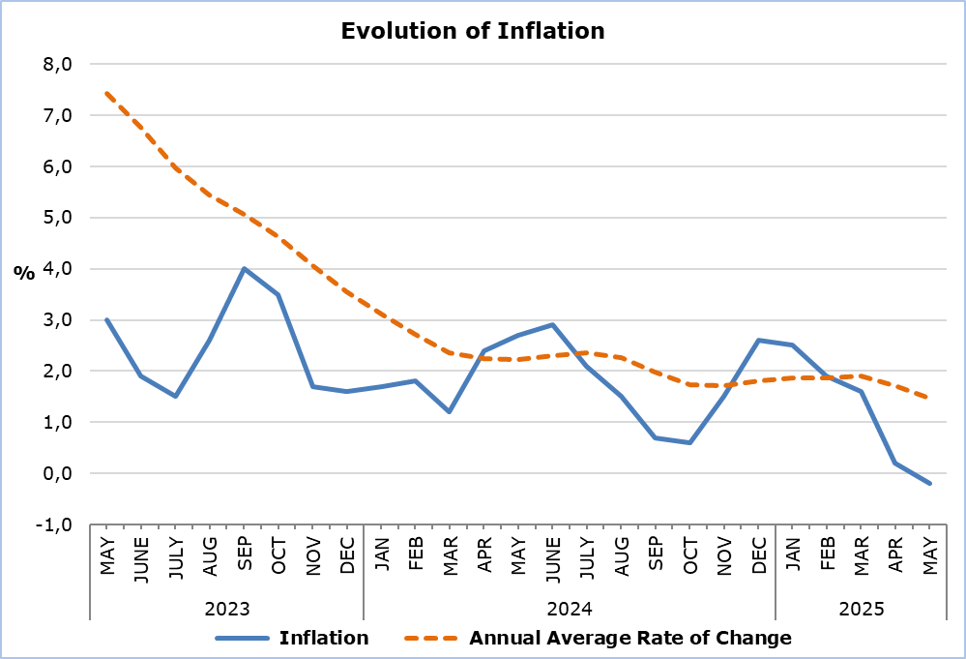

The largest positive changes among economic categories compared to May 2024 were recorded in *Agricultural Products* (4,7%) and *Services* (3,5%), while the largest negative changes were observed in *Petroleum Products* (-12,8%) and *Electricity* (-8,6%). Compared to April 2025, the largest change was recorded in *Petroleum Products* (-3,3%). (Table 2)

**Analysis of Percentage Changes**

Compared to May 2024, the largest changes were observed in the categories *Transport* (-6,6*%), Clothing and Footwear* (-5,3%), *Restaurants and Hotels* (4,9%), *Recreation and Culture* (4,0%), and *Education* (3,7%). (Table 1)

In comparison with April 2025, the largest changes were recorded in the categories *Clothing and Footwear* (2,4%) and *Transport* (-2,4%). (Table 1)

For the period January – May 2025, compared to the corresponding period of the previous year, the largest changes were noted in the categories *Clothing and Footwear* (-5,6%), *Restaurants and Hotels* (4,6%), and *Education* (3,7%). (Table 1)

**Analysis of Effects in Units**

The largest positive impact on the change of the CPI in May 2025 compared to May 2024 was recorded in the categories *Restaurants and Hotels* (0,52) and *Food and Non-Alcoholic Beverages* (0,46), while the largest negative impact was recorded in the *Transport* category (-1,21). (Table 3)

The category with the greatest impact on the CPI change in May 2025 compared to April 2025 was *Transport* (-0,41). (Table 3)

The largest positive impact on the CPI change in May 2025 compared to May 2024 was observed in *Catering Services* (0,53) and *Fresh Fruit* (0,25), while the largest negative impact was recorded in *Petroleum Products* (-1,47). (Table 4)

*Fresh Fruit* (0,22) and *Clothing Items* (0,14) had the largest positive impact on the CPI change in May 2025 compared to April 2025, while *Petroleum Products* had the largest negative impact (-0,30).

(Table 5)

|  |  |  |  |  |  |  |
| --- | --- | --- | --- | --- | --- | --- |
| **Table 1** | | | | | | |
| **Categories of Goods**  **and Services** | **CPI (2015=100)** | |  | **Change (%)** | | |
| **April**  **2025** | **May**  **2025** |  | **May 25/**  **May 24** | **May 25/**  **Apr 25** | **Jan- May 25/**  **Jan- May 24** |
| Food and Non-Alcoholic  Beverages | 122,45 | 123,97 |  | 1,98 | 1,24 | 2,74 |
| Alcoholic Beverages and Tobacco | 103,49 | 103,56 |  | 0,93 | 0,07 | 1,29 |
| Clothing and Footwear | 100,84 | 103,26 |  | -5,27 | 2,40 | -5,64 |
| Housing, Water, Electricity, Gas and Other Fuels | 142,58 | 142,91 |  | -1,53 | 0,23 | 1,14 |
| Furnishings, Household Equipment and Routine Maintenance of the House | 104,41 | 104,94 |  | -0,45 | 0,51 | -0,63 |
| Health | 107,89 | 107,97 |  | 1,62 | 0,07 | 1,71 |
| Transport | 114,72 | 112,01 |  | -6,60 | -2,36 | -0,54 |
| Communication | 91,45 | 91,36 |  | -0,23 | -0,10 | 0,01 |
| Recreation and Culture | 116,72 | 118,48 |  | 4,01 | 1,51 | 2,90 |
| Education | 116,08 | 116,08 |  | 3,73 | 0,00 | 3,73 |
| Restaurants and Hotels | 133,28 | 133,54 |  | 4,91 | 0,20 | 4,57 |
| Miscellaneous Goods  and Services | 112,25 | 112,42 |  | 0,96 | 0,15 | 1,18 |
| **General Consumer Price Index** | **117,31** | **117,57** |  | **-0,23** | **0,22** | **1,17** |

|  |  |  |  |
| --- | --- | --- | --- |
| **Table 2** | | | |
| **Economic Origin** | **Weights** | **Change (%)** | |
| **May 25/ May 24** | **May 25/ Apr 25** |
| Agricultural Goods | 749 | 4,72 | 1,78 |
| Industrial Goods  (excl. Petroleum Products) | 4021 | -0,89 | 0,72 |
| Electricity | 316 | -8,55 | 0,97 |
| Petroleum Products | 871 | -12,83 | -3,33 |
| Water | 72 | 0,00 | 0,00 |
| Services | 3971 | 3,48 | 0,13 |
| **General Index** | **10000** | **-0,23** | **0,22** |

|  |  |  |  |
| --- | --- | --- | --- |
| **Table 3** | | | |
| **Categories of Goods and Services** | **Weights** | **Effect (units)** | |
| **May 25/ May 24** | **May 25/ Apr 25** |
| Food and non-Alcoholic Beverages | 1906 | 0,46 | 0,29 |
| Alcoholic Beverages, Tobacco | 347 | 0,03 | 0,00 |
| Clothing and Footwear | 721 | -0,41 | 0,17 |
| Housing, Water, Electricity, Gas and Other Fuels | 1119 | -0,25 | 0,04 |
| Furnishings, Household Equipment and Routine Maintenance of the House | 644 | -0,03 | 0,03 |
| Health | 637 | 0,11 | 0,01 |
| Transport | 1524 | -1,21 | -0,41 |
| Communication | 439 | -0,01 | 0,00 |
| Recreation and Culture | 575 | 0,26 | 0,10 |
| Education | 392 | 0,16 | 0,00 |
| Restaurants and Hotels | 836 | 0,52 | 0,02 |
| Miscellaneous Goods and Services | 860 | 0,09 | 0,01 |
| **General Consumer Price Index** | **10000** | **-0,27** | **0,26** |
| Note: Totals are calculated on the basis of the effects of the categories with infinite decimal figures and rounded up to two decimals when published. Figures may not add to totals due to rounding error. | | | |

|  |  |
| --- | --- |
| **Table 4** | |
| **Goods/Services** | **Effect (units)** |
| **May 25/ May 24** |
| ***Positive Effect*** |  |
| Catering Services | 0,53 |
| Fresh Fruit | 0,25 |
| Meat | 0,21 |
| Rents | 0,15 |
| Various Other Goods and Services | 0,74 |
| ***Negative Effect*** |  |
| Petroleum Products | -1,47 |
| Electricity | -0,48 |
| Clothing Items | -0,28 |
| Airfares | -0,06 |
| **TOTAL** | **-0,27** |

|  |  |
| --- | --- |
| **Table 5** | |
| **Goods/Services** | **Effect (units)** |
| **May 25/ Apr 25** |
| ***Positive Effect*** |  |
| Fresh Fruit | 0,22 |
| Clothing Items | 0,14 |
| Television and Radio License Fees, Subscriptions | 0,10 |
| Electricity | 0,05 |
| Various Other Goods and Services | 0,24 |
| ***Negative Effect*** |  |
| Petroleum Products | -0,30 |
| Airfares | -0,13 |
| Potatoes | -0,06 |
| **TOTAL** | **0,26** |

**METHODOLOGICAL INFORMATION**

**Definitions**

The **Consumer Price Index (CPI)** is compiled to measure the changes of prices over time of consumer goods and services acquired, used or paid by households. Specifically, the national CPI of Cyprus covers the consumption expenses of specific goods and services (shopping basket of goods and services), of the resident households and of the households that intend to live in Cyprus for at least one year. CPI is the official index for the estimation of inflation.

The **Inflation** shows the change of the CPI when compared with the index of the corresponding month of the previous year.

The **Effect** represents the amount of the overall change in the General Index which is accounted for by any given category/product/service.

**Price Collection**

The price collection is carried out only in urban districts of Nicosia, Larnaca, Limassol and Paphos. For each city, the fluctuations in the product and services prices for each month, are weighted according to their population. Specifically, the weights for the four districts are: Nicosia 42%, Limassol 30%, Larnaca 18% and Paphos 10%.

The prices of 805 goods and services, which are included in the CPI, are recorded once every month, except for some seasonal products (e.g vegetables and fruit), meat and fuels, for which prices are collected every week (every Thursday).

**Base Year**

The index reference period was 2005=100 for the period between January 2006 and December 2015. From January 2016 and onwards, the base year is 2015=100.

**Classification**

Until December 2015, COICOP 4 classification up to four digits level of analysis, was used for the calculation and the dissemination of the CPI. From January 2016 and onwards, CYSTAT is adopting the ECOICOP classification satisfying relevant European Union Regulation. Consequently, the lowest level of detail for the classification used in CPI is COICOP 5-digits level of analysis.

**Products/Services and Weights**

From January 2018 and onwards, the products included in the CPI as well as their corresponding weights have been revised. The revision was based on the results of the Household Budget Survey 2015/2016.

***For more information:***

CYSTAT Portal, subtheme [Price Indices](https://www.cystat.gov.cy/en/SubthemeStatistics?s=47)

[CYSTAT-DB](https://cystatdb.cystat.gov.cy/pxweb/en/8.CYSTAT-DB/8.CYSTAT-DB__Price%20Indices__) (Online Database)

[Methodological Information](https://www.cystat.gov.cy/en/MethodologicalDetails?m=2090)

*Contact*

Sofronis Vikis: Tel: +35722602206, Email: [svikis@cystat.mof.gov.cy](mailto:svikis@cystat.mof.gov.cy)

Kyriakos Voutouris: Tel: +35722605132, Email: [kvoutouris@cystat.mof.gov.cy](mailto:kvoutouris@cystat.mof.gov.cy)

Filippos Kakoutsis: Tel: +35722605149, Email: [fkakoutsis@cystat.mof.gov.cy](mailto:fkakoutsis@cystat.mof.gov.cy)