5 October, 2023

**PRESS RELEASE**

CONSUMER PRICE INDEX (CPI): **SEPTEMBER 2023**

**Inflation 4,0%**

In September 2023, the Consumer Price Index increased by 1,33 units and reached 117,67 units compared to 116,34 units in August 2023. In September 2023, the inflation increased by 4,0%. (Table 1)

For the period January-September 2023, the CPI increased by 4,0% compared to the corresponding period of the previous year. (Table 1)

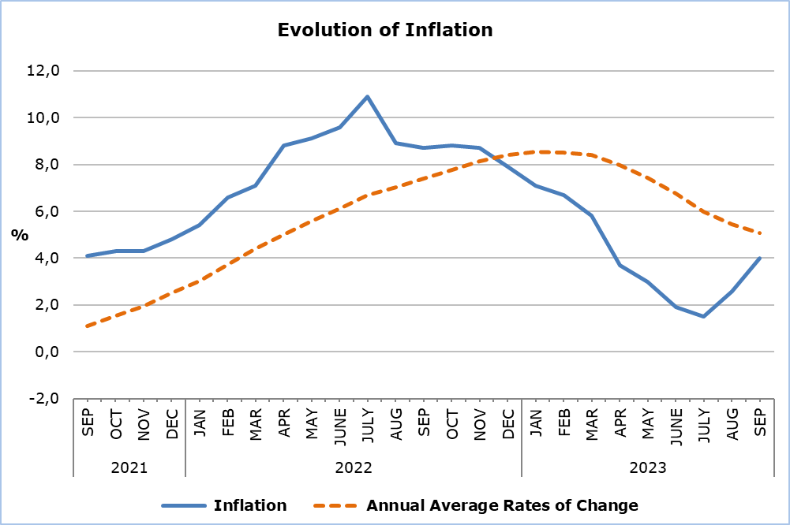

As regards the economic origin, the largest positive change when compared to the index of September 2022 was recorded in *Agricultural goods* (15,2%). In comparison to the index of the previous month, the largest change was monitored in *Petroleum products* (5,1%). (Table 2)

**Analysis of Percentage Changes**

Compared to September 2022, the largest positive change was monitored in the category *Food and Non-Alcoholic Beverages* (9,7%), whereas negative change was recorded in the category *Communication* (-0,6%). (Table 1)

In comparison to the CPI of the previous month, the largest change was noted in *Clothing and Footwear* (7,8%). (Table 1)

For the period January–September 2023, compared to the corresponding period of the previous year, the largest changes were recorded in *Food and Non-Alcoholic Beverages* (9,1%), *Restaurants and Hotels* (6,1%) and *Housing, Water, Electricity, Gas and Other Fuels* (5,8%). (Table 1)

**Analysis of Effects in Units**

Compared to the Index of September 2022, the category *Food and Non-Alcoholic Beverages* (2,08) had the largest positive effect on the change of the CPI. (Table 3)

The largest positive effect on the change of the CPI compared to the previous month was recorded in category *Clothing and Footwear* (0,54). (Table 3)

*Fresh vegetables* (0,71) had the most notable effect on the change of the CPI of September 2023 compared to September 2022. (Table 4)

Finally, *Petroleum products* (0,54) and *Clothing* (0,36) had the largest positive effect on the change of the CPI of September 2023 compared to the previous month. (Table 5)

|  |  |  |  |  |  |  |
| --- | --- | --- | --- | --- | --- | --- |
| **Table 1** | | | | | | |
| **Categories of Goods**  **and Services** | **CPI (2015=100)** | |  | **Change (%)** | | |
| **August**  **2023** | **September**  **2023** |  | **Sep 23/**  **Sep 22** | **Sep 23/ Aug 23** | **Jan- Sep 23/**  **Jan- Sep 22** |
| Food and Non-Alcoholic  Beverages | 122,43 | 123,48 |  | 9,70 | 0,86 | 9,13 |
| Alcoholic Beverages and Tobacco | 101,30 | 101,46 |  | 2,79 | 0,16 | 2,14 |
| Clothing and Footwear | 96,53 | 104,04 |  | 2,74 | 7,78 | 2,40 |
| Housing, Water, Electricity, Gas and Other Fuels | 144,34 | 146,08 |  | 0,68 | 1,21 | 5,81 |
| Furnishings, Household Equipment and Routine Maintenance of the House | 105,50 | 106,18 |  | 3,10 | 0,64 | 5,49 |
| Health | 105,31 | 105,41 |  | 1,60 | 0,09 | 1,55 |
| Transport | 121,41 | 122,53 |  | 3,39 | 0,92 | -2,02 |
| Communication | 91,15 | 91,34 |  | -0,58 | 0,21 | -1,81 |
| Recreation and Culture | 113,22 | 113,18 |  | 3,77 | -0,04 | 5,15 |
| Education | 109,30 | 111,60 |  | 2,31 | 2,10 | 1,87 |
| Restaurants and Hotels | 122,67 | 123,01 |  | 4,71 | 0,28 | 6,11 |
| Miscellaneous Goods  and Services | 108,42 | 108,92 |  | 4,13 | 0,46 | 4,28 |
| **General Consumer Price Index** | **116,34** | **117,67** |  | **4,02** | **1,14** | **3,98** |

|  |  |  |  |
| --- | --- | --- | --- |
| **Table 2** | | | |
| **Economic Origin** | **Weights** | **Change (%)** | |
| **Sep 23/ Sep 22** | **Sep 23/ Aug 23** |
| Agricultural goods | 749 | 15,16 | 1,94 |
| Industrial goods (excl. petroleum products) | 4021 | 4,48 | 1,47 |
| Electricity | 316 | -2,50 | 1,15 |
| Petroleum products | 871 | 1,37 | 5,13 |
| Water | 72 | 3,76 | 0,21 |
| Services | 3971 | 3,02 | -0,29 |
| **General Index** | **10000** | **4,02** | **1,14** |

|  |  |  |  |
| --- | --- | --- | --- |
| **Table 3** | | | |
| **Categories of Goods and Services** | **Weights** | **Effect (units)** | |
| **Sep 23/ Sep 22** | **Sep 23/ Aug 23** |
| Food and non-Alcoholic Beverages | 1906 | 2,08 | 0,20 |
| Alcoholic Beverages, Tobacco | 347 | 0,10 | 0,01 |
| Clothing and Footwear | 721 | 0,20 | 0,54 |
| Housing, Water, Electricity, Gas and Other Fuels | 1119 | 0,11 | 0,19 |
| Furnishings, Household Equipment and Routine Maintenance of the House | 644 | 0,21 | 0,04 |
| Health | 637 | 0,11 | 0,01 |
| Transport | 1524 | 0,61 | 0,17 |
| Communication | 439 | -0,02 | 0,01 |
| Recreation and Culture | 575 | 0,24 | 0,00 |
| Education | 392 | 0,10 | 0,09 |
| Restaurants and Hotels | 836 | 0,46 | 0,03 |
| Miscellaneous Goods and Services | 860 | 0,37 | 0,04 |
| **General Consumer Price Index** | **10000** | **4,55** | **1,33** |
| Note: Totals are calculated on the basis of the effects of the categories with infinite decimal figures and rounded up to two decimals when published. Figures may not add to totals due to rounding error. | | | |

|  |  |
| --- | --- |
| **Table 4** | |
| **Goods/Services** | **Effect (units)** |
| **Sep 23/ Sep 22** |
| ***Positive effect*** |  |
| Fresh vegetables | 0,71 |
| Catering services | 0,44 |
| Fresh fruit | 0,32 |
| Fresh meat | 0,24 |
| Other goods and services | 3,09 |
| ***Negative effect*** |  |
| Electricity | -0,15 |
| Potatoes | -0,10 |
| **TOTAL** | **4,55** |

|  |  |
| --- | --- |
| **Table 5** | |
| **Goods/Services** | **Effect (units)** |
| **Sep 23/ Aug 23** |
| ***Positive effect*** |  |
| Petroleum products | 0,54 |
| Clothing | 0,36 |
| Other goods and services | 0,70 |
| ***Negative effect*** |  |
| Airfares | -0,27 |
| **TOTAL** | **1,33** |

**METHODOLOGICAL NOTES**

**Definitions**

The **Consumer Price Index (CPI)** is compiled to measure the changes of prices over time of consumer goods and services acquired, used or paid by households. Specifically, the national CPI of Cyprus covers the consumption expenses of specific goods and services (shopping basket of goods and services), of the resident households and of the households that intend to live in Cyprus for at least one year. CPI is the official index for the estimation of inflation.

The **Inflation** shows the change of the CPI when compared with the index of the corresponding month of the previous year.

The **Effect** represents the amount of the overall change in the General Index which is accounted for by any given category.

**Collection**

The price collection is carried out only in urban districts of Nicosia, Larnaca, Limassol and Paphos. For each city, the fluctuations in the product prices each month, are weighted according to their population. Specifically, the weights for the four districts are: Nicosia 42%, Limassol 30%, Larnaca 18% and Paphos 10%.

The prices of 805 goods and services are recorded once every month, except for some seasonal products (e.g vegetables and fruit), meat and fuels, whose prices are collected every week (every Thursday).

**Base Year**

The index reference period was 2005=100 for the period between January 2006 and December 2015. From January 2016 and onwards, the base year is 2015=100.

**Classification**

Until January 2015, COICOP 4 classification was used for the calculation and the dissemination of the CPI. From January 2016 and onwards, CYSTAT is adopting the ECOICOP classification satisfying relevant Eurostat’s Regulation. In other words, the lowest level of detail for the classification used in CPI is COICOP 5-digits.

**Products/Services and Weights**

From January 2018 and onwards, the products included in the CPI as well as their corresponding weights have been revised. The revision was based on the results of the Household Budget Survey 2015/2016.

***For more information:***

CYSTAT Portal, subtheme [Price Indices](https://www.cystat.gov.cy/en/SubthemeStatistics?s=47)

[CYSTAT-DB](https://cystatdb.cystat.gov.cy/pxweb/en/8.CYSTAT-DB/8.CYSTAT-DB__Price%20Indices__) (Online Database)

[Predefined Tables](https://www.cystat.gov.cy/en/KeyFiguresList?s=47) (Excel)

[Methodological Information](https://www.cystat.gov.cy/en/MethodologicalDetails?m=2090)

**The Predefined Tables, available in Excel format, are updated up to and including December 2021. More recent data are published only on the CYSTAT-DB Online Database.**

*Contact*

Constandia Papageorgiou: Tel: +35722602116, Email: [cpapageorgiou@cystat.mof.gov.cy](mailto:cpapageorgiou@cystat.mof.gov.cy)