3 October, 2024

**PRESS RELEASE**

CONSUMER PRICE INDEX (CPI): **SEPTEMBER 2024**

**Inflation 0,7%**

In September 2024, the Consumer Price Index increased by 0,38 units and reached 118,48 units compared to 118,10 units in August 2024. In September 2024, the inflation increased by 0,7%. (Table 1)

For the period January-September 2024, the CPI increased by 1,9% compared to the corresponding period of the previous year. (Table 1)

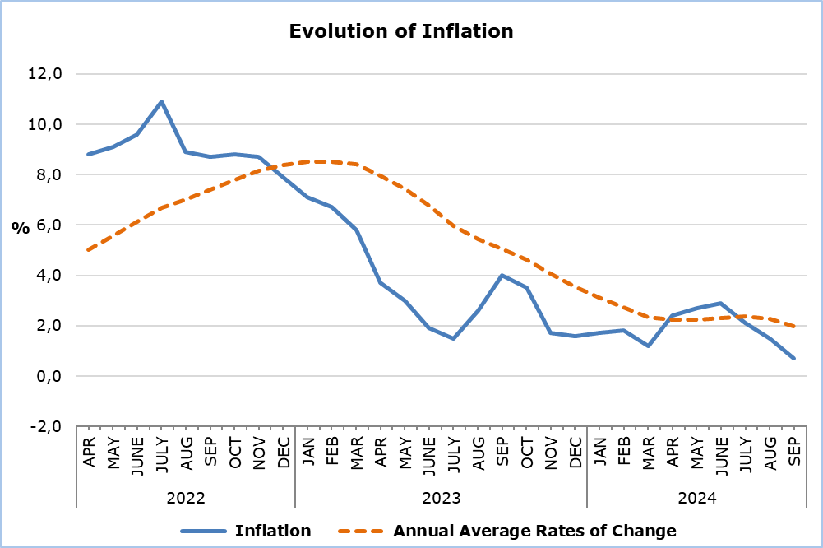

The largest change in economic categories compared to both September 2023 and the previous month was recorded in *Petroleum Products*, with percentages of -11,40% and -4,78%, respectively. (Table 2)

**Analysis of Percentage Changes**

Compared to September 2023, the largest changes were observed in the categories of *Restaurants and Hotels* (5,6%) and *Transportation* (-6,3%). (Table 1)

In relation to August 2024, the largest changes were noted in the categories of *Clothing and Footwear* (5,3%), *Transportation* (-3,4%), and *Education* (2,7%). (Table 1)

For the period January - September 2024, compared to the same period last year, the largest changes were observed in the categories of *Restaurants and Hotels* (5,7%) and *Other Goods and Services* (3,2%). (Table 1)

**Analysis of Effects in Units**

The largest positive impact on the change in the CPI for September 2024 compared to September 2023 came from the categories of *Food and Non-Alcoholic Beverages* (0,90) and *Restaurants and Hotels* (0,57). (Table 3)

The largest negative impact on the change in the CPI for September 2024 compared to September 2023 was from the category of *Transportation* (-1,18). (Table 3)

The greatest impact on the change in the CPI compared to the previous month came from the category of *Transportation* (-0,61). (Table 3)

The largest positive contribution to the change in the CPI of September 2024 compared to the index of September 2023 came from the categories of *Miscellaneous Other Goods and Services* (0,93), *Catering Services* (0,56) and *Fresh Vegetables* (0,36). (Table 4)

*Miscellaneous Other Goods and Services* (0,71) had the largest positive impact on the change in the CPI for September 2024 compared to the corresponding index of the previous month, while the largest negative impact was from the category of *Petroleum Products* (-0,51). (Table 5)

|  |  |  |  |  |  |  |
| --- | --- | --- | --- | --- | --- | --- |
| **Table 1** | | | | | | |
| **Categories of Goods**  **and Services** | **CPI (2015=100)** | |  | **Change (%)** | | |
| **August**  **2024** | **September**  **2024** |  | **Sep 24/**  **Sep 23** | **Sep 24/ Aug 24** | **Jan- Sep 24/**  **Jan- Sep 23** |
| Food and Non-Alcoholic  Beverages | 126,60 | 128,20 |  | 3,82 | 1,26 | 2,55 |
| Alcoholic Beverages and Tobacco | 103,60 | 104,05 |  | 2,55 | 0,43 | 2,05 |
| Clothing and Footwear | 96,85 | 102,00 |  | -1,96 | 5,32 | 0,43 |
| Housing, Water, Electricity, Gas and Other Fuels | 145,95 | 146,45 |  | 0,25 | 0,34 | 1,72 |
| Furnishings, Household Equipment and Routine Maintenance of the House | 104,61 | 105,28 |  | -0,85 | 0,64 | -0,53 |
| Health | 106,38 | 106,75 |  | 1,27 | 0,35 | 1,18 |
| Transport | 118,80 | 114,80 |  | -6,31 | -3,37 | 0,23 |
| Communication | 91,64 | 91,59 |  | 0,27 | -0,05 | 0,63 |
| Recreation and Culture | 115,38 | 115,38 |  | 1,94 | 0,00 | 1,96 |
| Education | 111,95 | 114,94 |  | 2,99 | 2,67 | 2,46 |
| Restaurants and Hotels | 129,57 | 129,84 |  | 5,55 | 0,21 | 5,70 |
| Miscellaneous Goods  and Services | 111,20 | 111,67 |  | 2,52 | 0,42 | 3,18 |
| **General Consumer Price Index** | **118,10** | **118,48** |  | **0,69** | **0,32** | **1,88** |

|  |  |  |  |
| --- | --- | --- | --- |
| **Table 2** | | | |
| **Economic Origin** | **Weights** | **Change (%)** | |
| **Sep 24/ Sep 23** | **Sep 24/ Aug 24** |
| Agricultural goods | 749 | 8,00 | 3,10 |
| Industrial goods (excl. petroleum products) | 4021 | 0,11 | 0,99 |
| Electricity | 316 | -2,82 | 0,24 |
| Petroleum products | 871 | -11,40 | -4,78 |
| Water | 72 | 0,00 | 0,00 |
| Services | 3971 | 3,21 | 0,28 |
| **General Index** | **10000** | **0,69** | **0,32** |

|  |  |  |  |
| --- | --- | --- | --- |
| **Table 3** | | | |
| **Categories of Goods and Services** | **Weights** | **Effect (units)** | |
| **Sep 24/ Sep 23** | **Sep 24/ Aug 24** |
| Food and non-Alcoholic Beverages | 1906 | 0,90 | 0,31 |
| Alcoholic Beverages, Tobacco | 347 | 0,09 | 0,02 |
| Clothing and Footwear | 721 | -0,15 | 0,37 |
| Housing, Water, Electricity, Gas and Other Fuels | 1119 | 0,04 | 0,06 |
| Furnishings, Household Equipment and Routine Maintenance of the House | 644 | -0,06 | 0,04 |
| Health | 637 | 0,09 | 0,02 |
| Transport | 1524 | -1,18 | -0,61 |
| Communication | 439 | 0,01 | 0,00 |
| Recreation and Culture | 575 | 0,13 | 0,00 |
| Education | 392 | 0,13 | 0,12 |
| Restaurants and Hotels | 836 | 0,57 | 0,02 |
| Miscellaneous Goods and Services | 860 | 0,24 | 0,04 |
| **General Consumer Price Index** | **10000** | **0,81** | **0,38** |
| Note: Totals are calculated on the basis of the effects of the categories with infinite decimal figures and rounded up to two decimals when published. Figures may not add to totals due to rounding error. | | | |

|  |  |
| --- | --- |
| **Table 4** | |
| **Goods/Services** | **Effect (units)** |
| **Sep 24/ Sep 23** |
| ***Positive effect*** |  |
| Other goods and services | 0,93 |
| Catering services | 0,56 |
| Fresh vegetables | 0,36 |
| Potatoes | 0,21 |
| Services for the maintenance and repair of the dwelling | 0,16 |
| Fresh fruit | 0,16 |
| ***Negative effect*** |  |
| Petroleum products | -1,34 |
| Electricity | -0,17 |
| Air fares | -0,06 |
| **TOTAL** | **0,81** |

|  |  |
| --- | --- |
| **Table 5** | |
| **Goods/Services** | **Effect (units)** |
| **Sep 24/ Aug 24** |
| ***Positive effect*** |  |
| Other goods and services | 0,71 |
| Clothing | 0,26 |
| Fresh vegetables | 0,12 |
| Footwear | 0,11 |
| Potatoes | 0,11 |
| ***Negative effect*** |  |
| Petroleum products | -0,51 |
| Air fares | -0,19 |
| **TOTAL** | **0,38** |

**METHODOLOGICAL INFORMATION**

**Definitions**

The **Consumer Price Index (CPI)** is compiled to measure the changes of prices over time of consumer goods and services acquired, used or paid by households. Specifically, the national CPI of Cyprus covers the consumption expenses of specific goods and services (shopping basket of goods and services), of the resident households and of the households that intend to live in Cyprus for at least one year. CPI is the official index for the estimation of inflation.

The **Inflation** shows the change of the CPI when compared with the index of the corresponding month of the previous year.

The **Effect** represents the amount of the overall change in the General Index which is accounted for by any given category.

**Collection**

The price collection is carried out only in urban districts of Nicosia, Larnaca, Limassol and Paphos. For each city, the fluctuations in the product prices each month, are weighted according to their population. Specifically, the weights for the four districts are: Nicosia 42%, Limassol 30%, Larnaca 18% and Paphos 10%.

The prices of 805 goods and services are recorded once every month, except for some seasonal products (e.g vegetables and fruit), meat and fuels, whose prices are collected every week (every Thursday).

**Base Year**

The index reference period was 2005=100 for the period between January 2006 and December 2015. From January 2016 and onwards, the base year is 2015=100.

**Classification**

Until January 2015, COICOP 4 classification was used for the calculation and the dissemination of the CPI. From January 2016 and onwards, CYSTAT is adopting the ECOICOP classification satisfying relevant Eurostat’s Regulation. In other words, the lowest level of detail for the classification used in CPI is COICOP 5-digits.

**Products/Services and Weights**

From January 2018 and onwards, the products included in the CPI as well as their corresponding weights have been revised. The revision was based on the results of the Household Budget Survey 2015/2016.

***For more information:***

CYSTAT Portal, subtheme [Price Indices](https://www.cystat.gov.cy/en/SubthemeStatistics?s=47)

[CYSTAT-DB](https://cystatdb.cystat.gov.cy/pxweb/en/8.CYSTAT-DB/8.CYSTAT-DB__Price%20Indices__) (Online Database)

[Predefined Tables](https://www.cystat.gov.cy/en/KeyFiguresList?s=47) (Excel)

[Methodological Information](https://www.cystat.gov.cy/en/MethodologicalDetails?m=2090)

**The Predefined Tables, available in Excel format, are updated up to and including December 2021. More recent data are published only on the CYSTAT-DB Online Database.**

*Contact*

Sofronis Vikis: Tel:+35722602206, Email: [svikis@cystat.mof.gov.cy](mailto:svikis@cystat.mof.gov.cy)

Kyriakos Voutouris: Tel:+35722605132, Email: [kvoutouris@cystat.mof.gov.cy](mailto:kvoutouris@cystat.mof.gov.cy)

Filippos Kakoutsis: Tel:+35722605149, Email: [fkakoutsis@cystat.mof.gov.cy](mailto:fkakoutsis@cystat.mof.gov.cy)