8 October, 2026

PRESS RELEASE

CONSUMER PRICE INDEX (CPI): September 2026

Inflation 3,7%

The Consumer Price Index in September 2026 increased by 0,76 units or 0,74%, reaching 104,01 units compared with 103,25 in August 2026. Inflation in September 2026 stood at 3,7%. (Table 1)

For the period January – September 2026, the Consumer Price Index (CPI) recorded an increase of 2,3% compared to the corresponding period of the previous year. (Table 1)

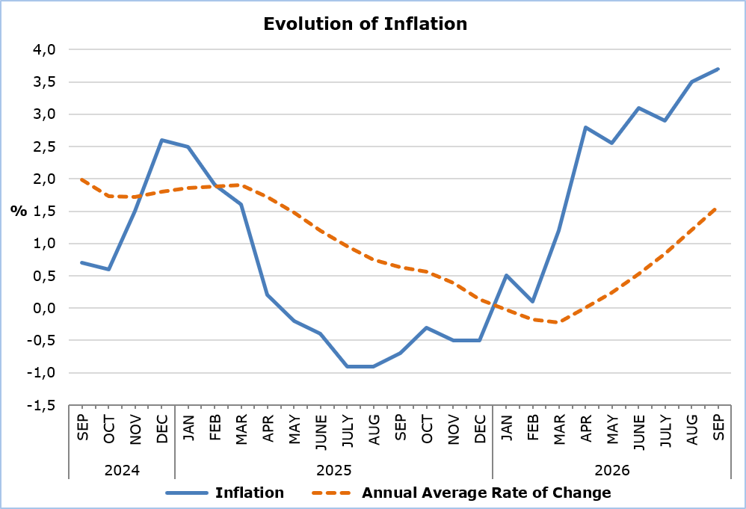

The largest increases compared with September 2025 were recorded in the economic categories Petroleum Products (25,8%) and Electricity and Water (11,2%), while a decrease was observed in Industrial Goods (-1,1%). Compared with August 2026, the largest increase was recorded in the economic category Electricity and Water (5,9%), while a decrease was observed in the economic category Services (-0,4%). (Table 2)

Analysis of Percentage Changes
Compared with September 2025, the largest changes were observed in the categories Transport (11,9%), Clothing and Footwear (-10,8%) and Housing, Water, Electricity, Natural Gas and Other Fuels (9,6%). (Table 1)

In relation to August 2026, the largest changes were recorded in the categories Housing, Water, Electricity, Natural Gas and Other Fuels (3,0%), Educational Services (1,8%), Food and Non-Alcoholic Beverages (1,3%) and Transport (-0,8%). (Table 1)

Analysis of Effects in Units
The largest positive contributions to the change in the CPI of September 2026 compared with September 2025 were recorded in the categories Restaurants and Accommodation Services (3,23), Recreation, Sports and Culture (2,83) and Alcoholic Beverages and Tobacco (1,86), while the largest negative contributions were observed in the categories Health (-2,62), Information and Communication (-1,58) and Clothing and Footwear (-1,41).
(Table 3)

The largest positive contributions to the change in the CPI in September 2026 compared with August 2026 were recorded in the categories Housing, Water, Electricity, Natural Gas and Other Fuels (0,38) and Food and Non-Alcoholic Beverages (0,23), while the largest negative contribution was recorded in the category Transport (-0,14). (Table 3)

The largest positive contribution to the change in the CPI of September 2026 compared with September 2025 was attributed to Recreation Services (2,97), while the largest negative contribution was attributed to Mobile Communication Services (-1,53). (Table 4)

Fuels and Lubricants (0,34) had the largest positive contribution to the change in the CPI of September 2026 compared with August 2026, while Passenger Transport by Air (-0,48) had the largest negative contribution. (Table 5)

Table 1
Categories of Goods  and Services | CPI (2025=100) |  |  | Change (%)
Categories of Goods  and Services | August  2026 | September  2026 |  | Sep 26 /  Sep 25 | Sep 26 /  Aug 26 | Jan - Sep 26 / Jan - Sep 25
Food and Non-Alcoholic  Beverages | 104,00 | 105,30 |  | 3,56 | 1,25 | 4,05
Alcoholic Beverages and Tobacco | 100,90 | 101,11 |  | 0,82 | 0,21 | 0,91
Clothing and Footwear | 86,63 | 87,30 |  | -10,75 | 0,77 | -7,08
Housing, Water, Electricity, Natural Gas and Other Fuels | 105,76 | 108,92 |  | 9,63 | 2,99 | 3,53
Furnishings and Home Decoration, Household Equipment, and Routine Home Maintenance | 99,01 | 99,31 |  | -0,48 | 0,30 | -0,42
Health | 101,14 | 101,42 |  | 1,29 | 0,28 | 0,98
Transport | 112,53 | 111,58 |  | 11,87 | -0,84 | 5,41
Information and Communication | 98,30 | 98,34 |  | -1,14 | 0,04 | -2,55
Recreation, Sports and Culture | 104,18 | 104,94 |  | 3,09 | 0,73 | 3,60
Educational Services | 102,58 | 104,42 |  | 3,11 | 1,79 | 3,60
Restaurants and Accommodation Services | 104,41 | 104,93 |  | 3,84 | 0,50 | 3,68
Insurance and Financial Services | 100,05 | 100,05 |  | 0,03 | 0,00 | 0,06
Personal Care, Social Protection, and Miscellaneous Goods and Services | 100,55 | 101,10 |  | 0,59 | 0,55 | 0,97
General Consumer Price Index | 103,25 | 104,01 |  | 3,69 | 0,74 | 2,26

Table 2
Economic Origin | Weights | Change (%)
Economic Origin | Weights | Sep 26/ Sep 25 | Sep 26/ Aug 26
Agricultural Goods | 648 | 5,28 | 3,49
Industrial Goods  (excl. Petroleum Products) | 4111 | -1,10 | 0,21
Electricity and Water | 393 | 11,19 | 5,88
Petroleum Products | 708 | 25,79 | 4,49
Services | 4140 | 3,84 | -0,42
General Index | 10000 | 3,69 | 0,74

Table 3
Categories of Goods and Services | Weights 2025 | Weights 2026 | Effect (units)
Categories of Goods and Services | Weights 2025 | Weights 2026 | Sep 26 /  Sep 25 | Sep 26 /  Aug 26
Food and Non-Alcoholic  Beverages | 1906 | 1762 | -0,83 | 0,23
Alcoholic Beverages and Tobacco | 347 | 528 | 1,86 | 0,01
Clothing and Footwear | 721 | 646 | -1,41 | 0,04
Housing, Water, Electricity, Natural Gas and Other Fuels | 1122 | 1187 | 1,78 | 0,38
Furnishings and Home Decoration, Household Equipment, and Routine Home Maintenance | 641 | 619 | -0,25 | 0,02
Health | 637 | 371 | -2,62 | 0,01
Transport | 1538 | 1481 | 1,18 | -0,14
Information and Communication | 569 | 415 | -1,58 | 0,00
Recreation, Sports and Culture | 437 | 694 | 2,83 | 0,05
Educational Services | 392 | 376 | -0,04 | 0,07
Restaurants and Accommodation Services | 836 | 1113 | 3,23 | 0,06
Insurance and Financial Services | 326 | 236 | -0,90 | 0,00
Personal Care, Social Protection, and Miscellaneous Goods and Services | 528 | 572 | 0,48 | 0,03
General Consumer Price Index | 10000 | 10000 | 3,70 | 0,76
Note: The totals are calculated based on the individual impacts using infinite-precision decimals and are published rounded to two decimal places. Any discrepancies in the totals are due to rounding effects as well as the change in the base year.

Table 4
Goods/Services | Effect (units)
Goods/Services | Sep 26 / Sep 25
Positive Effect
Recreation Services | 2,97
Catering Services (Food and Beverage Services) | 2,82
Rents | 1,56
Negative Effect
Mobile Communication Services | -1,53
Insurance | -1,13
Medicines | -0,94
Various Other Goods and Services | -0,05
TOTAL | 3,70

Table 5
Goods/Services | Effect (units)
Goods/Services | Sep 26 / Aug 26
Positive Effect
Fuels and Lubricants | 0,34
Electricity | 0,24
Vegetables | 0,23
Various Other Goods and Services | 0,46
Negative Effect
Passenger Transport by Air | -0,48
Purchase of Vehicles | -0,02
Household Appliances | -0,01
TOTAL | 0,76

METHODOLOGICAL INFORMATION

Definitions

The Consumer Price Index (CPI) is compiled to measure changes over time in the prices of consumer goods and services acquired, used or paid for by households. Specifically, the national CPI of Cyprus covers the consumption expenditure of specific goods and services (shopping basket of goods and services), of resident households and of households that intend to live in Cyprus for at least one year. The CPI is the official index for measuring inflation.

The Inflation shows the change in the CPI when compared with the index of the corresponding month of the previous year.

The Effect represents the amount of the overall change in the General Consumer Price Index which is accounted for by any given category/product/service.

Price Collection

The price collection is carried out only in the urban districts of Nicosia, Larnaca, Limassol and Paphos. For each city, the monthly price fluctuations for product and services are weighted according to the population. Specifically, the weights for the four districts are: Nicosia 40%, Limassol 30%, Larnaca 18% and Paphos 12%.

The prices of 850 goods and services, which are included in the CPI, are recorded once every month, except for some seasonal products (e.g., vegetables and fruit), meat and fuels, for which prices are collected every week (every Thursday).

Base Year

From January 2026 onwards, the base year is 2025=100. The index reference period (base year) was 2015=100 for the period between January 2016 and December 2025.

Classification

Until December 2025, the ECOICOP classification was used for the calculation and dissemination of the CPI. From January 2026 onwards, CYSTAT adopts the ECOICOP ver.2 classification. The lowest level of detail for the classification used in the CPI is the five-digits level of analysis.

Products/Services and Weights

From January 2026 onwards, the products and services included in the CPI, as well as their corresponding weights, have been revised. The revision was based on the results of the Household Budget Survey 2023.

For more information:
CYSTAT Portal, subtheme Price Indices
CYSTAT-DB (Online Database)
Methodological Information
CPI Revision January 2026

Contact
Sofronis Vikis: Tel.: +35722602206, Email: svikis@cystat.mof.gov.cy
Kyriakos Voutouris: Tel.: +35722605132, Email: kvoutouris@cystat.mof.gov.cy
Andreas Klonaris: Tel.: +35725270626, Email: aklonaris@cystat.mof.gov.cy

