12 December, 2025

PRESS RELEASE

CYPRUS IN FIGURES 2025

CYSTAT announces the electronic publication "Cyprus in Figures, 2025".

The publication contains a collection of data on the main social and economic indicators of Cyprus for the years 2020-2024 and is available free of charge on CYSTAT’s web portal.

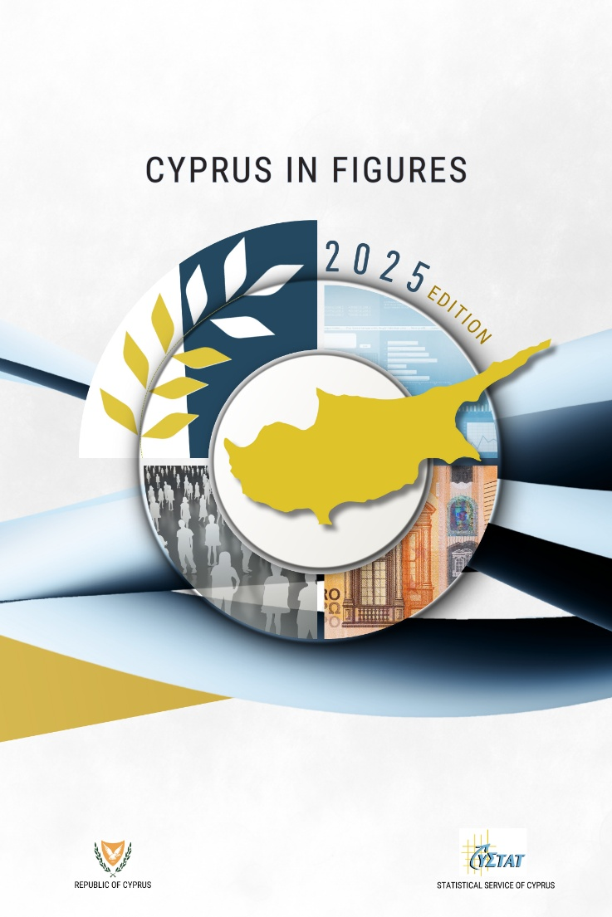

For access to the publication:
Cyprus in Figures 2025

