15 January 2025

PRESS RELEASE

DEMOGRAPHIC STATISTICS 2023

Population

The population in the Government controlled area of Cyprus is estimated at 966,4 thousand at the end of 2023, compared to 949,1 thousand at the end of 2022, recording an increase of 1,8%.

The proportion of children aged less than 15 years was estimated at 15,3% while the proportion of persons aged 65 and over increased to 17,7% in 2023, compared to 22,3% and 11,3% respectively in 2000. There was therefore a gradual increase in the proportion of old-aged persons and a decrease in the proportion of children, demonstrating the ageing process of the population.

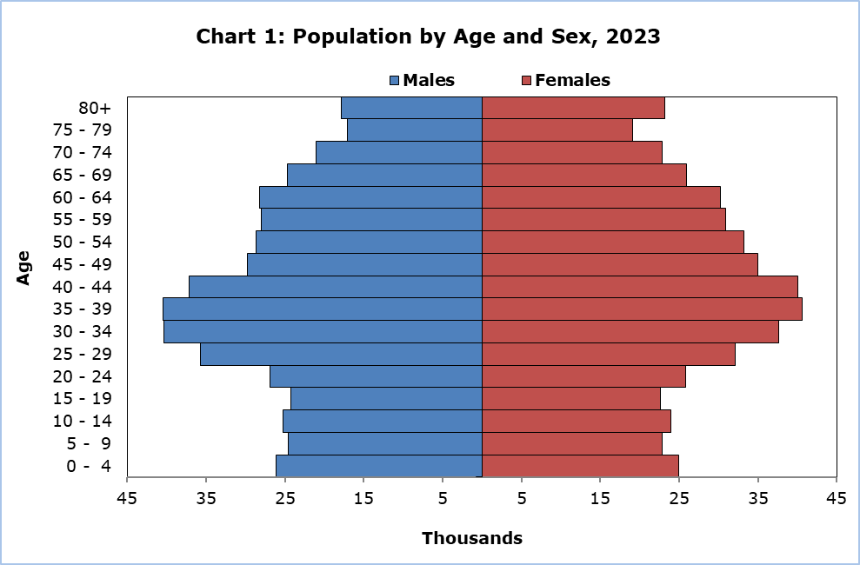

Fertility

In 2023, the number of births in the Government controlled area increased to 10.241 from 10.187 the year before, giving a crude birth rate of 10,7 per 1.000 population. The total fertility rate for 2023 was estimated at 1,4, remaining at the same level as in the previous year. The total fertility rate decreased gradually during the past years, from its local peak of 2,5 in 1982. Since 1995, the total fertility rate remains below the replacement level of 2,1.

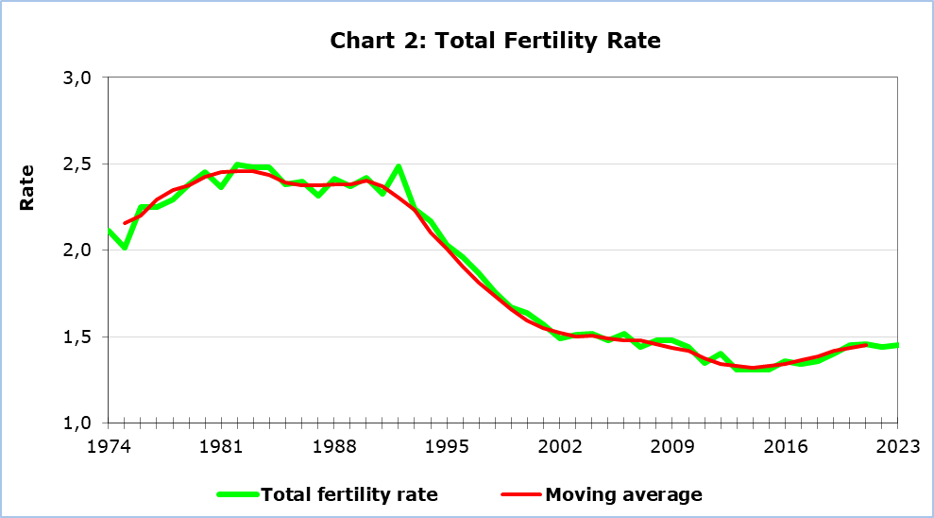

The mean age of women at the birth of their first child was 30,0 years while the mean age at birth irrespective of the order of child was 31,5 years in 2023.

Mortality

The number of deaths in the Government controlled area reached 6.742 in 2023, compared to 7.307 in 2022. The crude death rate for 2023 decreased to 7,0 deaths per 1.000 population, from 7,8 in 2022.

Life expectancy at birth was estimated at 81,0 years for males and 85,0 years for females in 2023, compared to 80,2 years for males and 83,9 for females in 2022.

Infant mortality has increased to 4,5 infant deaths per 1.000 live births in 2023, compared to 3,3 in 2022.

Migration

Net migration in Cyprus has been positive from 1983 to 2011. For the period 2012-2015, net migration has been negative. As of 2016, net migration became positive again. In 2023, it was estimated at 13.782.

Long-term immigrants (Cypriots and foreigners arriving for settlement or for temporary employment for 1 year or more) were 40.761 in 2023, compared to 37.558 in 2022.

The number of emigrants (Cypriots and foreigners who had resided in Cyprus for at least one year) was estimated at 26.979 in 2023 compared to 21.118 in 2022.

Marriages and Divorces

The total number of marriages in 2023 decreased to 11.766 from 13.350 the year before. Ecclesiastical marriages presented a minor decrease, from 4.486 in 2022 to 4.355 in 2023. Civil marriages also decreased from 8.864 in 2022 to 7.411 in 2023. As in the past few years, a large number of foreigners who married in Cyprus by civil marriage were not residing in Cyprus. Out of 7.411 civil marriages celebrated in 2023, only 2.076 were civil marriages of residents of Cyprus. Thus, the total number of marriages of residents totaled 6.431.

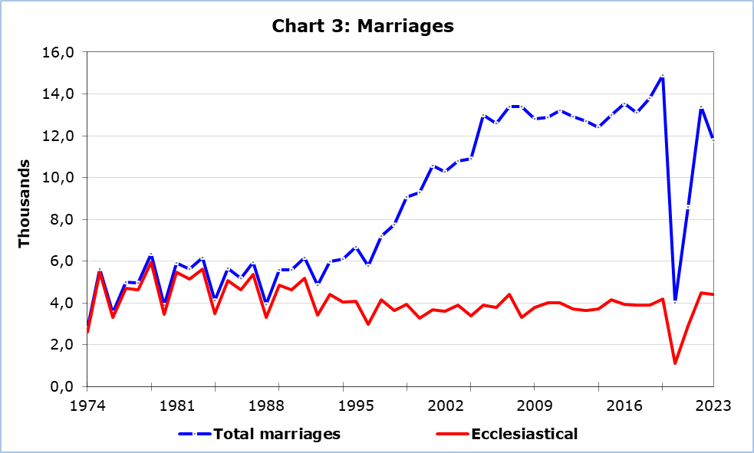

The total number of divorces in 2023 increased to 2.134, from 1.503 in 2022. The crude divorce rate was calculated at 2,23 per 1.000 population in 2023, as compared to 1,60 in 2022. The total divorce rate, which shows the proportion of marriages that are expected to end up in divorce, rose to 347,8 per 1.000 marriages in 2023, from 41,6 per 1.000 marriages in 1980.

METHODOLOGICAL INFORMATION

Demographic statistics from the year 2012 onwards have been revised based on the final results of the Census of Population and Housing 2021.

Definitions

Crude birth, death and divorce rates – Are respectively the numbers of births, deaths and divorces per 1.000 population.

Total fertility rate – The number of children a woman would have if she experienced the age specific fertility rates of a given year and she lived until the end of her reproductive life, i.e. until her 50th birthday.

Age specific fertility rate – The number of births occurring to women of a given age-group during a year divided by the total number of women in that age-group.

Life expectancy at birth – Indicates the number of years a newborn baby is expected to live if mortality in the various age-groups remains at the level of the period on which the life expectancy is computed.

Infant mortality rate – The ratio of deaths of infants under one year old per 1.000 live births of the same year.

Net migration – The balance between in-migration and out-migration.

Sources of Data and Coverage

Population estimates are based on Census results updated annually to take account of the components of change, births, deaths and net migration.

Birth Statistics are based on registered events occurring during the reference year, which are registered up to May of the following year.

Death statistics are mainly based on registered events occurring during the reference year, which are registered up to May of the following year.

Marriages are compiled by the staff of the Statistical Service from the Registers at the ecclesiastical districts of Cyprus as well as the Armenian, Maronite and Catholic Churches. Data concerning civil marriages are obtained from the Ministry of Interior.

Divorces are obtained from family courts.

Migration statistics are based on the results of the Passenger Survey, as well as on administrative and other sources available to the Statistical Service.

For more information:
Statistical Service (CYSTAT) Website, subtheme Population
CYSTAT-DB (Database)
Population - Predefined Tables

The Predefined Tables in Excel format include data up to the year 2019. For the data from the year 2020 onwards, the update will be done only in the CYSTAT-DB Database.

Contact
Andri Christofi: Tel: +35722602234, Email: achristofi@cystat.mof.gov.cy

