25 June, 2026

Cyprus Wins First Place in the European Statistics Competition

Today, at the European Statistics Competition awards ceremony held in Sofia, Bulgaria, the STATRUN team from Laniteio Gymnasium of Limassol was awarded first place in the 14–16 age category. Notably, this marks the first time that a team from Cyprus has won the European Statistics Competition.

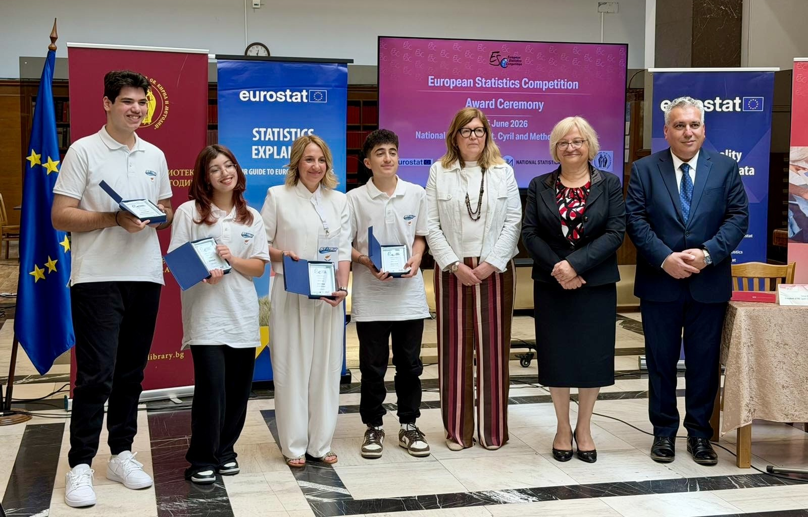
Team STATRUN from Laniteio Gymnasium of Limassol after receiving the first prize in the 14–16 age category of the European Statistics Competition 2026.

The European phase of the competition followed a highly demanding national phase with the participation of 9.096 teams comprising 28.832 students from 22 countries. The winning teams from each country (two per category) were invited to produce a two-minute video presenting a statistical “portrait” of the people of their country. Using official statistics, contestants were asked to create an engaging and accurate portrayal of their country’s population while also demonstrating how data can be used to describe national identity.

The evaluation of the 35 submissions in the 14–16 age category and the 39 submissions in the 16–18 age category was carried out in two stages. The jury, composed of experts and specialists in fields related to statistics and communication, selected the five best videos in each category, which were announced today during the awards ceremony.

The teams from Cyprus performed exceptionally well in the European phase. Of the four teams that participated, the STATRUN team won first place in the 14-16 age category, the ANOVA team won third place in the 16-18 age category and the OUTLIARS team was among the top twelve in the same category.

The Statistical Service, the Ministry of Education, Sport and Youth, the University of Cyprus and the Cyprus Statistical Society, co-organizers of the competition in Cyprus, extend their warmest congratulations to the students and tutors of the STATRUN team, who won first place, as well as the other Cypriot teams, for their outstanding work and for representing Cyprus with distinction. These achievements are an inspiration to the school community, highlighting the value of teamwork, creativity and systematic effort.

Below are the top five teams by category:

Age group 14-16

1. STATRUN (Cyprus)
2. EVJ (Slovakia)
3. DATAOUT (Romania)
4. ČOKOLINO1 (Slovenia)
5. FANTASTIK (Bulgaria)

Age group 16-18

1. STARTS (Greece)
2. OBCHODKARI (Slovakia)
3. ANOVA (Cyprus)
4. BLUESHRIMP (Italy)
5. MAT (Slovakia)

The video of the awards ceremony of the European Statistics Competition is available by following the link https://www.youtube.com/live/EdciQSYj3nI.

The videos of the top twelve teams in each category can be viewed by following the link ESC2026.

For more information:
Email: esophocleous@cystat.mof.gov.cy
Tel.: 24205831

