22 December, 2025

PRESS RELEASE

POPULATION BY INCOME CLASS

The Statistical Service announces the publication of the "Population by Income Class" (EL), which is based on the results of the Survey on Income and Living Conditions of the Households, 2024.

The publication includes economic and social characteristics concerning the population by income class (upper, middle, lower) based on their equivalent disposable income. It presents the upper and lower thresholds of each income class and their changes over time, as well as the profile of each income class in relation to their activity status, household type and age groups of the population. Additionally, the various socio-economic characteristics of the middle class, which is the largest income class, are further broken down into upper, middle, and lower middle class.

Based on the methodology recommended by the Organisation for Economic Co-operation and Development (OECD), the ‘middle income class’ is defined as the percentage of the population living in households with an income between 75% and 200% of the national median income. The population living in households where their income is above 200% of the national median income belongs to the ‘upper income class’ and the population with an income below 75% of the national median income belongs to the ‘lower income class’.

The publication is available on the portal of the Statistical Service (only in Greek language).

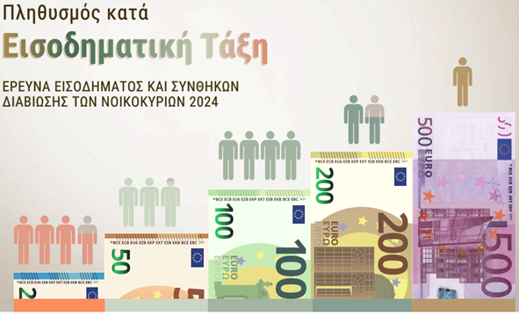

For access to the publication:
Population by Income Class

