2 October, 2023

PRESS RELEASE

EARNINGS OF EMPLOYEES: ANNUAL DATA 2022

Monthly earnings – Average €2.202, Median €1.701

The average gross monthly earnings of employees for 2022 were €2.202. In monetary terms, the average gross monthly earnings have increased by 7,1% compared to the previous year. In real terms (deflating using the Consumer Price Index) the average gross monthly earnings have decreased by 1,2%. Median gross monthly earnings of employees were €1.701.

The graph that follows shows the time series of the average and median gross monthly earnings from 2010 to 2022.

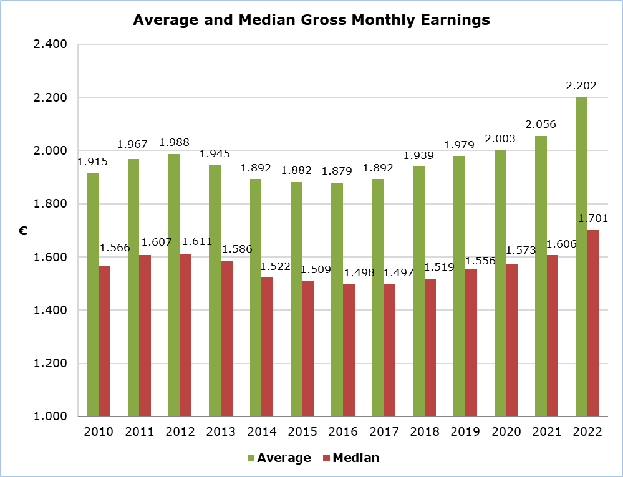

The average gross monthly earnings by branch of economic activity, as shown in the table below, range from €918 in the Agriculture, Hunting and Forestry sector to €4.011 in the Financial and Insurance Activities sector.

Table
Nace Rev.2 | Economic Activity | Average monthly earnings (€)
Α | Agriculture, Forestry and Fishing | 918
B | Mining and Quarrying | 2.957
C | Manufacturing | 1.694
D | Electricity, Gas, Steam and Air Conditioning Supply | 3.171
E | Water Supply, Sewerage, Waste Management and Remediation Activities | 1.928
F | Construction | 1.675
G | Wholesale and Retail Trade, Repair of Motor Vehicles and Motorcycles | 1.612
H | Transportation and Storage | 2.511
I | Accommodation and Food Service Activities | 1.413
J | Information and Communication | 3.406
K | Financial and Insurance Activities | 4.011
L | Real Estate Activities | 1.986
M | Professional, Scientific and Technical Activities | 2.635
N | Administrative and Support Service Activities | 1.979
O | Public Administration and Defence, Compulsory Social Security | 2.960
 | - Government | 3.067
 | - Other | 2.300
P | Education | 2.081
Q | Human Health and Social Work Activities | 1.848
R | Arts, Entertainment and Recreation | 2.041
S | Other Service Activities | 1.570
 | Total | 2.202

The graph that follows shows the percentage distribution of employees by group of monthly gross earnings and sex. The highest percentage of employees (15,4%) is observed among employees who receive between €1.000 and €1.249.

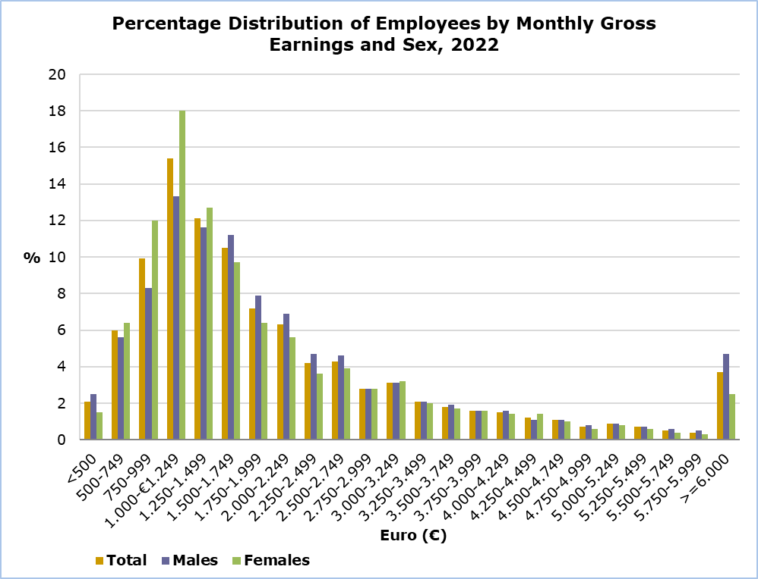
METHODOLOGICAL INFORMATION

Identity

The average monthly earnings of employees are calculated by dividing the total gross earnings before any deductions for compulsory social security contributions, by the total number of employees who received remuneration. The data source is the records of the Social Insurance Services. The results are published on an annual basis.

Data Coverage

All sectors of economic activities according to the Statistical Classification of Economic Activities in the European Community (NACE Rev.2) are covered, except Section T: Activities of households as employers and Section U: Activities of extraterritorial organisations and bodies.

All employees recorded at the Social Insurance Services’ Records are covered. Persons with remuneration indicating that no regular work has been performed during the reference period are excluded from the data (e.g. persons who received arrear payments only, persons who worked for a limited number of hours, etc.). The minimum amount of earnings acceptable in order to be included in the data is revised every year, based on the level of the minimum wage according to the Minimum Wage Order.

Definitions

The Earnings of employees include the basic salary, the cost-of-living allowance, earnings for overtime, the Holiday Fund, any other allowances received by employees during the reference period and payments in arrears. Allowances include both regular and irregular payments (13th salary, 14th salary, bonuses etc.).

For more information:

CYSTAT Portal, subtheme Labour Cost and Earnings
CYSTAT-DB (Online Database)
Methodological Information

The data included in the Predefined Tables in Excel format are available up to 2020. Data from 2021 onwards are available only on the CYSTAT-DB Online Database.

Contact
Phani Lagou: Tel: +35722602115, Email: plagou@cystat.mof.gov.cy

