6 November, 2024

**PRESS RELEASE**

###### EARNINGS OF EMPLOYEES: ANNUAL DATA 2023

**Monthly earnings – Average: €2.363, Median: €1.792**

The average gross monthly earnings of employees for 2023 were €2.363 compared to €2.202 in 2022 (Graph 1). The average gross monthly earnings have increased by 7,3% compared to the previous year. For 2022 the corresponding increase was 7,1%. Median gross monthly earnings of employees were €1.792.

**Graph 1**

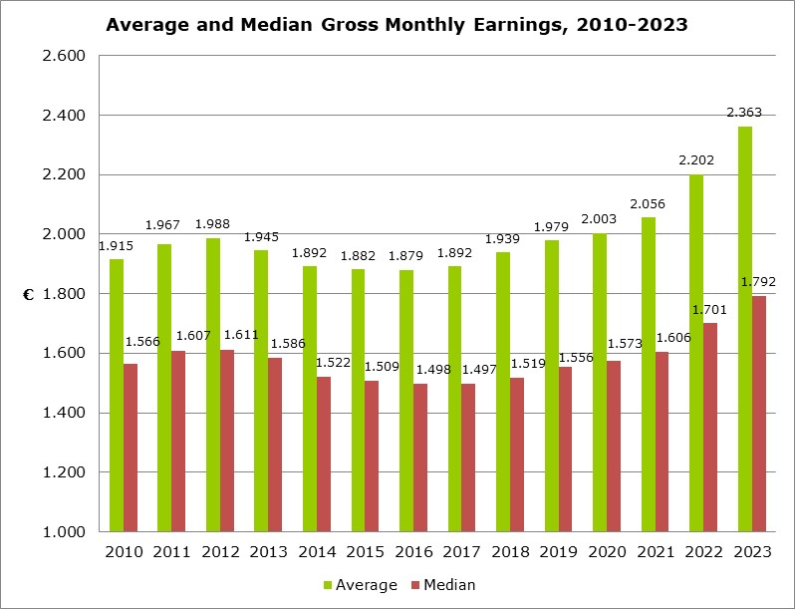

**Distribution of Employees by group of Gross Monthly Earnings and Sex**

Graph 2 shows the percentage distribution of employees by group of monthly gross earnings and sex.

The highest percentage of employees (14,9%) is observed among employees who earn between €1.000 and €1.249. The groups of employees who earn between €1.250 and €1.499 (11,7%) and those who earn between €1.500 and €1.749 (10,8%) follow.

There is a bigger concentration of women in the groups with the lower earnings compared to the distribution of men. Indicatively, nearly half of women (46,4%) earn less than €1.500, compared to 38,2% of men.

**Graph 2**

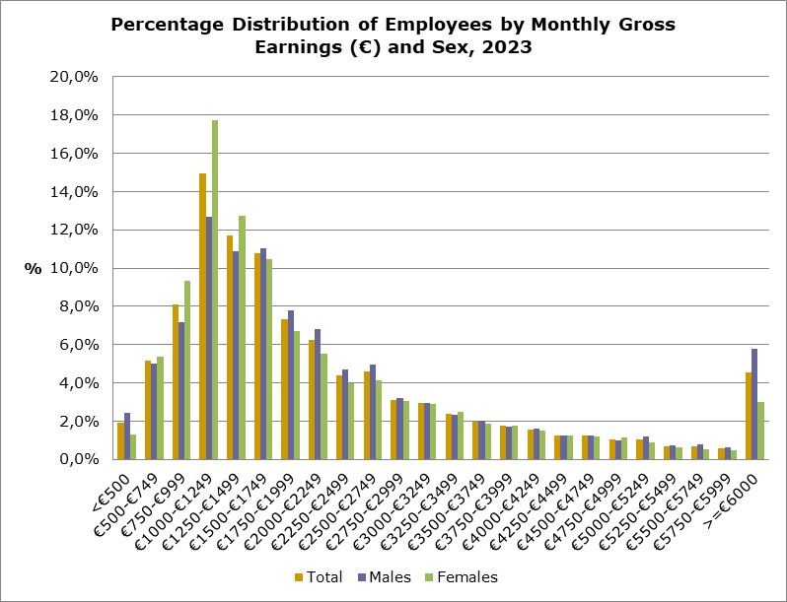

**Average Gross Monthly Earnings by branch of Economic Activity**

The average gross monthly earnings by branch of economic activity, for 2023, range from €924 in the Agriculture, Forestry and Fishing sector to €4.493 in the Financial and Insurance Activities sector.

There is an increase in all sectors of economic activity compared to the previous year, with the biggest increase observed in the Information and Communication sector (14,5%). Mining and Quarrying (12,8%), Financial and Insurance Activities (12,0%) and Administrative and Support Service Activities (10,0%) sectors follow. The smallest increase (0,7%) was observed in the Agriculture, Forestry and Fishing and Transport and Storage sectors.

|  |  |  |  |  |  |
| --- | --- | --- | --- | --- | --- |
| **Table 1** |  |  | |  | |
| **Nace Rev.2** | **Economic Activity** | **Average Monthly Earnings (€)** | | **Annual Change (%)** | |
| Α | Agriculture, Forestry and Fishing | 924 | | 0,7 | |
| B | Mining and Quarrying | 3.336 | | 12,8 | |
| C | Manufacturing | 1.777 | | 4,9 | |
| D | Electricity, Gas, Steam and Air Conditioning Supply | 3.392 | | 6,9 | |
| E | Water Supply, Sewerage, Waste Management and Remediation Activities | 2.072 | | 7,5 | |
| F | Construction | 1.752 | | 4,6 | |
| G | Wholesale and Retail Trade, Repair of Motor Vehicles and Motorcycles | 1.699 | | 5,4 | |
| H | Transportation and Storage | 2.528 | | 0,7 | |
| I | Accommodation and Food Service Activities | 1.496 | | 5,9 | |
| J | Information and Communication | 3.899 | | 14,5 | |
| K | Financial and Insurance Activities | 4.493 | | 12,0 | |
| L | Real Estate Activities | 2.042 | | 2,8 | |
| M | Professional, Scientific and Technical Activities | 2.827 | | 7,3 | |
| N | Administrative and Support Service Activities | 2.176 | | 10,0 | |
| O | Public Administration and Defence, Compulsory Social Security | 3.152 | | 6,5 | |
|  | - Government (Civil Service, Education and Security Forces) | 3.320 | | 8,3 | |
|  | - Other public bodies | 2.355 | | 2,4 | |
| P | Education | 2.191 | | 5,3 | |
| Q | Human Health and Social Work Activities | 1.976 | | 6,9 | |
| R | Arts, Entertainment and Recreation | 2.086 | | 2,2 | |
| S | Other Service Activities | 1.661 | | 5,8 | |
|  | **Total** | **2.363** | | **7,3** | |
|  | | |  | |

**Average and Median Gross Monthly Earnings by Citizenship**

The average gross monthly earnings of Cypriots for 2023 were €2.377 and of non-Cypriots €2.334 (Table 2). The annual change in average gross monthly earnings for Cypriot employees was 5,7% and for non-Cypriot employees it was 10,9%.

The median gross monthly earnings for Cypriot employees were €1.938 and for non-Cypriot employees were €1.463.

|  |  |  |  |
| --- | --- | --- | --- |
| **Table 2** |  |  |  |
| **Citizenship** | **Cypriots** | **Non-Cypriots** | **Total** |
| Average monthly earnings (€) | 2.377 | 2.334 | 2.363 |
| Annual change (%) | 5,7 | 10,9 | 7,3 |
| Median monthly earnings (€) | 1.938 | 1.463 | 1.792 |

**Distribution of Employees by Gross Monthly Earnings and Citizenship**

In graph 3, the percentage distribution of employees by group of gross monthly earnings and citizenship is given. Non-Cypriot employees gather higher percentages of employees, compared to Cypriots, in the groups with the lowest (<€1.500) and the highest (>=€6.000) earnings. This explains the difference observed between the average and median gross monthly earnings of non-Cypriots.

**Graph 3**

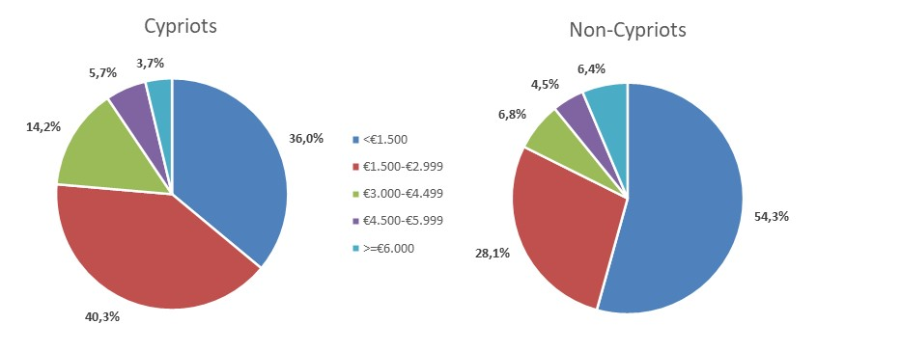

**Average gross monthly earnings by branch of Economic Activity and Citizenship**

Average gross monthly earnings by branch of economic activity are shown in table 3. The average gross monthly earnings of Cypriots by branch of economic activity for 2023 range between €1.591 in the Agriculture, Forestry and Fishing sector and €3.758 in the Financial and Insurance Activities sector. The average gross monthly earnings of non-Cypriots range between €639 in the Agriculture, Forestry and Fishing sector and €6.255 in the Financial and Insurance Activities sector.

|  |  |  |  |  |  |
| --- | --- | --- | --- | --- | --- |
| **Table 3** |  |  | |  | |
| **Nace Rev.2** | **Economic Activity** | **Average monthly earnings (€)** | | | |
| **Cypriots** | | **Non-Cypriots** | |
| Α | Agriculture, Forestry and Fishing | 1.591 | | 639 | |
| B | Mining and Quarrying | 3.019 | | 4.663 | |
| C | Manufacturing | 1.909 | | 1.526 | |
| D | Electricity, Gas, Steam and Air Conditioning Supply | 3.434 | | 2.073 | |
| E | Water Supply, Sewerage, Waste Management and Remediation Activities | 2.351 | | 1.459 | |
| F | Construction | 1.891 | | 1.532 | |
| G | Wholesale and Retail Trade, Repair of Motor Vehicles and Motorcycles | 1.741 | | 1.593 | |
| H | Transportation and Storage | 2.455 | | 2.655 | |
| I | Accommodation and Food Service Activities | 1.702 | | 1.338 | |
| J | Information and Communication | 3.011 | | 4.733 | |
| K | Financial and Insurance Activities | 3.758 | | 6.255 | |
| L | Real Estate Activities | 1.959 | | 2.210 | |
| M | Professional, Scientific and Technical Activities | 2.527 | | 3.558 | |
| N | Administrative and Support Service Activities | 2.131 | | 2.228 | |
| O | Public Administration and Defence, Compulsory Social Security | 3.143 | | 3.445 | |
|  | - Government | 3.323 | | 3.182 | |
|  | - Other | 2.244 | | 3.833 | |
| P | Education | 2.154 | | 2.363 | |
| Q | Human Health and Social Work Activities | 1.975 | | 1.978 | |
| R | Arts, Entertainment and Recreation | 1.802 | | 2.561 | |
| S | Other Service Activities | 1.740 | | 1.420 | |
|  | **Total** | **2.377** | | **2.334** | |
|  | | |  | |

**METHODOLOGICAL INFORMATION**

**Identity**

The average monthly earnings of employees are calculated by dividing the total gross earnings before any deductions for compulsory social security contributions, by the total number of employees who received remuneration. The data source is the records of the Social Insurance Services. The results are published on an annual basis.

**Data coverage**

All sectors of economic activities according to the Statistical Classification of Economic Activities in the European Community (NACE Rev.2) are covered, except Section T: Activities of households as employers and Section U: Activities of extraterritorial organisations and bodies.

All employees recorded at the Social Insurance Services’ Records are covered. Persons with remuneration indicating that no regular work has been performed during the reference period are excluded from the data (e.g. persons who received arrear payments only, persons who worked for a limited number of hours, etc.). The minimum amount of earnings acceptable in order to be included in the data is revised every year, based on the level of the minimum wage according to the Minimum Wage Order until 2022 and in accordance with the Minimum Wage Law from 2023.

**Definitions**

The **Earnings** of employees include the basic salary, the cost-of-living allowance, earnings for overtime, the Holiday Fund, any other allowances received by employees during the reference period and payments in arrears. Allowances include both regular and irregular payments (13th salary, 14th salary, bonuses etc.).

In **Citizenship,** the category 'Cypriots', includes the communities Greek Cypriots and Turkish Cypriots, as reported at the Social Insurance Services. The category 'Non-Cypriots' includes all other employees.

***For more information:***

CYSTAT Portal, subtheme [Labour Cost and Earnings](https://www.cystat.gov.cy/en/SubthemeStatistics?s=42)

[CYSTAT-DB](https://cystatdb.cystat.gov.cy/pxweb/en/8.CYSTAT-DB/8.CYSTAT-DB__Labour%20Cost%20and%20Earnings__) (Online Database)

[Methodological Information](https://www.cystat.gov.cy/en/MethodologicalDetails?m=2098)

*Contact*

Phani Lagou: Tel: +35722602115, Email: [plagou@cystat.mof.gov.cy](mailto:plagou@cystat.mof.gov.cy)