14 October, 2025

**PRESS RELEASE**

###### EARNINGS OF EMPLOYEES: 2024 (FINAL DATA)

**Monthly Earnings – Average: €2.483, Median: €1.881**

According to the estimates of the Statistical Service, the average gross monthly earnings of employees for 2024 were €2.483 compared to €2.363 in 2023 recording an increase of 5,1% compared to the previous year. For 2023 the corresponding increase was 7,3%. Median gross monthly earnings of employees were €1.881. (Figure 1)

**Distribution of Employees by Group of Gross Monthly Earnings and Sex**

Figure 2 shows the percentage distribution of employees by group of monthly gross earnings and sex.

The highest percentage of employees (14,2%) is observed among employees who earn between €1.000 and €1.249, followed by the groups of employees who earn between €1.250 and €1.499 (11,6%) and those who earn between €1.500 and €1.749 (11,2%).

**Average Gross Monthly Earnings by Branch of Economic Activity**

The average gross monthly earnings by branch of economic activity, for 2024, range from €941 in the Agriculture, Forestry and Fishing sector to €4.710 in the Financial and Insurance Activities sector.

Compared to 2023, there is a decrease of 2% in the Real Estate Activities sector and of 0,8% in the Mining and Quarrying sector. It is noted that these sectors employ a small number of workers, which results in more pronounced fluctuations. This means that small changes in the composition of the workforce or other factors can have a greater impact on the results of these sectors. In all other economic activity sectors, an increase is observed compared to the previous year, with the largest increase occurring in the Information and Communication sector (8,1%), followed by the Human Health and Social Work Activities sector (7,6%) and the Water Supply, Sewerage, Waste Management and Remediation Activities sector (6,9%).

|  |  |  |  |  |  |
| --- | --- | --- | --- | --- | --- |
| **Table 1** |  |  | |  | |
| **Nace Rev.2** | **Economic Activity** | **Average Monthly Earnings (€)** | | **Annual Change (%)** | |
| Α | Agriculture, Forestry and Fishing | 941 | | 1,8 | |
| B | Mining and Quarrying | 3.310 | | -0,8 | |
| C | Manufacturing | 1.870 | | 5,2 | |
| D | Electricity, Gas, Steam and Air Conditioning Supply | 3.544 | | 4,5 | |
| E | Water Supply, Sewerage, Waste Management and Remediation Activities | 2.215 | | 6,9 | |
| F | Construction | 1.805 | | 3,1 | |
| G | Wholesale and Retail Trade, Repair of Motor Vehicles and Motorcycles | 1.781 | | 4,8 | |
| H | Transportation and Storage | 2.658 | | 5,1 | |
| I | Accommodation and Food Service Activities | 1.583 | | 5,8 | |
| J | Information and Communication | 4.217 | | 8,1 | |
| K | Financial and Insurance Activities | 4.710 | | 4,8 | |
| L | Real Estate Activities | 2.001 | | -2,0 | |
| M | Professional, Scientific and Technical Activities | 2.913 | | 3,0 | |
| N | Administrative and Support Service Activities | 2.287 | | 5,1 | |
| O | Public Administration and Defence, Compulsory Social Security | 3.283 | | 4,1 | |
|  | - Government (Civil Service, Education and Security Forces) | 3.475 | | 4,7 | |
|  | - Other public bodies | 2.439 | | 3,6 | |
| P | Education | 2.307 | | 5,3 | |
| Q | Human Health and Social Work Activities | 2.126 | | 7,6 | |
| R | Arts, Entertainment and Recreation | 2.205 | | 5,7 | |
| S | Other Service Activities | 1.730 | | 4,2 | |
|  | **Total** | **2.483** | | **5,1** | |
|  | | |  | |

**Average and Median Gross Monthly Earnings by Citizenship**

The average gross monthly earnings of Cypriots for 2024 were €2.506 and of non-Cypriots €2.434. The annual change in average gross monthly earnings for Cypriot employees was 5,4% and for non-Cypriot employees it was 4,3%. (Table 2)

The median gross monthly earnings for Cypriot employees were €2.053 and for non-Cypriot employees were €1.544.

|  |  |  |  |
| --- | --- | --- | --- |
| **Table 2** |  |  |  |
| **Citizenship** | **Cypriots** | **Non-Cypriots** | **Total** |
| Average monthly earnings (€) | 2.506 | 2.434 | 2.483 |
| Annual change (%) | 5,4 | 4,3 | 5,1 |
| Median monthly earnings (€) | 2.053 | 1.544 | 1.881 |

**Distribution of Employees by Gross Monthly Earnings and Citizenship**

Figure 3 shows the percentage distribution of employees by group of gross monthly earnings and citizenship. Compared to Cypriot employees, non-Cypriot employees have higher percentages in both the lowest (<€1,500) and highest (≥€6,000) earnings groups.

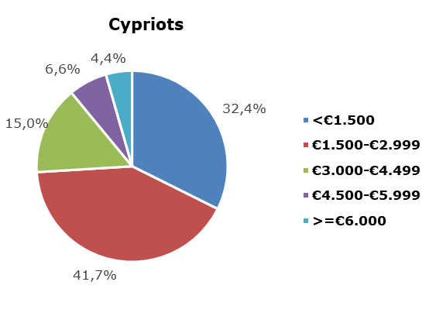

**Figure 3: Distribution of Employees by Gross Monthly Earnings**

**and Citizenship, 2024**

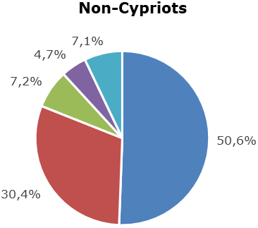

**Average gross monthly earnings by branch of Economic Activity and Citizenship**

Average gross monthly earnings by branch of economic activity are shown in table 3. The average gross monthly earnings of Cypriots by branch of economic activity for 2024 range between €1.677 in the Agriculture, Forestry and Fishing sector and €4.129 in the Financial and Insurance Activities sector. The average gross monthly earnings of non-Cypriots range between €650 in the Agriculture, Forestry and Fishing sector and €6.172 in the Financial and Insurance Activities sector.

|  |  |  |  |  |  |
| --- | --- | --- | --- | --- | --- |
| **Table 3** |  |  | |  | |
| **Nace Rev.2** | **Economic Activity** | **Average Monthly Earnings (€)** | | | |
| **Cypriots** | | **Non-Cypriots** | |
| Α | Agriculture, Forestry and Fishing | 1.677 | | 650 | |
| B | Mining and Quarrying | 3.123 | | 4.173 | |
| C | Manufacturing | 2.002 | | 1.628 | |
| D | Electricity, Gas, Steam and Air Conditioning Supply | 3.585 | | 2.259 | |
| E | Water Supply, Sewerage, Waste Management and Remediation Activities | 2.474 | | 1.572 | |
| F | Construction | 1.952 | | 1.580 | |
| G | Wholesale and Retail Trade, Repair of Motor Vehicles and Motorcycles | 1.831 | | 1.659 | |
| H | Transportation and Storage | 2.601 | | 2.767 | |
| I | Accommodation and Food Service Activities | 1.785 | | 1.434 | |
| J | Information and Communication | 3.197 | | 5.083 | |
| K | Financial and Insurance Activities | 4.129 | | 6.172 | |
| L | Real Estate Activities | 1.957 | | 2.089 | |
| M | Professional, Scientific and Technical Activities | 2.653 | | 3.521 | |
| N | Administrative and Support Service Activities | 2.274 | | 2.304 | |
| O | Public Administration and Defence, Compulsory Social Security | 3.278 | | 3.444 | |
|  | - Government | 3.480 | | 3.254 | |
|  | - Other | 2.340 | | 3.707 | |
| P | Education | 2.280 | | 2.428 | |
| Q | Human Health and Social Work Activities | 2.103 | | 2.205 | |
| R | Arts, Entertainment and Recreation | 1.891 | | 2.731 | |
| S | Other Service Activities | 1.819 | | 1.484 | |
|  | **Total** | **2.506** | | **2.434** | |
|  | | |  | |

**METHODOLOGICAL INFORMATION**

**Identity**

The average monthly earnings of employees are calculated by dividing the total gross earnings before any deductions for compulsory social security contributions, by the total number of employees who received remuneration. The data source is the records of the Social Insurance Services. The results are published on an annual basis.

**Data coverage**

All sectors of economic activities according to the Statistical Classification of Economic Activities in the European Community (NACE Rev.2) are covered, except Section T: Activities of households as employers and Section U: Activities of extraterritorial organisations and bodies.

All employees recorded at the Social Insurance Services’ Records are covered. Persons with remuneration indicating that no regular work has been performed during the reference period are excluded from the data (e.g. persons who received arrear payments only, persons who worked for a limited number of hours, etc.). The minimum amount of earnings acceptable in order to be included in the data is revised every year, based on the level of the minimum wage according to the Minimum Wage Order until 2022 and in accordance with the Minimum Wage Law from 2023.

**Definitions**

The **Earnings** of employees include the basic salary, the cost-of-living allowance, earnings for overtime, the Holiday Fund, any other allowances received by employees during the reference period and payments in arrears. Allowances include both regular and irregular payments (13th salary, 14th salary, bonuses etc.).

In **Citizenship,** the category 'Cypriots', includes the communities Greek Cypriots and Turkish Cypriots, as reported at the Social Insurance Services. The category 'Non-Cypriots' includes all other employees.

***For more information:***

CYSTAT Portal, subtheme [Labour Cost and Earnings](https://www.cystat.gov.cy/en/SubthemeStatistics?s=42)

[CYSTAT-DB](https://cystatdb23px.cystat.gov.cy/pxweb/en/8.CYSTAT-DB/8.CYSTAT-DB__Labour%20Cost%20and%20Earnings__) (Online Database)

[Methodological Information](https://www.cystat.gov.cy/en/MethodologicalDetails?m=2098)

*Contact*

Phani Lagou: Tel: +35722602115, Email: [plagou@cystat.mof.gov.cy](mailto:plagou@cystat.mof.gov.cy)