19 October, 2026

PRESS RELEASE

EARNINGS OF EMPLOYEES: 2025 (FINAL DATA)

Monthly Earnings – Median: €1.953, Average: €2.591

According to the estimates by the Statistical Service, the median gross monthly earnings of employees in 2025 were €1.953 recording an increase of 3,8% compared with €1.881 in 2024. The average gross monthly earnings of employees for 2025 were €2.591 compared to €2.483 in 2024 recording an increase of 4,3% compared to the previous year. (Figure 1)

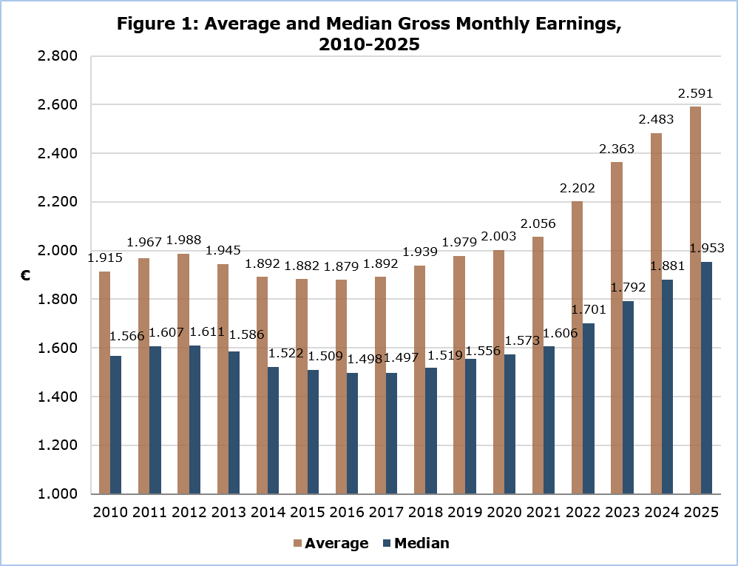

Distribution of Employees by Group of Gross Monthly Earnings and Sex

Figure 2 shows the percentage distribution of employees by group of monthly gross earnings and sex for 2025.

The largest share of employees, accounting for 13,0% of the total, earn monthly earnings between €1.000 and €1.249. They are followed by employees earning between €1.500 and €1.749 (11,4%) and between €1.250 and €1.499 (11,2%).

Comparing the distribution of employees by sex, the largest differences between males and females are observed in specific earnings groups. In particular, in the €1.000–€1.249 and €1.250–€1.499 earnings groups, the proportion of females is higher than the corresponding proportion of males by 3,3 and 3,5 percentage points, respectively. In contrast, in the highest earnings group of €6,000 and above, the proportion of males is 3,1 percentage points higher than that of females.

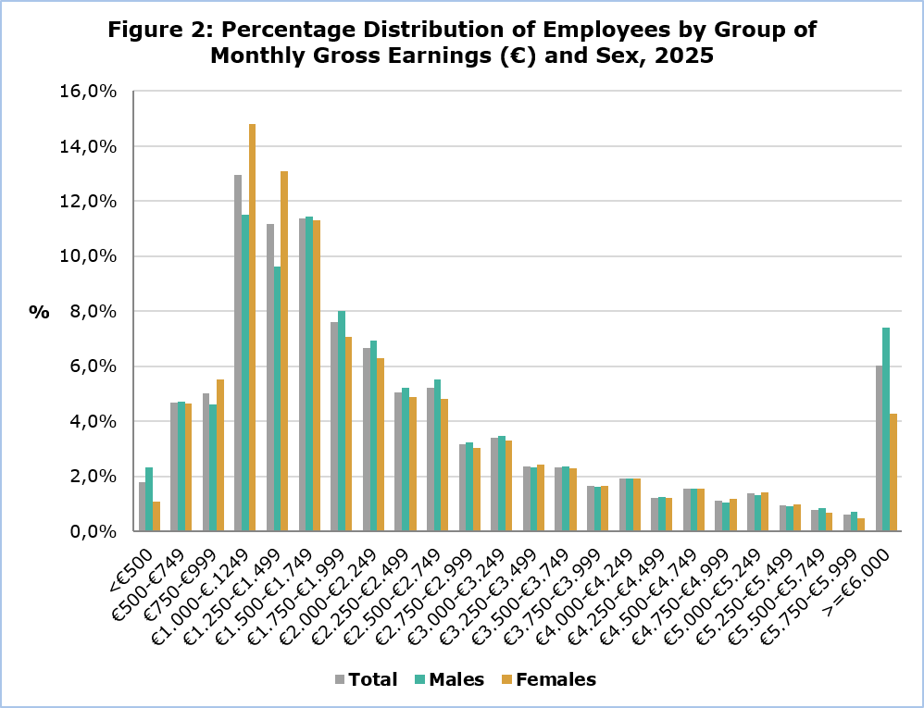

Average Gross Monthly Earnings by Section of Economic Activity

The average gross monthly earnings by section of economic activity for 2025, range from €956 in the Agriculture, Forestry and Fishing sector to €5.038 in the Financial and Insurance Activities sector.

An increase is observed in all economic activity sectors compared to the previous year, with the largest increase occurring in the Mining and Quarrying sector (10,3%), a sector employing a small number of employees, making statistical estimates more sensitive to changes in individual data. This was followed by an increase of 7,7% in Information and Communication and 7,0% in Financial and Insurance Activities.

It is noted that, in the table below, the data covering all state employees are presented as a subcategory of the sector “Public Administration and Defence, Compulsory Social Security”.

Table 1
Nace Rev.2 | Economic Activity | Average Monthly Earnings (€) |  | Annual Change (%)
Α | Agriculture, Forestry and Fishing | 956 |  | 1,5
B | Mining and Quarrying | 3.650 |  | 10,3
C | Manufacturing | 1.939 |  | 3,7
D | Electricity, Gas, Steam and Air Conditioning Supply | 3.762 |  | 6,2
E | Water Supply, Sewerage, Waste Management and Remediation Activities | 2.329 |  | 5,2
F | Construction | 1.897 |  | 5,1
G | Wholesale and Retail Trade, Repair of Motor Vehicles and Motorcycles | 1.850 |  | 3,9
H | Transportation and Storage | 2.738 |  | 3,0
I | Accommodation and Food Service Activities | 1.649 |  | 4,2
J | Information and Communication | 4.540 |  | 7,7
K | Financial and Insurance Activities | 5.038 |  | 7,0
L | Real Estate Activities | 2.037 |  | 1,8
M | Professional, Scientific and Technical Activities | 3.014 |  | 3,5
N | Administrative and Support Service Activities | 2.323 |  | 1,6
O | Public Administration and Defence, Compulsory Social Security | 3.394 |  | 3,4
 | - Civil Service, Educational Service and Security Forces | 3.623 |  | 4,3
 | - Other public bodies | 2.499 |  | 2,4
P | Education | 2.422 |  | 5,0
Q | Human Health and Social Work Activities | 2.197 |  | 3,3
R | Arts, Entertainment and Recreation | 2.296 |  | 4,1
S | Other Service Activities | 1.789 |  | 3,4
 | Total | 2.591 |  | 4,3

Average and Median Gross Monthly Earnings by Citizenship

The average gross monthly earnings of Cypriots for 2025 were €2.625 and of non-Cypriots €2.524. The annual change in average gross monthly earnings for Cypriot employees was 4,7% and for non-Cypriot employees it was 3,7%. (Table 2)

The median gross monthly earnings were €2.145 for Cypriot employees and €1.597 for non-Cypriot employees, recording an annual increase of 4,5% and 3,4%, respectively compared to 2024.

Table 2
Citizenship | Cypriots | Non-Cypriots | Total
Average monthly earnings (€) | 2.625 | 2.524 | 2.591
Annual change (%) | 4,7 | 3,7 | 4,3
Median monthly earnings (€) | 2.145 | 1.597 | 1.953
Annual change (%) | 4,5 | 3,4 | 3,8

Distribution of Employees by Group of Gross Monthly Earnings and Citizenship

Figure 3 shows the percentage distribution of employees by group of gross monthly earnings and citizenship. Compared to Cypriot employees, non-Cypriot employees have higher percentages in both the lowest (<€1.500) and highest (≥€6.000) earnings groups.

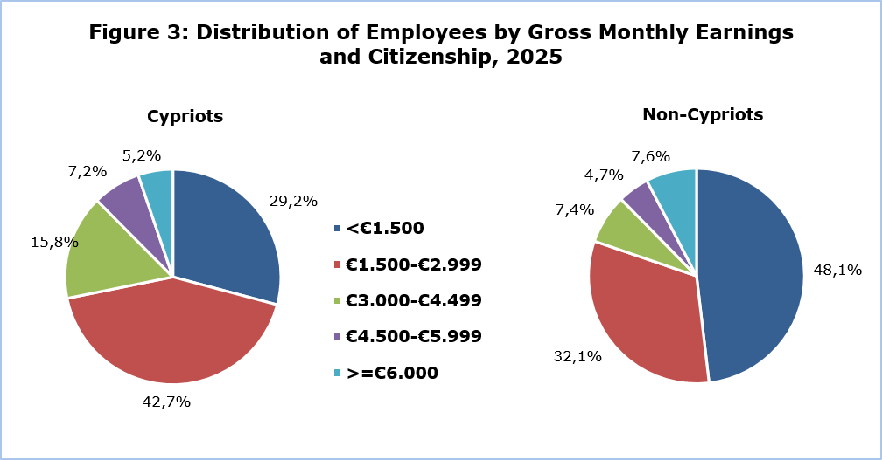

Average Gross Monthly Earnings by Section of Economic Activity and Citizenship

Average gross monthly earnings by section of economic activity and citizenship are shown in table 3.

The average gross monthly earnings of Cypriots by section of economic activity for 2025 range between €1.744 in the Agriculture, Forestry and Fishing sector and €4.383 in the Financial and Insurance Activities sector. The average gross monthly earnings of non-Cypriots range between €664 in the Agriculture, Forestry and Fishing sector and €6.649 in the Financial and Insurance Activities sector.

Table 3
Nace Rev.2 | Economic Activity | Average Gross Monthly Earnings (€)
Nace Rev.2 | Economic Activity | Cypriots |  | Non-Cypriots
Α | Agriculture, Forestry and Fishing | 1.744 |  | 664
B | Mining and Quarrying | 3.294 |  | 5.156
C | Manufacturing | 2.096 |  | 1.668
D | Electricity, Gas, Steam and Air Conditioning Supply | 3.814 |  | 2.287
E | Water Supply, Sewerage, Waste Management and Remediation Activities | 2.586 |  | 1.699
F | Construction | 2.051 |  | 1.666
G | Wholesale and Retail Trade, Repair of Motor Vehicles and Motorcycles | 1.912 |  | 1.706
H | Transportation and Storage | 2.760 |  | 2.698
I | Accommodation and Food Service Activities | 1.883 |  | 1.495
J | Information and Communication | 3.404 |  | 5.442
K | Financial and Insurance Activities | 4.383 |  | 6.649
L | Real Estate Activities | 1.960 |  | 2.184
M | Professional, Scientific and Technical Activities | 2.794 |  | 3.476
N | Administrative and Support Service Activities | 2.337 |  | 2.307
O | Public Administration and Defence, Compulsory Social Security | 3.390 |  | 3.514
 | - Civil Service, Educational Service and Security Forces | 3.630 |  | 3.346
 | - Other public bodies | 2.399 |  | 3.722
P | Education | 2.402 |  | 2.505
Q | Human Health and Social Work Activities | 2.189 |  | 2.222
R | Arts, Entertainment and Recreation | 1.927 |  | 2.938
S | Other Service Activities | 1.893 |  | 1.527
 | Total | 2.625 |  | 2.524

METHODOLOGICAL INFORMATION

Identity

The average monthly earnings of employees are calculated by dividing the total gross earnings before any deductions for compulsory social security contributions, by the total number of employees who received remuneration. The data source is the records of the Social Insurance Services. The results are published on an annual basis.

Data coverage

All sectors of economic activities according to the Statistical Classification of Economic Activities in the European Community (NACE Rev.2) are covered, except Section T: Activities of households as employers and Section U: Activities of extraterritorial organisations and bodies.

All employees in the records of the Social Insurance Services are covered. Persons with remuneration indicating that no regular work has been performed during the reference period are excluded from the data (e.g. persons who received arrear payments only, persons who worked for a limited number of hours, etc.). The minimum amount of earnings acceptable in order to be included in the data is revised every year, based on the level of the minimum wage according to the Minimum Wage Order until 2022 and in accordance with the Minimum Wage Law from 2023.

Definitions

The Earnings of employees include the basic salary, the cost-of-living allowance, earnings for overtime, the Holiday Fund, any other allowances received by employees during the reference period and payments in arrears. Allowances include both regular and irregular payments (13th salary, 14th salary, bonuses etc.).

Gross earnings refer to the total amount earned before any deductions, including income tax and deductions for compulsory schemes such as the Social Insurance Fund and the General Healthcare Scheme.

In Citizenship, the category 'Cypriots', includes the communities Greek Cypriots and Turkish Cypriots, as reported at the Social Insurance Services. The category 'Non-Cypriots' includes all other employees.

For more information:

CYSTAT Portal, subtheme Labour Cost and Earnings
CYSTAT-DB (Online Database)
Methodological Information

Contact
Phani Lagou: Tel: +35722602115, Email: plagou@cystat.mof.gov.cy

