18 December, 2025

PRESS RELEASE

STRUCTURE OF EARNINGS SURVEY 2022

According to the results of the Structure of Earnings Survey 2022, the mean hourly earnings of full-time employees reached €12,23, recording an increase of 13,4% compared to the corresponding earnings in 2018, which stood at €10,78. The respective amounts for previous years were €10,46 in 2014 and €11,32 in 2010. (Figure 1)

The mean hourly earnings of full-time male employees were €12,84, while those of female employees were €11,52, recording a gender pay gap of 10,2%. Compared to 2018, the average hourly earnings increased by 13,3% for males and 13,5% for females. The corresponding gender pay gap in 2018 was 10,4%. (Figure 2)

The median hourly earnings of full-time employees, which more accurately reflect the overall earnings distribution compared to mean earnings, were €8,98 in 2022 (€9,47 for males, €8,42 for females), recording an increase of 9,8% compared to 2018 (9,9% for males, 9,9% for females). (Figure 2)

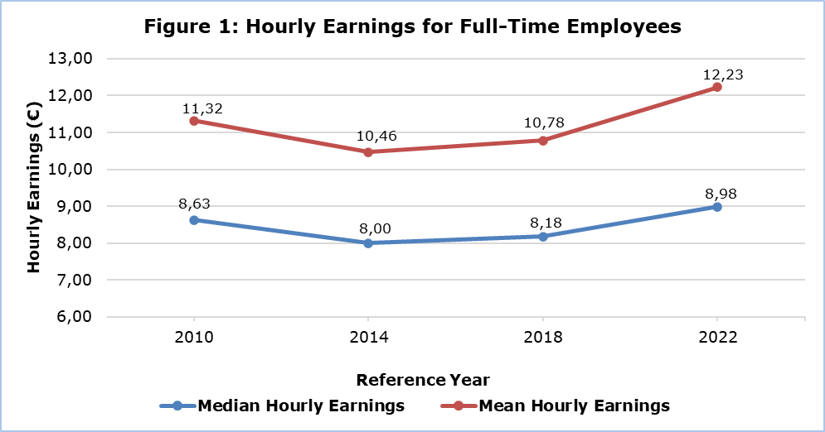

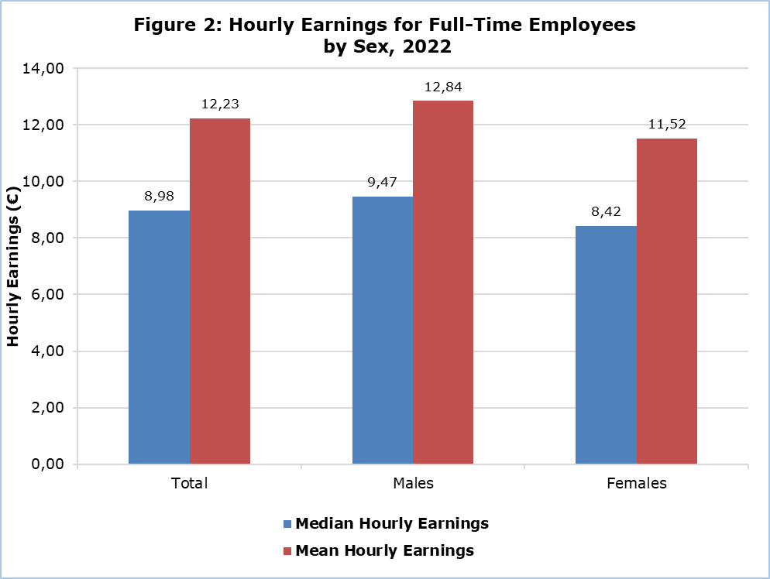

By Occupational Category (Table 1)
According to the survey data, in 2022 the occupational category with the highest total mean hourly earnings for full-time employees was “Managers” with €31,08, followed by “Professionals” with €17,71.
The corresponding median hourly earnings for these categories were €26,72 and €14,61 respectively.

The occupational categories with the lowest hourly earnings were “Elementary Occupations” with mean earnings at €7,07 and median earnings at €6,35, “Service and Sales Workers” with mean earnings at €7,71 and median earnings at €6,78, as well as “Skilled Agricultural, Forestry and Fishery Workers” (very small sample of employees in this category for the specific survey) with mean hourly earnings at €6,48 and median earnings at €7,18.

By Economic Activity (Table 2)
The economic activity sector with the highest total hourly earnings for full-time employees was “Education”, with mean earnings at €20,44 and median earnings at €20,35. This was followed by the sectors of “Information and Communication” with mean earnings at €19,26 and median earnings at €15,98 and “Financial and Insurance Activities” with mean earnings at €18,62 and median earnings at €15,74 per hour.

The lowest hourly earnings were recorded in the sector of “Accommodation and Food Service Activities”, with mean hourly earnings at €7,68 and median earnings at €6,70 per hour.

By Citizenship (Table 3)
Based on the results of the survey (median hourly earnings), 50% of full-time employees with Cypriot citizenship earned less than €9,65 per hour, employees with European Union citizenship (excluding Cyprus) earned less than €7,15, while those with non-European Union countries citizenship earned less than €7,06 per hour.

On average, employees with Cypriot citizenship earned €12,66 per hour, approximately at the same level as employees with non-European Union (EU) countries citizenship, who earned €12,61 per hour. In contrast, employees with EU citizenship earned an average of €9,80 per hour.

In the highest-paid occupational category, “Managers”, employees with non-EU countries citizenship received the highest mean hourly earnings (€40,74), followed by employees from EU countries (€34,58 per hour), while employees with Cypriot citizenship earned on average €29,19 per hour.

The figure below presents the distribution of full-time employees by hourly earnings group and citizenship. Across all categories, the largest proportion of employees appears to have earned between €5,00 and €10,00 per hour. The highest share of employees earning less than €5,00 per hour was observed among those with citizenship from non-EU countries (14,4%). The same group also recorded the highest proportion of employees with hourly earnings of €25,00 or more per hour (13,7%). (Figure 3)

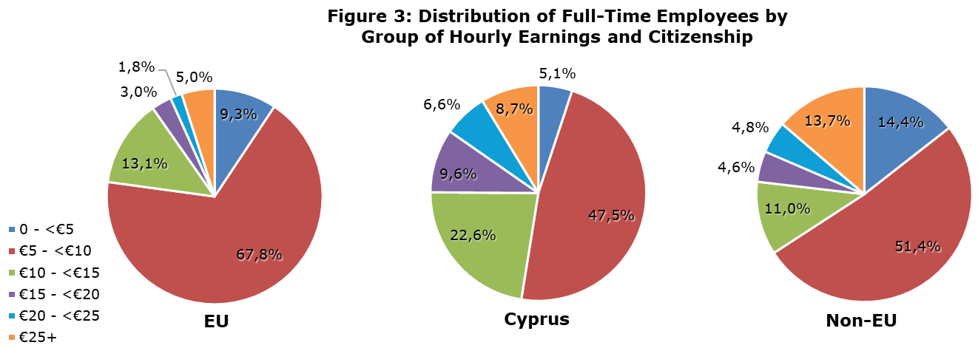

Table 1
ISCO-08 | Occupational Category | Hourly Earnings of Full-Time Employees (€)
ISCO-08 | Occupational Category | Mean |  |  | Median
ISCO-08 | Occupational Category | Total | Males | Females | Total | Males | Females
 | Total | 12,23 | 12,84 | 11,52 | 8,98 | 9,47 | 8,42
1 | Managers | 31,08 | 31,69 | 29,48 | 26,72 | 26,72 | 26,83
2 | Professionals | 17,71 | 18,53 | 17,02 | 14,61 | 15,14 | 14,37
3 | Technicians and associate professionals | 13,19 | 13,73 | 12,52 | 11,05 | 11,25 | 10,91
4 | Clerical support workers | 8,96 | 9,34 | 8,80 | 8,05 | 8,05 | 8,05
5 | Service and sales workers | 7,71 | 8,44 | 7,05 | 6,78 | 7,55 | 6,38
6 | Skilled agricultural, forestry and fishery workers | 6,48 | u | u | 7,18 | u | u
7 | Craft and related trades workers | 8,64 | 8,80 | 7,05 | 7,99 | 8,25 | 6,68
8 | Plant and machine operators and assemblers | 9,18 | 9,21 | 8,72 | 8,54 | 8,62 | 7,36
9 | Elementary occupations | 7,07 | 7,74 | 6,23 | 6,35 | 7,09 | 5,86
u: Data with low reliability - the data are not presented due to the small number of persons in the sample.
Note: For the Structure of Earnings Survey’s purposes which does not cover agricultural activities, the occupational category “Skilled agricultural, forestry and fishery workers” primarily includes gardeners.

Table 2
Nace Rev.2 | Economic Activity | Hourly Earnings of  Full-Time Employees (€)
Nace Rev.2 | Economic Activity | Mean | Median
 | Total | 12,23 | 8,98
B | Mining and Quarrying | u | u
C | Manufacturing | 9,05 | 7,89
D | Electricity, Gas, Steam and Air Conditioning Supply | 17,17 | 15,12
E | Water Supply; Sewerage, Waste Management and Remediation Activities | 9,39 | 7,08
F | Construction | 9,59 | 8,75
G | Wholesale and Retail Trade; Repair of Motor Vehicles and Motorcycles | 8,55 | 7,22
H | Transportation and Storage | 14,40 | 9,68
I | Accommodation and Food Service Activities | 7,68 | 6,70
J | Information and Communication | 19,26 | 15,98
K | Financial and Insurance Activities | 18,62 | 15,74
L | Real Estate Activities | 7,89 | 7,47
M | Professional, Scientific and Technical Activities | 13,87 | 10,34
N | Administrative and Support Service Activities | 10,43 | 7,41
O | Public Administration and Defence; Compulsory Social Security | 15,13 | 13,02
P | Education | 20,44 | 20,35
Q | Human Health and Social Work Activities | 15,00 | 11,10
R | Arts, Entertainment and Recreation | 9,30 | 7,51
S | Other Service Activities | 8,28 | 6,81
u: Data with low reliability - the data are not presented due to the small number of persons in the sample
Note: The Structure of Earnings Survey covers enterprises in all economic activities, excluding Agriculture, Fishing, Activities of Private Households and Extra-territorial Organisations.

Table 3
ISCO-08 | Occupational Category |  | Hourly Earnings of Full-Time Employees (€)
ISCO-08 |  |  | Cypriot Citizenship |  | EU Citizenship (excl. Cyprus) |  |  | Non-EU Countries Citizenship
ISCO-08 |  |  | Mean | Median |  | Mean | Median | Mean |  | Median
 | Total |  | 12,66 | 9,65 |  | 9,80 | 7,15 | 12,61 |  | 7,06
1 | Managers |  | 29,19 | 25,55 |  | 34,58 | 27,59 | 40,74 |  | 36,68
2 | Professionals |  | 17,07 | 14,37 |  | 19,49 | 13,65 | 22,59 |  | 19,87
3 | Technicians and associate professionals |  | 13,44 | 11,34 |  | 10,24 | 9,03 | 14,20 |  | 11,49
4 | Clerical support workers |  | 9,18 | 8,16 |  | 7,60 | 6,58 | 8,25 |  | 6,90
5 | Service and sales workers |  | 8,08 | 7,17 |  | 6,74 | 6,20 | 6,92 |  | 6,22
6 | Skilled agricultural, forestry and fishery workers |  | u | u |  | u | u | u |  | u
7 | Craft and related trades workers |  | 9,08 | 8,58 |  | 8,58 | 8,18 | 6,54 |  | 6,07
8 | Plant and machine operators and assemblers |  | 9,47 | 8,94 |  | 8,54 | 7,76 | 7,19 |  | 7,01
9 | Elementary occupations |  | 7,77 | 7,16 |  | 6,87 | 6,14 | 5,78 |  | 5,53
u: Data with low reliability - the data are not presented due to the small number of persons in the sample

METHODOLOGICAL INFORMATION

General Information

The Structure of Earnings Survey (SES) 2022 is part of a series of four-yearly surveys, conducted under the Council Regulation 530/1999 and the Commission Regulation 1916/2000 as amended by Commission Regulation 1738/2005 of the European Union.

The aim of this survey is to provide accurate and harmonised data between EU Member States and Candidate Countries for policy-making and research purposes. The 2022 SES gives detailed and comparable information on relationships between the level of remuneration, individual characteristics of employees (sex, age, occupation, length of service, highest educational level attained, etc.) and their employer (economic activity, size, etc.).

In Cyprus, the survey was conducted for the sixth time during 2023, with 2022 being the reference year.

Data Coverage

The SES 2022 covered enterprises in all economic activities, excluding Agriculture, Fishing, Activities of Private Households and Extra-territorial Organisations. All enterprises covered had one or more employees.

The SES collected data both for the reference month of October 2022 (monthly data) and the reference year 2022 (annual data). All data collected referred to employees who worked in the enterprise during October 2022.

The data collection was conducted by means of personal and telephone interviews at the enterprises.

Classification Systems

Statistical Codes of Economic Activities, 2008: This classification system refers to the statistical codes and the classification of economic activities in Cyprus on the basis of the “Statistical Classification of Economic Activities in the European Community (NACE Rev.2)”.

International Standard Classification of Occupations, 2008: The International Standard Classification of Occupations, 2008 (ISCO-08) was developed by the Bureau of Statistics of the International Labour Office and presents the statistical codes of the various occupations. This classification system is a tool for organising jobs into a clearly defined set of groups according to the tasks and duties undertaken in the job. ISCO-08 is intended to facilitate international communication on the subject of occupations and occupational groups.

Definitions

Mean: The mean (or average) is defined as the sum of the values of all observations in the sample divided by the number of observations.

Median: The median is the value that lies exactly in the middle, such that 50% of the ordered observations are above the median and the other 50% are below it.

Gender pay gap: It is the difference between the mean gross hourly earnings of men and women, expressed as a percentage of the mean gross hourly earnings of men.

Hourly Earnings of Employees: The gross earnings per hour, paid to the employee (full-timer or part-timer) during the reference month of October 2022. This is derived from total gross monthly earnings for the reference month divided by the total number of hours paid during the same period (normal hours and overtime).

Total Monthly Earnings of Employees: This variable covers gross remuneration paid in cash to employees during the reference month of October 2022, before any tax deductions and social security contributions. In cases where the employees were paid a reduced salary due to absence, the amount was adjusted accordingly in order to represent a full month of regular work of the employee. In the broad public sector, earnings reductions have been deducted from monthly earnings.

Total monthly earnings include all payments relating to the month of October 2022 (even if paid outside the representative month), payments for overtime, shift work premium, allowances for team work, night work, weekend work, commissions, payments for periods of absence and work stoppage paid for entirely by the employer, family allowances and other gratuities in cash fixed by collective agreements or voluntarily agreed, payments to employees’ savings schemes and in general, bonuses and allowances paid regularly in each pay period even if the amount varies monthly.

Total monthly earnings exclude payments made during the reference month of October 2022, but relating to other periods, payments for periods of absence paid by the employer at a reduced rate, payments in kind, reimbursements or payments for travel, subsistence, etc., expenses incurred in carrying out the employers business, allowances for work clothes or tools, statutory family allowances and in general, periodic bonuses and gratuities not paid regularly at each pay date.

For more information:
Statistical Service (CYSTAT) web portal, subtheme Labour Cost and Earnings
CYSTAT-DB (Database)
Methodological Information

Contact
Marilena Loukaidou: Tel.: +357-22602244, Email: mloukaidou@cystat.mof.gov.cy.
Maria Kkoushi: Tel.: +357-22602235, Email: mkkoushi@cystat.mof.gov.cy

