13 August, 2024

**PRESS RELEASE**

MONTHLY ECONOMIC DEVELOPMENTS: **JANUARY-JUNE 2024**

The Statistical Service announces the publication of the bimonthly bulletin «Monthly Economic Developments» for the period January – June 2024. The bulletin includes the most important economic developments for the Cyprus Economy, for the latest months up to June 2024, as well as comparative data for the last four years, which were available until the 12th of August 2024.

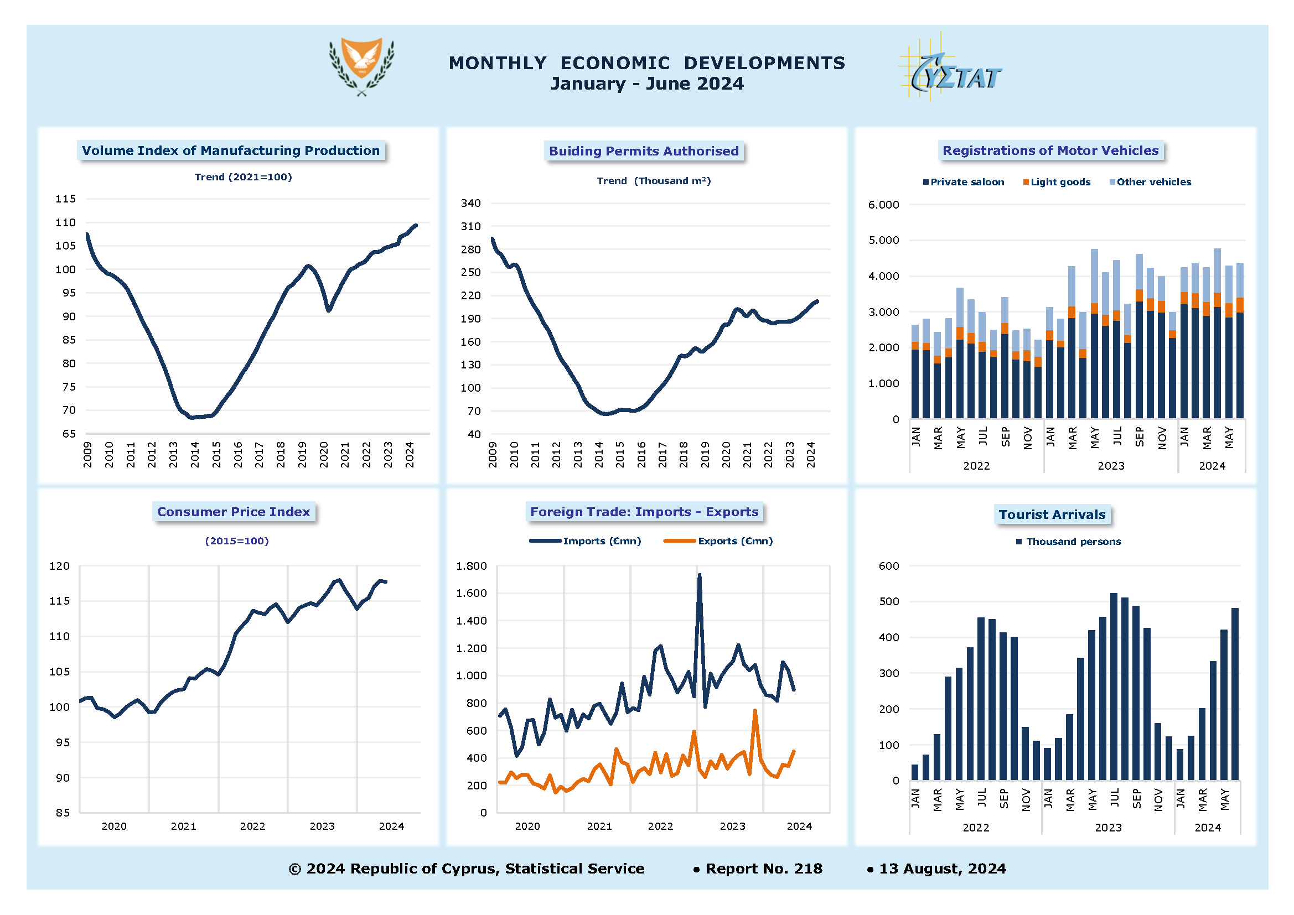

Note: The Trend component depicts the long-term evolution of the series, that can be observed over a long period of time. It is the result of influences such as population growth, technological development and general economic development.

**Manufacturing Production** during the period January-May 2024 recorded an increase of 4,9% compared to January-May 2023.

The total area of **Building Permits Authorized** reached 1.032,6 thousand square metres during the period January-May 2024, recording an increase of 13,4% compared to the corresponding period of the previous year.

The total **Registrations of Motor Vehicles** increased by 19,2%, reaching to 26.250 during the period January-June 2024. Private saloon cars increased to 18.200, recording a rise of 26,9% and light goods vehicles increased to 2.369 recording a rise of 43,5% compared to January-June 2023.

The **Consumer Price Index** increased by 2,1% during the period January-June 2024, compared to the corresponding period of the previous year.

The total **Imports of Goods** reached €5.557,7 mn during the period January–June 2024, recording a decrease of 14,4% and total **Exports of Goods** reached €1.985,9 mn, recording also a decrease of 1,5%.

The **Arrivals of Tourists** totaled 1.652.475 during the period January-June 2024, compared to 1.613.690 in the corresponding period of 2023, recording an increase of 2,4%.

More statistics are available in the [**Monthly Economic Developments**](https://www.cystat.gov.cy/en/PublicationList?s=32&pcID=3) bulletin, available in electronic form on the online portal of the Statistical Service.

*Contact*

Agathi Sofroniou: Τel: +35722602225, Email: [asofroniou@cystat.mof.gov.cy](mailto:asofroniou@cystat.mof.gov.cy)