2 August, 2023

**PRESS RELEASE**

**ANNUAL SURVEY ON EDUCATION, 2020/2021**

Based on the results of the Annual Survey on Education for the school year 2020/2021, the total number of pupils and students at all educational levels amounted to 201.273 remaining approximately at the same levels as in 2019/2020, where the total number of pupils and students was 201.242. The total number of educational institutions in 2020/2021 was 1.317 compared to 1.329 educational institutions in 2019/2020. Finally, the total number of teachers in 2020/2021, was 15.809 showing an increase of 2,0%, compared to 15.499 teachers of the previous school year.

**Number of Students and Educational** **Institutions by Level of Education**

For the school year 2020/2021 in Pre-school and Pre-primary education, 734 kindergartens and day nurseries operated with 32.958 children, noting a slight decrease (1,1%) compared to the 2019/2020 school year, where 743 kindergartens and day nurseries operated, with 33.329 children.

In Primary education 360 schools operated, with 58.093 pupils, also showing a minor decrease (1,2%) compared to 2019/2020 where 361 schools operated with 58.799 students.

In Secondary education during 2020/2021, 56.714 pupils enrolled in 168 schools, showing a small increase (1,4%) compared to 2019/2020 where in the same number of schools there were 55.922 pupils.

In Tertiary education, 55 educational institutions operated with a total number of 53.508 students. The corresponding figures the academic year 2019/2020, were 57 educational institutions with 53.192 students.

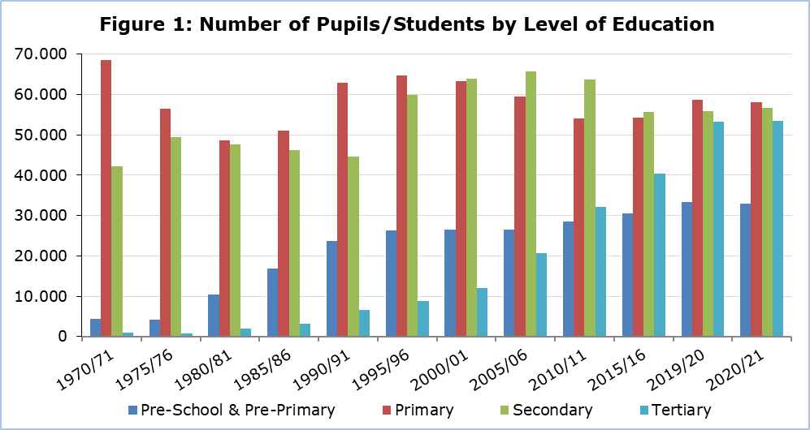

Additionally, in 2020/2021, 11 Special Schools operated with 498 pupils and 147 teachers, while in 2019/2020 for the same number of schools we had 466 pupils and 146 teachers. Therefore, in 2020/2021 we had a 6,9% increase in special school students.

**Financial Statistics of Education**

Public expenditure in all levels of education, amounted to €1.306,5 million, in 2020, and accounted for 13,4% of the Government Budget and 6,0% of the Gross Domestic Product.

The corresponding amounts for the financial year 2019 amounted to €1.280,7 million and accounted for 14.5% of the Government Budget and 5.5% of the Gross Domestic Product.

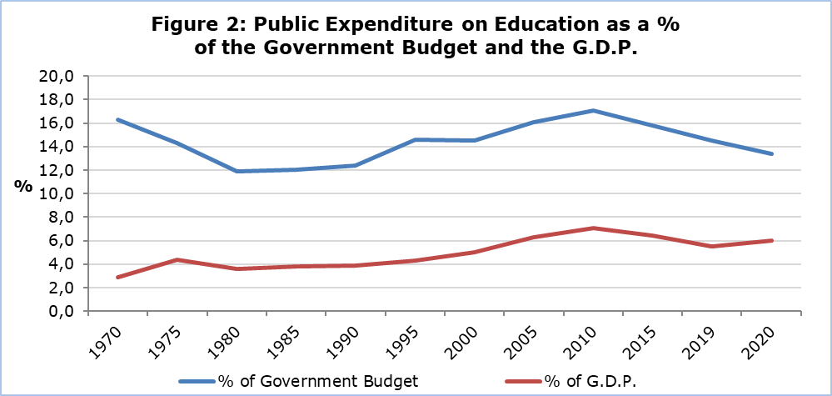

The cost per student for public education, in 2020 measured, in terms of current expenditure, €5.204 for Pre-School and Pre-Primary, €6.978 for Primary, €11.510 for Secondary General, €14.114 for Secondary Vocational and €12.143 for Tertiary education.

The corresponding cost per student for public education, in 2019, was €5,098 for Pre-School and Pre-Primary, €6.668 for Primary, €10.826 for Secondary General, €14.205 for Secondary Vocational and €12.558 for Tertiary education.

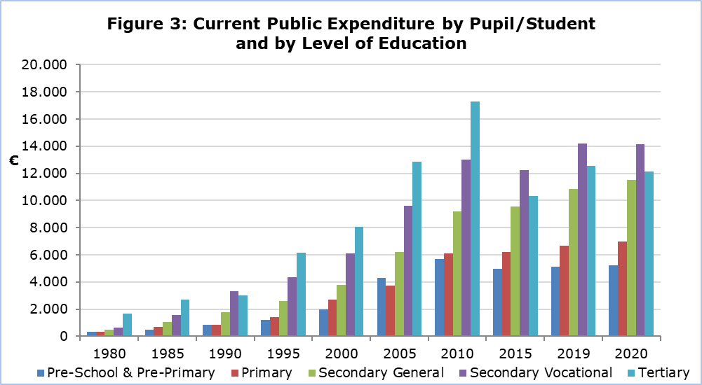

|  |  |  |  |  |  |  |  |  |
| --- | --- | --- | --- | --- | --- | --- | --- | --- |
| **Table 1** |  | | | | | | | |
| **SCHOOL YEAR** | **PUPILS/STUDENTS BY** **EDUCATION LEVEL** | | | | | | | |
| **Pre-School & Pre-Primary** | | **Primary** | | **Secondary** | | **Tertiary** | |
| 2020/21 | 32.958 |  | 58.093 |  | 56.714 |  | 53.508 |  |
| 2019/20 | 33.329 |  | 58.779 |  | 55.922 |  | 53.192 |  |
| 2018/19 | 33.108 |  | 58.060 |  | 55.499 |  | 50.211 |  |
| 2017/18 | 32.522 |  | 56.699 |  | 54.966 |  | 47.169 |  |
| 2016/17 | 31.678 |  | 55.482 |  | 55.212 |  | 45.263 |  |
| 2015/16 | 30.471 |  | 54.292 |  | 55.711 |  | 40.347 |  |
| 2010/11 | 28.582 |  | 54.083 |  | 63.764 |  | 32.118 |  |
| 2005/06 | 26.557 |  | 59.401 |  | 65.660 |  | 20.587 |  |
| 2000/01 | 26.455 |  | 63.387 |  | 64.023 |  | 11.934 |  |
| 1995/96 | 26.254 |  | 64.660 |  | 59.845 |  | 8.874 |  |
| 1990/91 | 23.694 |  | 62.962 |  | 44.614 |  | 6.554 |  |
| 1985/86 | 16.810 |  | 50.990 |  | 46.159 |  | 3.134 |  |
| 1980/81 | 10.397 |  | 48.701 |  | 47.599 |  | 1.940 |  |
| 1975/76 | 4.229 |  | 56.554 |  | 49.373 |  | 602 |  |
| 1970/71 | 4.325 |  | 69.160 |  | 42.245 |  | 698 |  |

|  |  |  |  |  |  |  |  |  |
| --- | --- | --- | --- | --- | --- | --- | --- | --- |
| **Tableς 2** |  | | | | | | | |
| **SCHOOL YEAR** | **EDUCATIONAL INSTITUTIONS BY** **EDUCATION LEVEL** | | | | | | | |
| **Pre-School & Pre-Primary** | | **Primary** | | **Secondary** | | **Tertiary** | |
| 2020/21 | 734 |  | 360 |  | 168 |  | 55 |  |
| 2019/20 | 743 |  | 361 |  | 168 |  | 57 |  |
| 2018/19 | 745 |  | 361 |  | 164 |  | 57 |  |
| 2017/18 | 745 |  | 362 |  | 165 |  | 55 |  |
| 2016/17 | 742 |  | 360 |  | 167 |  | 49 |  |
| 2015/16 | 726 |  | 362 |  | 167 |  | 48 |  |
| 2010/11 | 680 |  | 368 |  | 166 |  | 43 |  |
| 2005/06 | 682 |  | 365 |  | 158 |  | 36 |  |
| 2000/01 | 642 |  | 367 |  | 134 |  | 32 |  |
| 1995/96 | 647 |  | 381 |  | 123 |  | 33 |  |
| 1990/91 | 572 |  | 383 |  | 108 |  | 27 |  |
| 1985/86 | 423 |  | 380 |  | 103 |  | 16 |  |
| 1980/81 | 259 |  | 443 |  | 91 |  | 13 |  |
| 1975/76 | 96 |  | 400 |  | 80 |  | 6 |  |
| 1970/71 | 109 |  | 565 |  | 83 |  | 5 |  |

**METHODOLOGICAL INFORMATION**

**Coverage of Annual Survey on Education**

The Annual Survey on Education collects annually detailed data on pupils/students, graduates, staff and funding for all levels of education. It covers all educational institutions, public and private, in the Government controlled areas.

**Reference period**

The reference period for the data of Pre-School and Pre-Primary, Primary, Secondary and Special education is October 2020. The reference period for Tertiary education is the academic year 2020/2021. For the financial statistics of education, the reference period is the calendar year 2020.

**Sources of Data**

The data collection is carried out via questionnaires sent to all educational institutions and completed by them following the written instructions. Additionally, administrative sources are used, mainly for the compilation of economic statistics of education.

**Definitions**

**Public expenditure on education as % of Gross Domestic Product (G.D.P.):** The total public expenditure on education is compiled according to the definitions and methodology of the European Statistical Service (EUROSTAT). The public expenditure on education as a % of GDP is calculated by dividing the total public expenditure on education, by the amount of the GDP and multiplying by 100.

***For further information:***

Statistical Service (CYSTAT) Website, subtheme [Education](https://www.cystat.gov.cy/en/SubthemeStatistics?id=33)

[CYSTAT-DB](https://cystatdb.cystat.gov.cy/pxweb/en/8.CYSTAT-DB/8.CYSTAT-DB__Education__) (Database)

[Predefined Tables](https://www.cystat.gov.cy/en/KeyFiguresList?s=33) (Excel)

[Methodological Information](https://www.cystat.gov.cy/en/MethodologicalDetails?m=2104)

**The Predefined Tables in Excel format include data up to school year 2018/2019. Data from school year 2019/2020 onwards, are available only in the CYSTAT-DB Online Database.**

*Contact*

Loukia Nicolaou: Tel.: +35722602147, Email: [lnicolaou@cystat.mof.gov.cy](mailto:lnicolaou@cystat.mof.gov.cy)

Maria Hadjiprokopi: Tel: +35722602146, Email: [mhadjiprokopi@cystat.mof.gov.cy](mailto:mhadjiprokopi@cystat.mof.gov.cy)