8 March, 2024

**PRESS RELEASE - REVISED**

**ANNUAL SURVEY ON EDUCATION, 2021/2022**

Based on the results of the Annual Survey on Education for the school year 2021/2022, the total number of pupils and students at all educational levels reached 203.041 compared to 201.273 the school year 2020/2021, recording a minor increase (0,9%). The total number of educational institutions in 2021/2022 was 1.313 compared to 1.317 in 2020/2021. Finally, the total number of teachers in 2021/2022, was 15.907 remaining almost at the same levels as in 2020 where teachers were 15.809.

**Number of Students and Educational** **Institutions by Level of Education**

For the school year 2021/2022 in Pre-school and Pre-primary education, 728 kindergartens and day nurseries operated with 34.980 children, recording an increase (6,1%) compared to the 2020/2021 school year, where 734 kindergartens and day nurseries operated with 32.958 children.

In Primary education 360 schools operated with 56.853 pupils, showing a decrease (2,1%) compared to 2020/2021 where in the same number of schools there were 58.093 pupils.

In Secondary education during 2021/2022, 58.212 pupils enrolled in 167 schools, showing an increase (2,6%) compared to 2020/2021 where 168 schools operated with 56.714 pupils.

In Tertiary education, 58 educational institutions operated with a total number of 52.996 students. The corresponding figures for the academic year 2020/2021, were 55 educational institutions with 53.508 students.

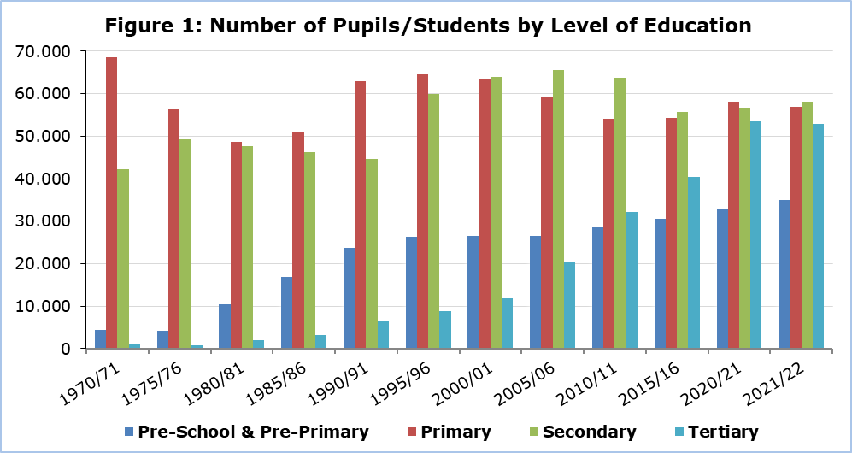

Additionally, in 2021/2022, 11 Special Schools operated with 524 pupils and 217 teachers, while in 2020/2021 for the same number of schools we had 498 pupils and 180 teachers.

**Financial Statistics of Education**

Public expenditure in all levels of education, amounted to €1.357,3 million in 2021 and accounted for 13,1% of the Government Budget and 5,4% of the Gross Domestic Product.

The corresponding amounts for the financial year 2020 amounted to €1.306,5 million and accounted for 13,4% of the Government Budget and 5,9% of the Gross Domestic Product.

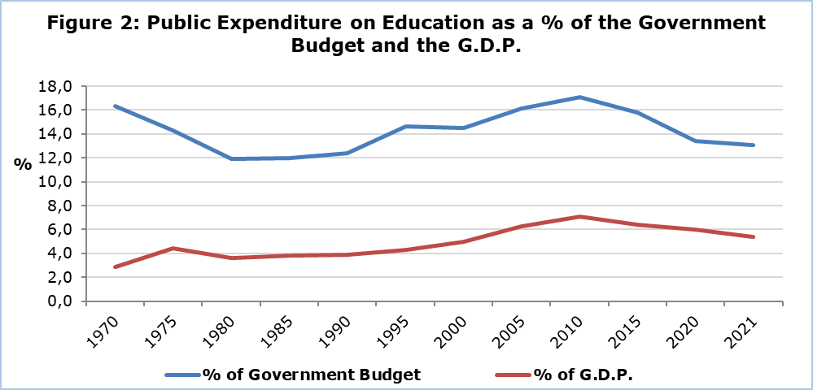

The cost per student for public education, in 2021 measured, in terms of current expenditure, €5.637 for Pre-School and Pre-Primary, €7.377 for Primary, €11.419 for Secondary General, €14.006 for Secondary Vocational and €12.955 for Tertiary education.

The corresponding current expenditure per pupil, for public education, in 2020, was €5.204 for Pre-School and Pre-Primary, €6.978 for Primary, €11.510 for Secondary General, €14.114 for Secondary Vocational and €12.143 for Tertiary education.

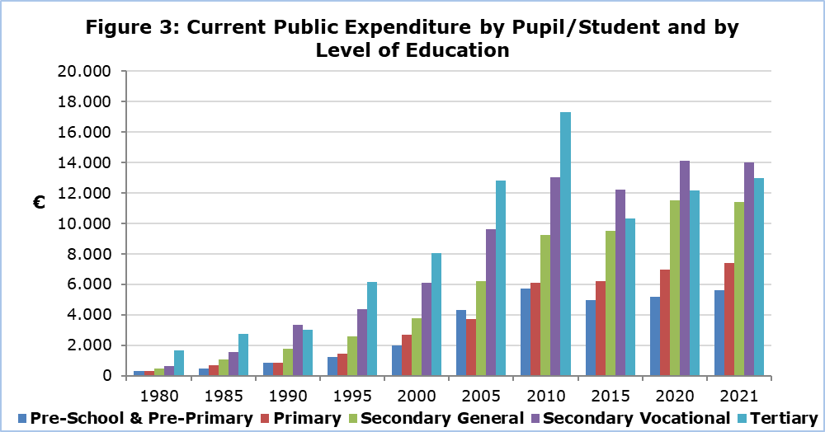

|  |  |  |  |  |  |  |  |  |
| --- | --- | --- | --- | --- | --- | --- | --- | --- |
| **Table 1** |  | | | | | | | |
| **SCHOOL YEAR** | **PUPILS/STUDENTS BY** **EDUCATION LEVEL** | | | | | | | |
| **Pre-School & Pre-Primary** | | **Primary** | | **Secondary** | | **Tertiary** | |
| 2021/22 | 34.980 |  | 56.853 |  | 58.212 |  | 52.996 |  |
| 2020/21 | 32.958 |  | 58.093 |  | 56.714 |  | 53.508 |  |
| 2019/20 | 33.329 |  | 58.779 |  | 55.922 |  | 53.192 |  |
| 2018/19 | 33.108 |  | 58.060 |  | 55.499 |  | 50.211 |  |
| 2017/18 | 32.522 |  | 56.699 |  | 54.966 |  | 47.169 |  |
| 2015/16 | 30.471 |  | 54.292 |  | 55.711 |  | 40.347 |  |
| 2010/11 | 28.582 |  | 54.083 |  | 63.764 |  | 32.118 |  |
| 2005/06 | 26.557 |  | 59.401 |  | 65.660 |  | 20.587 |  |
| 2000/01 | 26.455 |  | 63.387 |  | 64.023 |  | 11.934 |  |
| 1995/96 | 26.254 |  | 64.660 |  | 59.845 |  | 8.874 |  |
| 1990/91 | 23.694 |  | 62.962 |  | 44.614 |  | 6.554 |  |
| 1985/86 | 16.810 |  | 50.990 |  | 46.159 |  | 3.134 |  |
| 1980/81 | 10.397 |  | 48.701 |  | 47.599 |  | 1.940 |  |
| 1975/76 | 4.229 |  | 56.554 |  | 49.373 |  | 602 |  |
| 1970/71 | 4.325 |  | 69.160 |  | 42.245 |  | 698 |  |

|  |  |  |  |  |  |  |  |  |
| --- | --- | --- | --- | --- | --- | --- | --- | --- |
| **Tableς 2** |  | | | | | | | |
| **SCHOOL YEAR** | **EDUCATIONAL INSTITUTIONS BY** **EDUCATION LEVEL** | | | | | | | |
| **Pre-School & Pre-Primary** | | **Primary** | | **Secondary** | | **Tertiary** | |
| 2021/22 | 728 |  | 360 |  | 167 |  | 58 |  |
| 2020/21 | 734 |  | 360 |  | 168 |  | 55 |  |
| 2019/20 | 743 |  | 361 |  | 168 |  | 57 |  |
| 2018/19 | 745 |  | 361 |  | 164 |  | 57 |  |
| 2017/18 | 745 |  | 362 |  | 165 |  | 55 |  |
| 2015/16 | 726 |  | 362 |  | 167 |  | 48 |  |
| 2010/11 | 680 |  | 368 |  | 166 |  | 43 |  |
| 2005/06 | 682 |  | 365 |  | 158 |  | 36 |  |
| 2000/01 | 642 |  | 367 |  | 134 |  | 32 |  |
| 1995/96 | 647 |  | 381 |  | 123 |  | 33 |  |
| 1990/91 | 572 |  | 383 |  | 108 |  | 27 |  |
| 1985/86 | 423 |  | 380 |  | 103 |  | 16 |  |
| 1980/81 | 259 |  | 443 |  | 91 |  | 13 |  |
| 1975/76 | 96 |  | 400 |  | 80 |  | 6 |  |
| 1970/71 | 109 |  | 565 |  | 83 |  | 5 |  |

**METHODOLOGICAL INFORMATION**

**Coverage of Annual Survey on Education**

The Annual Survey on Education collects annually detailed data on pupils/students, graduates, staff and funding for all levels of education. It covers all educational institutions, public and private, in the Government controlled areas.

**Reference period**

The reference period for the data of Pre-School and Pre-Primary, Primary, Secondary and Special education is October 2021. The reference period for Tertiary education is the academic year 2021/2022. For the financial statistics of education, the reference period is the calendar year 2021.

**Sources of Data**

The data collection is carried out via questionnaires sent to all educational institutions and completed by them following the written instructions. Additionally, administrative sources are used, mainly for the compilation of economic statistics of education.

**Definitions**

**Public expenditure on education as % of Gross Domestic Product (G.D.P.):** The total public expenditure on education is compiled according to the definitions and methodology of the European Statistical Service (EUROSTAT). The public expenditure on education as a % of GDP is calculated by dividing the total public expenditure on education, by the amount of the GDP and multiplying by 100.

***For further information:***

Statistical Service (CYSTAT) Website, subtheme [Education](https://www.cystat.gov.cy/en/SubthemeStatistics?id=33)

[CYSTAT-DB](https://cystatdb.cystat.gov.cy/pxweb/en/8.CYSTAT-DB/8.CYSTAT-DB__Education__) (Database)

[Predefined Tables](https://www.cystat.gov.cy/en/KeyFiguresList?s=33) (Excel)

[Methodological Information](https://www.cystat.gov.cy/en/MethodologicalDetails?m=2104)

**The Predefined Tables in Excel format include data up to school year 2018/2019. Data from school year 2019/2020 onwards, are available only in the CYSTAT-DB Online Database.**

*Contact*

Loukia Nicolaou: Tel.: +35722602147, Email: [lnicolaou@cystat.mof.gov.cy](mailto:lnicolaou@cystat.mof.gov.cy)

Maria Hadjiprokopi: Tel: +35722602146, Email: [mhadjiprokopi@cystat.mof.gov.cy](mailto:mhadjiprokopi@cystat.mof.gov.cy)

13 March, 2024

**CORRIGENDUM**

An error was detected in the press release whereby the total number of teachers in 2021/2022, was 15.907 instead of 15.855 which was erroneously written.