19 December, 2024

**PRESS RELEASE**

**EDUCATION SURVEY, 2022/2023**

Based on the results of the Annual Survey on Education for the school year 2022/2023, the total number of pupils and students at all educational levels reached 208.374 compared to 203.041 the school year 2021/2022, recording an increase (2,6%). The total number of educational institutions in 2022/2023 was 1.351 compared to 1.313 in 2021/2022. Finally, the total number of teachers in 2022/2023, was 16.475 recording an increase (3,6%) compared to 2021/2022 where teachers were 15.907.

**Number of Students and Educational** **Institutions by Level of Education**

For the school year 2022/2023 in Pre-school and Pre-primary education, 764 kindergartens and day nurseries operated with 37.344 children, recording an increase (6,8%) compared to the 2021/2022 school year, where 728 kindergartens and day nurseries operated with 34.980 children.

In Primary education 358 schools operated with 58.168 pupils, showing an increase (2,3%) compared to 2021/2022 where 360 schools operated with 56.853 pupils.

In Secondary education during 2022/2023, 59.926 pupils enrolled in 171 schools, showing an increase (2,9%) compared to 2021/2022 where 167 schools operated with 58.212 pupils.

In Tertiary education, 58 educational institutions operated with a total number of 52.936 students. The corresponding figures for the academic year 2021/2022, were 58 educational institutions and 52.996 students.

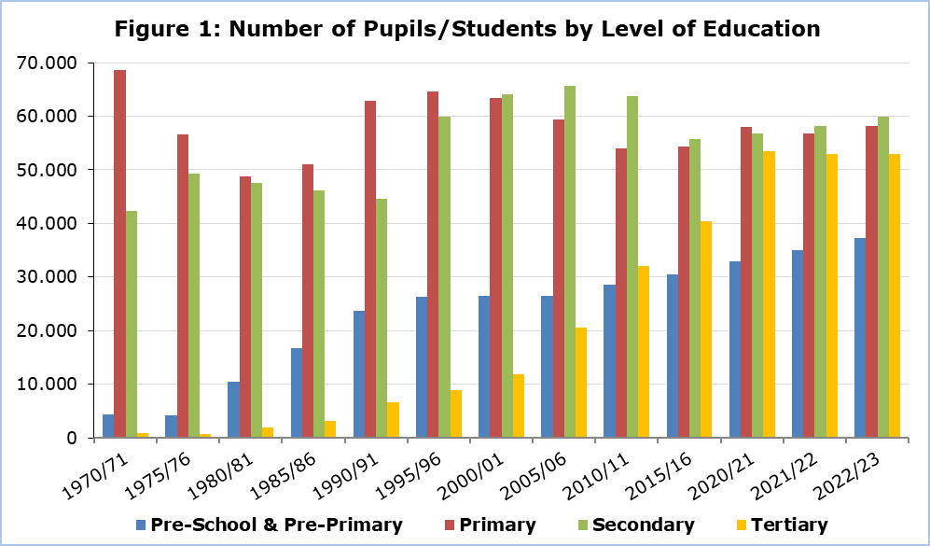

Additionally, in 2022/2023, 11 Special Schools operated with 551 pupils and 211 teachers, while in 2021/2022 for the same number of schools we had 524 pupils and 217 teachers.

**Financial Statistics of Education**

Public expenditure in all levels of education, amounted to €1.445,9 million in 2022 and accounted for 13,0% of the Government Budget and 4,9% of the Gross Domestic Product.

The corresponding amounts for the financial year 2021 amounted to €1.357,3 million and accounted for 13,1% of the Government Budget and 5,4% of the Gross Domestic Product.

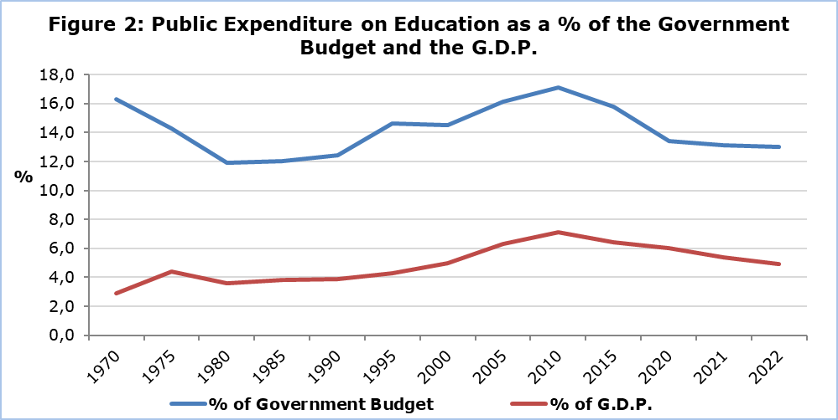

The cost per student for public education, in 2022 measured, in terms of current expenditure, €5.770 for Pre-School and Pre-Primary, €8.082 for Primary, €12.026 for Secondary General, €14.361 for Secondary Vocational and €13.591 for Tertiary education.

The corresponding current expenditure per pupil, for public education, in 2021, was €5.637 for Pre-School and Pre-Primary, €7.377 for Primary, €11.419 for Secondary General, €14.006 for Secondary Vocational and €12.955 for Tertiary education.

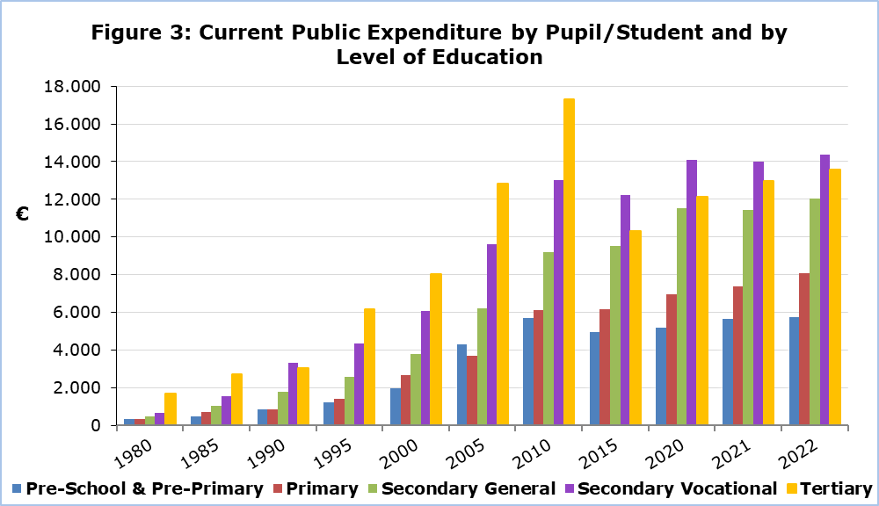

|  |  |  |  |  |  |  |  |  |
| --- | --- | --- | --- | --- | --- | --- | --- | --- |
| **Table 1** |  | | | | | | | |
| **School Year** | **Pupils/Students by** **Education Level** | | | | | | | |
| **Pre-School & Pre-Primary** | | **Primary** | | **Secondary** | | **Tertiary** | |
| 2022/23 | 37.344 |  | 58.168 |  | 59.926 |  | 52.936 |  |
| 2021/22 | 34.980 |  | 56.853 |  | 58.212 |  | 52.996 |  |
| 2020/21 | 32.958 |  | 58.093 |  | 56.714 |  | 53.508 |  |
| 2019/20 | 33.329 |  | 58.779 |  | 55.922 |  | 53.192 |  |
| 2018/19 | 33.108 |  | 58.060 |  | 55.499 |  | 50.211 |  |
| 2017/18 | 32.522 |  | 56.699 |  | 54.966 |  | 47.169 |  |
| 2015/16 | 30.471 |  | 54.292 |  | 55.711 |  | 40.347 |  |
| 2010/11 | 28.582 |  | 54.083 |  | 63.764 |  | 32.118 |  |
| 2005/06 | 26.557 |  | 59.401 |  | 65.660 |  | 20.587 |  |
| 2000/01 | 26.455 |  | 63.387 |  | 64.023 |  | 11.934 |  |
| 1995/96 | 26.254 |  | 64.660 |  | 59.845 |  | 8.874 |  |
| 1990/91 | 23.694 |  | 62.962 |  | 44.614 |  | 6.554 |  |
| 1985/86 | 16.810 |  | 50.990 |  | 46.159 |  | 3.134 |  |
| 1980/81 | 10.397 |  | 48.701 |  | 47.599 |  | 1.940 |  |
| 1975/76 | 4.229 |  | 56.554 |  | 49.373 |  | 602 |  |
| 1970/71 | 4.325 |  | 69.160 |  | 42.245 |  | 698 |  |

|  |  |  |  |  |  |  |  |  |
| --- | --- | --- | --- | --- | --- | --- | --- | --- |
| **Tableς 2** |  | | | | | | | |
| **School Year** | **Educational Institutions by** **Education Level** | | | | | | | |
| **Pre-School & Pre-Primary** | | **Primary** | | **Secondary** | | **Tertiary** | |
| 2022/23 | 764 |  | 358 |  | 171 |  | 58 |  |
| 2021/22 | 728 |  | 360 |  | 167 |  | 58 |  |
| 2020/21 | 734 |  | 360 |  | 168 |  | 55 |  |
| 2019/20 | 743 |  | 361 |  | 168 |  | 57 |  |
| 2018/19 | 745 |  | 361 |  | 164 |  | 57 |  |
| 2017/18 | 745 |  | 362 |  | 165 |  | 55 |  |
| 2015/16 | 726 |  | 362 |  | 167 |  | 48 |  |
| 2010/11 | 680 |  | 368 |  | 166 |  | 43 |  |
| 2005/06 | 682 |  | 365 |  | 158 |  | 36 |  |
| 2000/01 | 642 |  | 367 |  | 134 |  | 32 |  |
| 1995/96 | 647 |  | 381 |  | 123 |  | 33 |  |
| 1990/91 | 572 |  | 383 |  | 108 |  | 27 |  |
| 1985/86 | 423 |  | 380 |  | 103 |  | 16 |  |
| 1980/81 | 259 |  | 443 |  | 91 |  | 13 |  |
| 1975/76 | 96 |  | 400 |  | 80 |  | 6 |  |
| 1970/71 | 109 |  | 565 |  | 83 |  | 5 |  |

**METHODOLOGICAL INFORMATION**

**Coverage of Annual Survey on Education**

The Annual Survey on Education collects annually detailed data on pupils/students, graduates, staff and funding for all levels of education. It covers all educational institutions, public and private, in the Government controlled areas.

**Reference period**

The reference period for the data of Pre-School and Pre-Primary, Primary, Secondary and Special education is October 2022. The reference period for Tertiary education is the academic year 2022/2023. For the financial statistics of education, the reference period is the calendar year 2022.

**Sources of Data**

The data collection is carried out via questionnaires sent to all educational institutions and completed by them following the written instructions. Additionally, administrative sources are used, mainly for the compilation of economic statistics of education.

**Definitions**

**Public expenditure on education as % of Gross Domestic Product (G.D.P.):** The total public expenditure on education is compiled according to the definitions and methodology of the European Statistical Service (EUROSTAT). The public expenditure on education as a % of GDP is calculated by dividing the total public expenditure on education, by the amount of the GDP and multiplying by 100.

***For further information:***

Statistical Service (CYSTAT) Website, subtheme [Education](https://www.cystat.gov.cy/en/SubthemeStatistics?id=33)

[CYSTAT-DB](https://cystatdb.cystat.gov.cy/pxweb/en/8.CYSTAT-DB/8.CYSTAT-DB__Education__) (Database)

[Predefined Tables](https://www.cystat.gov.cy/en/KeyFiguresList?s=33) (Excel)

[Methodological Information](https://www.cystat.gov.cy/en/MethodologicalDetails?m=2104)

**The Predefined Tables in Excel format include data up to school year 2018/2019. Data from school year 2019/2020 onwards, are available only in the CYSTAT-DB Online Database.**

*Contact*

Loukia Nicolaou: Tel.: +35722602147, Email: [lnicolaou@cystat.mof.gov.cy](mailto:lnicolaou@cystat.mof.gov.cy)

Maria Hadjiprokopi: Tel: +35722602146, Email: [mhadjiprokopi@cystat.mof.gov.cy](mailto:mhadjiprokopi@cystat.mof.gov.cy)

George Georgiou: Tel.: +35722602233, Email: galgeorgiou@cystat.mof.gov.cy