30 December, 2025

PRESS RELEASE

EDUCATION SURVEY, 2023/2024

Based on the results of the Annual Survey on Education for the school year 2023/2024, the total number of pupils and students at all educational levels reached 218.129 compared to 208.374 for the school year 2022/2023, recording an increase of 4,7%. The total number of educational institutions in 2023/2024 was 1.368 compared to 1.351 in 2022/2023. Finally, the total number of teachers in 2023/2024, was 17.298 recording an increase of 5,0% compared to 2022/2023 where teachers were 16.475.

Number of Students and Educational Institutions by Level of Education
For the school year 2023/2024 in Pre-school and Pre-primary education, 778 kindergartens and day nurseries operated with 38.931 children, recording an increase (4,2%) compared to the 2022/2023 school year, where 764 kindergartens and day nurseries operated with 37.344 children.

In Primary education 361 schools operated with 60.079 pupils, showing an increase (3,3%) compared to 2022/2023, where 358 schools operated with 58.168 pupils.

In Secondary education during 2023/2024, 61.230 pupils enrolled in 170 schools, showing an increase (2,2%) compared to 2022/2023, where 171 schools operated with 59.926 pupils.

In Tertiary education, 59 educational institutions operated with a total number of 57.889 students, showing an increase (9,4%) compared to the academic year 2022/2023, were 58 educational institutions operated and 52.936 students were enrolled.

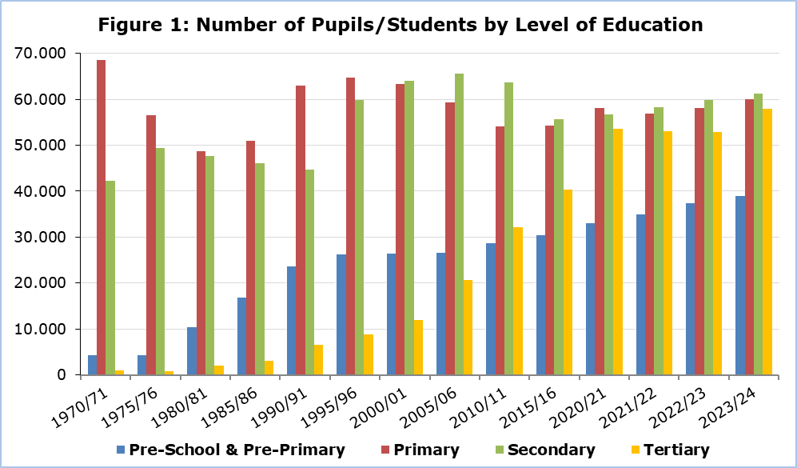

Additionally, in 2023/2024, 11 Special Schools operated with 575 pupils and 213 teachers, while in 2022/2023 the same number of schools operated with 551 pupils and 211 teachers.

Financial Statistics of Education
Public expenditure in all levels of education, amounted to €1.599,2 million in 2023, accounting to 12,1% of the Government Budget and 4,9% of the Gross Domestic Product.

The corresponding figures for the financial year 2022 amounted to €1.445,9 million, accounting to 12,9% of the Government Budget and 4,9% of the Gross Domestic Product.

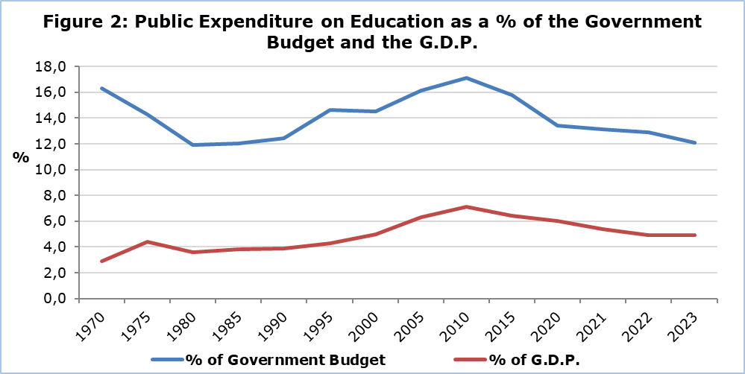

The cost per student for public education, in 2023 measured, in terms of current public expenditure, €6.413 for Pre-School and Pre-Primary, €8.975 for Primary, €13.232 for Secondary General, €15.692 for Secondary Vocational and €15.084 for Tertiary education.

The corresponding current public expenditure per pupil, for public education, in 2022, was €5.770 for Pre-School and Pre-Primary, €8.082 for Primary, €12.026 for Secondary General, €14.361 for Secondary Vocational and €13.591 for Tertiary education.

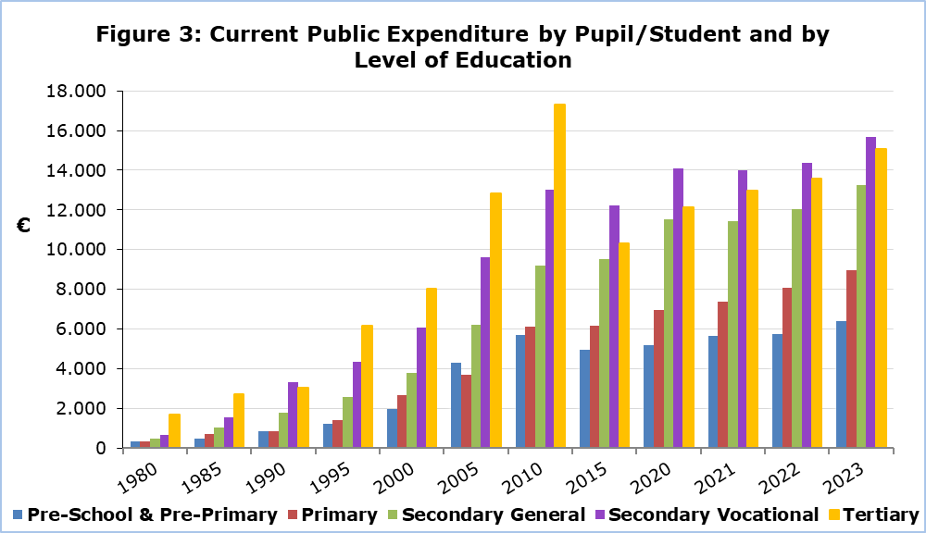
Table 1
School Year | Pupils/Students by Level of Education
School Year | Pre-School & Pre-Primary | Primary | Secondary | Tertiary
2023/24 | 38.931 | 60.079 | 61.230 | 57.889
2022/23 | 37.344 | 58.168 | 59.926 | 52.936
2021/22 | 34.980 | 56.853 | 58.212 | 52.996
2020/21 | 32.958 | 58.093 | 56.714 | 53.508
2019/20 | 33.329 | 58.779 | 55.922 | 53.192
2018/19 | 33.108 | 58.060 | 55.499 | 50.211
2017/18 | 32.522 | 56.699 | 54.966 | 47.169
2015/16 | 30.471 | 54.292 | 55.711 | 40.347
2010/11 | 28.582 | 54.083 | 63.764 | 32.118
2005/06 | 26.557 | 59.401 | 65.660 | 20.587
2000/01 | 26.455 | 63.387 | 64.023 | 11.934
1995/96 | 26.254 | 64.660 | 59.845 | 8.874
1990/91 | 23.694 | 62.962 | 44.614 | 6.554
1985/86 | 16.810 | 50.990 | 46.159 | 3.134
1980/81 | 10.397 | 48.701 | 47.599 | 1.940
1975/76 | 4.229 | 56.554 | 49.373 | 602
1970/71 | 4.325 | 69.160 | 42.245 | 698

Table 2
School Year | Educational Institutions by Level of Education
School Year | Pre-School & Pre-Primary | Primary | Secondary | Tertiary
2023/24 | 778 | 361 | 170 | 59
2022/23 | 764 | 358 | 171 | 58
2021/22 | 728 | 360 | 167 | 58
2020/21 | 734 | 360 | 168 | 55
2019/20 | 743 | 361 | 168 | 57
2018/19 | 745 | 361 | 164 | 57
2017/18 | 745 | 362 | 165 | 55
2015/16 | 726 | 362 | 167 | 48
2010/11 | 680 | 368 | 166 | 43
2005/06 | 682 | 365 | 158 | 36
2000/01 | 642 | 367 | 134 | 32
1995/96 | 647 | 381 | 123 | 33
1990/91 | 572 | 383 | 108 | 27
1985/86 | 423 | 380 | 103 | 16
1980/81 | 259 | 443 | 91 | 13
1975/76 | 96 | 400 | 80 | 6
1970/71 | 109 | 565 | 83 | 5

METHODOLOGICAL INFORMATION

Coverage of Annual Survey on Education

The Annual Survey on Education collects annually detailed data on pupils/students, graduates, staff and funding for all levels of education. It covers all educational institutions, public and private, in the Government controlled areas.

Reference period

The reference period for the data of Pre-School and Pre-Primary, Primary, Secondary and Special education is October 2023. The reference period for Tertiary education is the academic year 2023/2024. For the financial statistics of education, the reference period is the calendar year 2023.

Sources of Data

The data collection is carried out via questionnaires sent to all educational institutions and completed by them following the written instructions. Additionally, administrative sources are used, mainly for the compilation of the economic statistics on education.

Definitions

Public expenditure on education as % of Gross Domestic Product (G.D.P.): The total public expenditure on education is compiled according to the definitions and methodology of the European Statistical Service (EUROSTAT). The public expenditure on education as a % of GDP is calculated by dividing the total public expenditure on education, by the amount of the GDP and multiplying by 100.

For further information:
Statistical Service (CYSTAT) Website, subtheme Education
CYSTAT-DB (Database)
Predefined Tables (Excel)
Methodological Information

The Predefined Tables in Excel format include data up to the school year 2018/2019. Data from the school year 2019/2020 onwards, are available only in the CYSTAT-DB Online Database.

Contact
Anastasia Pashiardi: Tel.: +35722605113, Email: apashiardi@cystat.mof.gov.cy
Andreas Aristotelous: Tel.: +35722602155, Email: aaristotelous@cystat.mof.gov.cy
George Georgiou: Tel.: +35722602233, Email: galgeorgiou@cystat.mof.gov.cy

