14 June, 2024

**PRESS RELEASE**

###### EMPLOYMENT IN THE BROAD PUBLIC SECTOR: 1st QUARTER 2024

**Total Employment 75.723**

Total employment in the Broad Public Sector in the 1st quarter of 2024 reached 75.723 persons. The employment in General Government was 69.929 and in the Publicly Owned Enterprises and Companies 5.794 persons.

In General Government, which consists of the Government, Non-Profit Organizations and Local Authorities, total employment reached 54.698, 10.767 and 4.464 persons respectively.

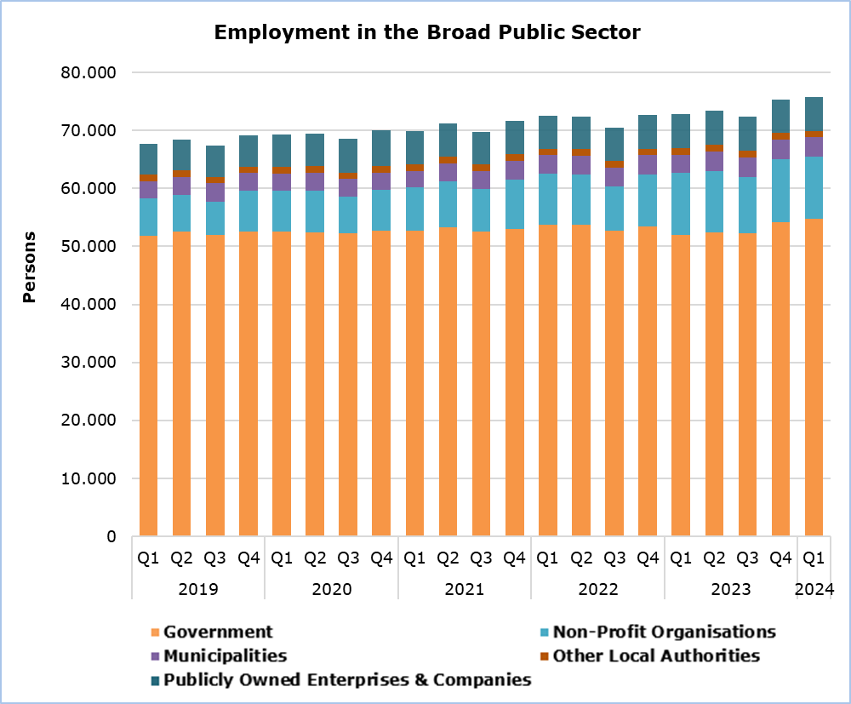

The employment in the Broad Public Sector increased by 2.993 persons (4,1%) compared to the same quarter of 2023. The employment in Central Government increased by 2.847 persons (4,5%) and in Local Authorities by 165 persons (3,8%), whereas in Publicly Owned Enterprises and Companies it decreased by 19 persons (-0,3%). The increase in Central Government employment is mainly attributed to the increase of the Educational Service staff (Government), due to the abolition of the purchase of services regime in the supporting programs of the Ministry of Education, Sport and Youth as from the school year 2023-2024.

Compared to the 4th quarter of 2023, the employment in the Broad Public Sector increased by 362 persons (0,5%). Employment increased in Central Government by 442 persons (0,7%), whereas in Local Authorities and in Publicly Owned Enterprises and Companies it decreased by 65 persons (-1,4%) and by 15 persons (-0,3%) respectively.

|  |  |  |  |  |  |  |
| --- | --- | --- | --- | --- | --- | --- |
| **Table** |  |  |  |  |  |  |
|  | **Number of Persons** | | |  | **% Change** | |
|  | **Q1 2023** | **Q4 2023** | **Q1 2024** |  | **Q1 2024/**  **Q4 2023** | **Q1 2024/2023** |
| **General Government** | **66.917** | **69.552** | **69.929** |  | **0,5** | **4,5** |
| **Central Government** | **62.618** | **65.023** | **65.465** |  | **0,7** | **4,5** |
| Government | 52.020 | 54.168 | 54.698 |  | 1,0 | 5,1 |
| Non-profit Organizations | 10.598 | 10.855 | 10.767 |  | -0,8 | 1,6 |
| **Local Authorities** | **4.299** | **4.529** | **4.464** |  | **-1,4** | **3,8** |
| Municipalities | 3.179 | 3.409 | 3.344 |  | -1,9 | 5,2 |
| Other Local Authorities | 1.120 | 1.120 | 1.120 |  | 0,0 | 0,0 |
| **Publicly Owned Enterprises and Companies** | **5.813** | **5.809** | **5.794** |  | **-0,3** | **-0,3** |
| **Broad Public Sector** | **72.730** | **75.361** | **75.723** |  | **0,5** | **4,1** |

**METHODOLOGICAL INFORMATION**

**Coverage**

The employment in the **Broad Public Sector** includes employment in General Government Sector and in Publicly Owned Enterprises and Companies.

**General Government Sector** includes Central Government and Local Authorities.

**Central Government** includes Government and Non-Profit Organizations. Government includes Civil Service, Educational Service, Police Service, Fire Service, Hourly Paid Workers and Military Personnel. Non-Profit Organizations include School Committees, University of Cyprus, Cyprus University of Technology, Open University, Cyprus Athletic Organization, Cyprus Theatrical Organization, Youth Organization, Investment Promotion Foundation, Symphony Orchestra Foundation, Cyprus National Addictions Authority, Bank of Cyprus Oncology Centre, Cyprus Broadcasting Corporation, Cyprus News Agency, Cyprus Agricultural Payment Organization, Cyprus Petroleum Company, Central Agency of Equal Distribution of Burden, Research and Innovation Foundation, Fauna Fund, Human Resource Development Authority, Office of the Commissioner of Electronic Communications and Postal Regulation, Cyprus Radiotelevision Authority, Cyprus Energy Regulatory Authority, Pancyprian Refugees Union, Cyprus Standard Organization, Cyprus Asset Management Company Limited, State Health Services Organization and National Betting Authority. As from January 2023, Hourly Paid Workers from the Ministry of Health (Government) have been included to the State Health Services Organisation (Non-Profit Organizations).

**Local Authorities** include Municipalities and other Local Authorities.

**Publicly Owned Enterprises and Companies** include: Cyprus Telecommunication Authority, Electricity Authority of Cyprus, Cyprus Port Authority, Sewage Disposal Boards, Water Boards, Forest Industries, Cyprus Stock Exchange, Home Finance Organization, Cyprus Potato Marketing Board, Cyprus Securities and Exchange Commission, Cyprus Land Development Corporation, Cyprus Scientific and Technical Chamber, Precious Metals Engraving Organization, Council for the Registration and Control of Building Contractors, Board for the Registration of the Real Estate Agencies, Council of Commercial Agents, Cyprus Certification Company and Health Insurance Organization.

**Clarifications on the Classification of Entities**

1. From the first quarter of 2015 onwards Fauna Fund, Human Resource Development Authority, Office of the Commissioner of Electronic Communications and Postal Regulation, Cyprus Radiotelevision Authority, Cyprus Energy Regulatory Authority, Pancyprian Refugees Union have been moved from Publicly Owned Enterprises and Companies to Non-Profit Organizations due to revision in the classification of the organizations. Cyprus Certification Company has moved to Publicly Owned Enterprises and Companies.

2. From the first quarter of 2015 the Cyprus Institute of Energy has been moved from ‘Non-Profit Organizations’ to Government (Energy Service).

3. From the fourth quarter of 2018 in the 'Non-Profit organizations', Cyprus Asset Management Company Limited was included.

4. From the first quarter of 2019 in the 'Non-Profit Organizations', the State Health Services Organization was included.

5. From the first quarter of 2019 the Cyprus Tourism Organization has been moved from ‘Non-Profit Organizations’ to Government (Deputy Ministry of Tourism).

6. From the first quarter of 2020 the Cyprus Cultural Foundation has been moved from ‘Non-Profit Organizations’ to Government.

7. From the third quarter of 2019 the Agricultural Insurance Organization has been moved from ‘Non-Profit Organizations’ to Government.

8. From the third quarter of 2020 the Grain Commission has been moved from ‘Publicly Owned Enterprises and Companies’ to Government.

9. From the first quarter of 2022 in the 'Non-Profit organizations', the National Betting Authority was included.

**Collection of Data**

Data concerning employment in Government is provided by the Treasury of the Republic and refers to the number of persons that were employed in the reference quarter, while for the remaining sectors data is collected from the Organizations on a quarterly basis via a telephone survey.

***For more information:***

CYSTAT Portal, subtheme [Labour Market](https://www.cystat.gov.cy/en/SubthemeStatistics?s=43)

[CYSTAT-DB](https://cystatdb.cystat.gov.cy/pxweb/en/8.CYSTAT-DB/8.CYSTAT-DB__Labour%20Market__) (Online Database)

[Predefined Tables](https://www.cystat.gov.cy/en/KeyFiguresList?s=43) (Excel)

[Methodological Information](https://www.cystat.gov.cy/en/MethodologicalDetails?m=2258)

**The data included in the Predefined Tables in Excel format are available up to 4th Quarter 2021. Data from the 1st Quarter 2022 onwards are available only in the CYSTAT-DB Online Database.**

*Contact*

Maria Kkoushi: Tel: +357-22602235, Email: [mkkoushi@cystat.mof.gov.cy](mailto:mkkoushi@cystat.mof.gov.cy)