16 March, 2026

PRESS RELEASE

EMPLOYMENT IN THE BROAD PUBLIC SECTOR: 4th QUARTER 2025

Total Employment 78.124

Total employment in the Broad Public Sector in the 4th quarter of 2025 reached 78.124 persons. The employment in General Government was 73.006 and in the Publicly Owned Enterprises and Companies 5.118 persons.

In General Government, which consists of the Government, Non-Profit Organisations and Local Authorities, total employment reached 55.215, 11.566 and 6.225 persons respectively.

For the year 2025, employment in the Broad Public Sector reached 76.726 persons (Figure 1). Employment in the General Government was 71.675 persons, while employment in the Publicly Owned Enterprises and Companies was 5.051 persons. Compared with 2024, employment in the Broad Public Sector increased by 1.373 persons (1.8%). More specifically, employment in the General Government increased by 1.684 persons (2.4%), whereas employment in Government-Controlled Companies and Enterprises decreased by 311 persons (-5.8%).

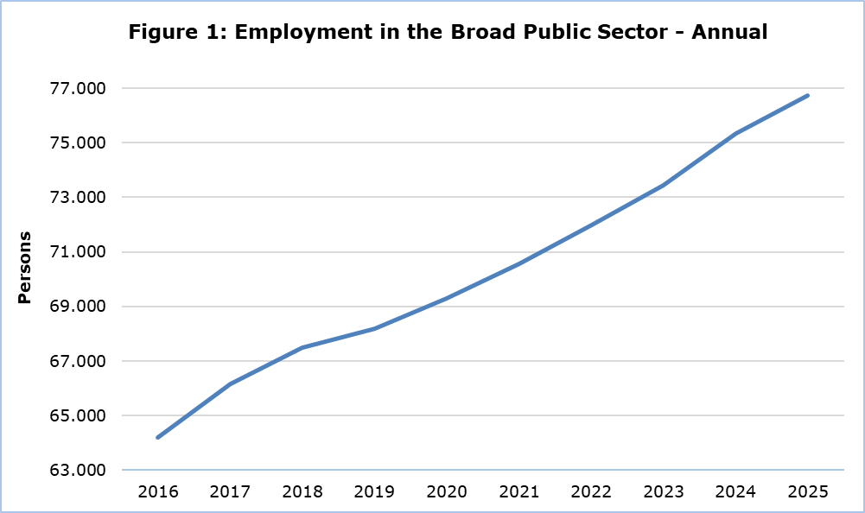

The employment in the Broad Public Sector increased by 1.287 persons (1,7%) compared to the same quarter of 2024. The employment in Central Government increased by 550 persons (0,8%), in Local Authorities by 585 persons (10,4%) and in Publicly Owned Enterprises and Companies by 152 persons (3,1%). The increase in Local Authorities’ employment is mainly attributed to the increase in District Local Government Organisations’ employment by 427 persons (48,4%). (Figure 2)

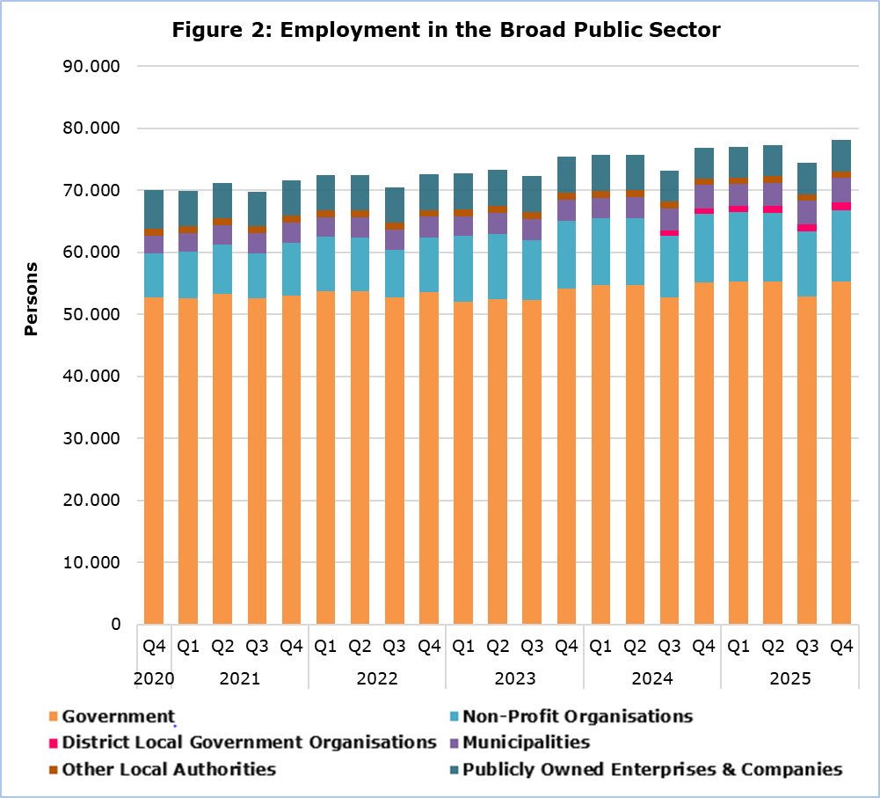

Table
 | Number of Persons |  |  |  | % Change
 | Q4 2024 | Q4 2025 | 2025 |  | Q4 2025/2024 | 2025/2024
General Government | 71.871 | 73.006 | 71.675 |  | 1,6 | 2,4
Central Government | 66.231 | 66.781 | 65.743 |  | 0,8 | 1,2
Government | 55.125 | 55.215 | 54.636 |  | 0,2 | 0,6
Non-profit Organisations | 11.106 | 11.566 | 11.107 |  | 4,1 | 4,5
Local Authorities | 5.640 | 6.225 | 5.932 |  | 10,4 | 17,6
District Local Government Organisations | 882 | 1.309 | 1.124 |  | 48,4 | 159,7
Municipalities | 3.698 | 3.856 | 3.748 |  | 4,3 | 6,4
Other Local Authorities | 1.060 | 1.060 | 1.060 |  | 0,0 | -2,8
Publicly Owned Enterprises and Companies | 4.966 | 5.118 | 5.051 |  | 3,1 | -5,8
Broad Public Sector | 76.837 | 78.124 | 76.726 |  | 1,7 | 1,8

METHODOLOGICAL INFORMATION

Coverage

The employment in the Broad Public Sector includes employment in General Government Sector and in Publicly Owned Enterprises and Companies.

General Government Sector includes Central Government and Local Authorities.

Central Government includes Government and Non-Profit Organizations. Government includes Civil Service, Educational Service, Police Service, Fire Service, Hourly Paid Workers and Military Personnel. Non-Profit Organizations include School Committees, University of Cyprus, Cyprus University of Technology, Open University, Cyprus Athletic Organization, Cyprus Theatrical Organization, Youth Organization, Investment Promotion Foundation, Symphony Orchestra Foundation, Cyprus National Addictions Authority, Bank of Cyprus Oncology Centre, Cyprus Broadcasting Corporation, Cyprus News Agency, Cyprus Agricultural Payment Organization, Cyprus Petroleum Company, Central Agency of Equal Distribution of Burden, Research and Innovation Foundation, Fauna Fund, Human Resource Development Authority, Office of the Commissioner of Electronic Communications and Postal Regulation, Cyprus Radiotelevision Authority, Cyprus Energy Regulatory Authority, Pancyprian Refugees Union, Cyprus Standard Organization, Cyprus Asset Management Company Limited, State Health Services Organization and National Betting Authority. As from January 2023, Hourly Paid Workers from the Ministry of Health (Government) have been included to the State Health Services Organisation (Non-Profit Organizations).

Local Authorities include District Local Government Organisations, Municipalities and other Local Authorities.

Publicly Owned Enterprises and Companies include: Cyprus Telecommunication Authority, Electricity Authority of Cyprus, Cyprus Port Authority, Sewerage Boards, Water Boards, Forest Industries, Cyprus Stock Exchange, Home Finance Organization, Cyprus Potato Marketing Board, Cyprus Securities and Exchange Commission, Cyprus Land Development Corporation, Cyprus Scientific and Technical Chamber, Precious Metals Engraving Organization, Council for the Registration and Control of Building Contractors, Board for the Registration of the Real Estate Agencies, Council of Commercial Agents, Cyprus Certification Company and Health Insurance Organization.

Clarifications on the Classification of Entities

1. From the first quarter of 2015 onwards Fauna Fund, Human Resource Development Authority, Office of the Commissioner of Electronic Communications and Postal Regulation, Cyprus Radiotelevision Authority, Cyprus Energy Regulatory Authority, Pancyprian Refugees Union have been moved from Publicly Owned Enterprises and Companies to Non-Profit Organizations due to revision in the classification of the organizations. Cyprus Certification Company has moved to Publicly Owned Enterprises and Companies.

2. From the first quarter of 2015 the Cyprus Institute of Energy has been moved from ‘Non-Profit Organizations’ to Government (Energy Service).

3. From the fourth quarter of 2018 in the 'Non-Profit organizations', Cyprus Asset Management Company Limited was included.

4. From the first quarter of 2019 in the 'Non-Profit Organizations', the State Health Services Organization was included.

5. From the first quarter of 2019 the Cyprus Tourism Organization has been moved from ‘Non-Profit Organizations’ to Government (Deputy Ministry of Tourism).

6. From the first quarter of 2020 the Cyprus Cultural Foundation has been moved from ‘Non-Profit Organizations’ to Government.

7. From the third quarter of 2019 the Agricultural Insurance Organization has been moved from ‘Non-Profit Organizations’ to Government.

8. From the third quarter of 2020 the Grain Commission has been moved from ‘Publicly Owned Enterprises and Companies’ to Government.

9. From the first quarter of 2022 in the 'Non-Profit organizations', the National Betting Authority was included.

10. From the third quarter of 2024 the newly established District Local Government Organisations (DLGOs) have been added in ‘Local Authorities’. Activities of Sewerage Boards and Water Boards were transferred under the jurisdiction of the DLGOs and therefore they were removed from ‘Publicly Owned Enterprises and Companies’.

Collection of Data

Data concerning employment in Government is provided by the Treasury of the Republic and refers to the number of persons that were employed in the reference quarter, while for the remaining sectors data is collected from the Organizations on a quarterly basis via a telephone survey.

For more information:
CYSTAT Portal, subtheme Labour Market
CYSTAT-DB (Online Database)
Methodological Information

Contact
Maria Kkoushi: Tel.: +357-22602235, Email: mkkoushi@cystat.mof.gov.cy

