6 June, 2025

**PRESS RELEASE**

###### EMPLOYMENT - NATIONAL ACCOUNTS: 1st QUARTER 2025 (Provisional Estimate)

**Annual Change +1,5% in Persons and +1,9% in Hours Worked**

**Persons**

Total Employment for the 1st quarter of 2025 is estimated at 497.343 persons, of which 444.635 are employees and 52.708 are self-employed.

Compared to the corresponding quarter of 2024, total employment increased by 1,5% for the 1st quarter of 2025. The most significant percentage increases were observed in the economic activities of Arts, Entertainment and Recreation (NACE R), Manufacturing (NACE C), Information and communication (NACE J) and Construction (NACE F).

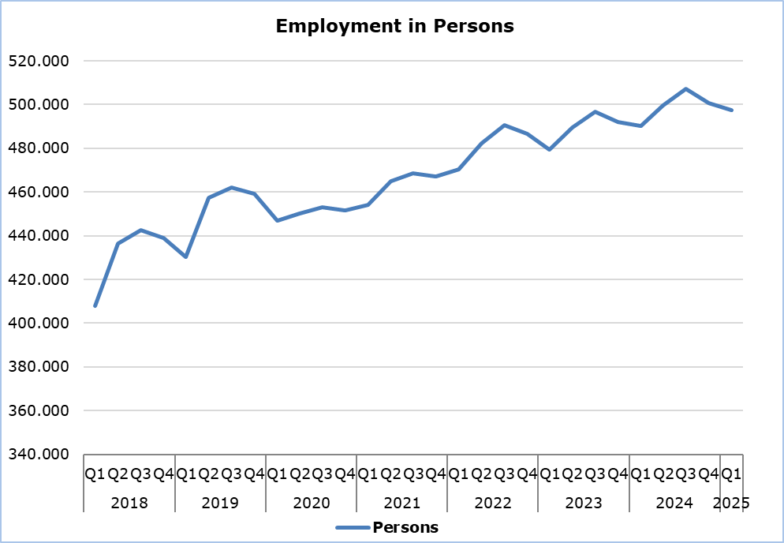

**Hours Worked**

Actual hours worked for the 1st quarter of 2025 are estimated at 230.173 thousand; an increase of 1,9% compared to the corresponding quarter of 2024. The most significant percentage increases were observed in the economic activities of Arts, Entertainment and Recreation (NACE R), Manufacturing (NACE C), Information and communication (NACE J) and Construction (NACE F).

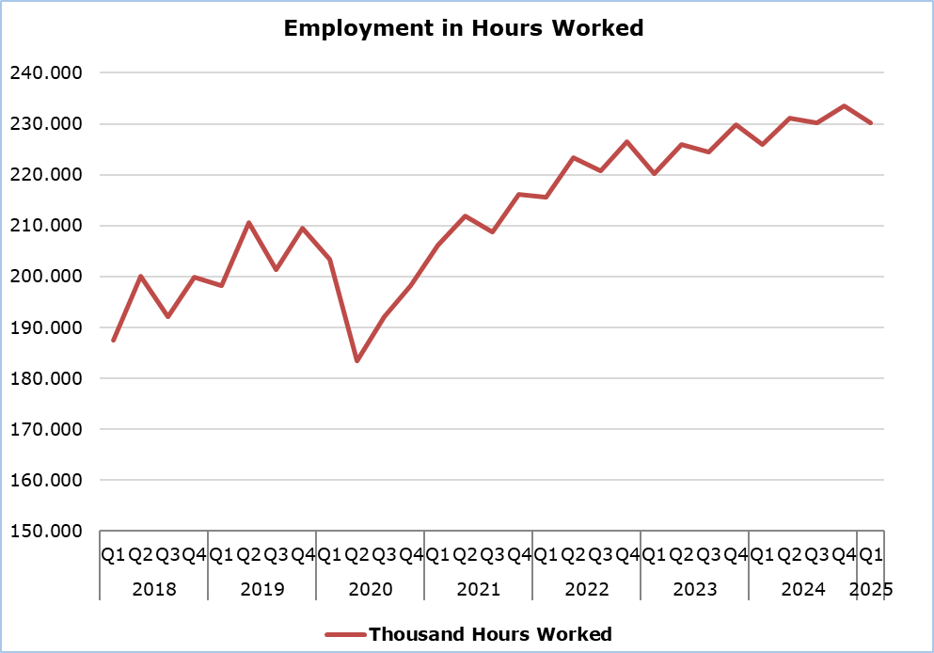

**METHODOLOGICAL NOTES**

**Data Coverage and Methodology**

Information is provided for the number of persons employed and hours worked by economic activity and professional status (self-employed and employees).

The statistical data for the number of persons employed and hours worked are given by economic activity and professional status (self-employed and employees), based on NACE Rev.2 Classification System and according to the methodology for the estimation of national accounts employment based on the European System of Accounts 2010 (ESA 2010).

**Source of Data**

In order to derive the data, the following data sources are used:

- Employment and Job Vacancies Survey,

- Labor Force Survey,

- Employment (in persons) from the Social Insurance Register,

- Treasury of the Republic of Cyprus.

***For more information:***

CYSTAT Portal, subtheme [National Accounts](https://www.cystat.gov.cy/en/SubthemeStatistics?s=45)

[CYSTAT-DB](https://cystatdb.cystat.gov.cy/pxweb/en/8.CYSTAT-DB/8.CYSTAT-DB__National%20Accounts__) (Online Database)

[Predefined Tables](https://www.cystat.gov.cy/en/KeyFiguresList?s=45) (Excel)

[Methodological Information](https://www.cystat.gov.cy/en/MethodologicalDetails?m=2150)

**The data included in the Predefined Tables in Excel format are available up to 4th Quarter 2021. Data from the 1st Quarter 2022 onwards are available only in the CYSTAT-DB Online Database.**

*Contact*

Demetriou Stavroula: Τel: +35722602205, Email: [sdemetriou@cystat.mof.gov.cy](mailto:sdemetriou@cystat.mof.gov.cy)