5 September, 2025

**PRESS RELEASE**

###### EMPLOYMENT - NATIONAL ACCOUNTS: 2nd QUARTER 2025 (Provisional Estimate)

**Annual Change +1,8% in Persons and +2,2% in Hours Worked**

**Persons**

Total Employment for the 2nd quarter of 2025 is estimated at 508.291 persons, of which 455.484 are employees and 52.807 are self-employed.

Compared to the corresponding quarter of 2024, total employment increased by 1,8% for the 2nd quarter of 2025. The most significant percentage increases were observed in the economic activities of Information and communication (NACE J), Wholesale and retail trade; repair of motor vehicles and motorcycles (NACE G) and Accommodation and food service activities (NACE I).

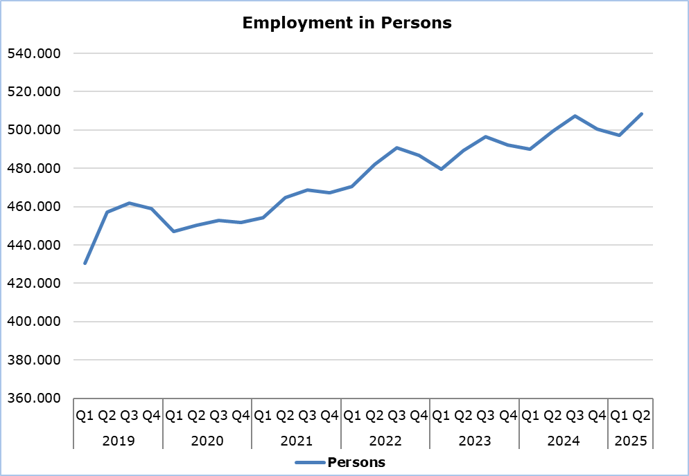

**Hours Worked**

Actual hours worked for the 2nd quarter of 2025 are estimated at 236.196 thousand; an increase of 2,2% compared to the corresponding quarter of 2024. The most significant percentage increases were observed in the economic activities of Information and communication (NACE J), Wholesale and retail trade; repair of motor vehicles and motorcycles (NACE G) and Accommodation and food service activities (NACE I).

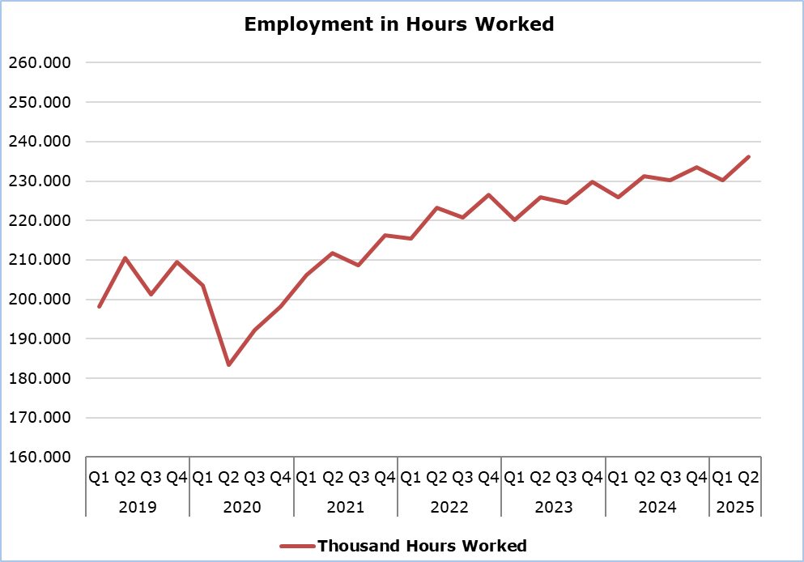

**METHODOLOGICAL NOTES**

**Data Coverage and Methodology**

Information is provided for the number of persons employed and hours worked by economic activity and professional status (self-employed and employees).

The statistical data for the number of persons employed and hours worked are given by economic activity and professional status (self-employed and employees), based on NACE Rev.2 Classification System and according to the methodology for the estimation of national accounts employment based on the European System of Accounts 2010 (ESA 2010).

**Source of Data**

In order to derive the data, the following data sources are used:

- Employment and Job Vacancies Survey,

- Labor Force Survey,

- Employment (in persons) from the Social Insurance Register,

- Treasury of the Republic of Cyprus.

***For more information:***

CYSTAT Portal, subtheme [National Accounts](https://www.cystat.gov.cy/en/SubthemeStatistics?s=45)

[CYSTAT-DB](https://cystatdb.cystat.gov.cy/pxweb/en/8.CYSTAT-DB/8.CYSTAT-DB__National%20Accounts__) (Online Database)

[Methodological Information](https://www.cystat.gov.cy/en/MethodologicalDetails?m=2150)

*Contact*

Demetriou Stavroula: Τel: +35722602205, Email: [sdemetriou@cystat.mof.gov.cy](mailto:sdemetriou@cystat.mof.gov.cy)