10 March, 2025

**PRESS RELEASE**

###### EMPLOYMENT - NATIONAL ACCOUNTS: 4th QUARTER 2024 (Provisional Estimate)

**Annual Change +1,7% in Persons and +1,7% in Hours Worked**

**Persons**

Total Employment for the 4th quarter of 2024 is estimated at 500.606 persons, of which 448.007 are employees and 52.599 are self-employed.

Compared to the corresponding quarter of 2023, total employment increased by 1,7% for the 4th quarter of 2024. The most significant percentage increases were observed in the economic activities of Arts, Entertainment and Recreation (NACE R), Accommodation and Food Service Activities (NACE I) and Information and communication (NACE J).

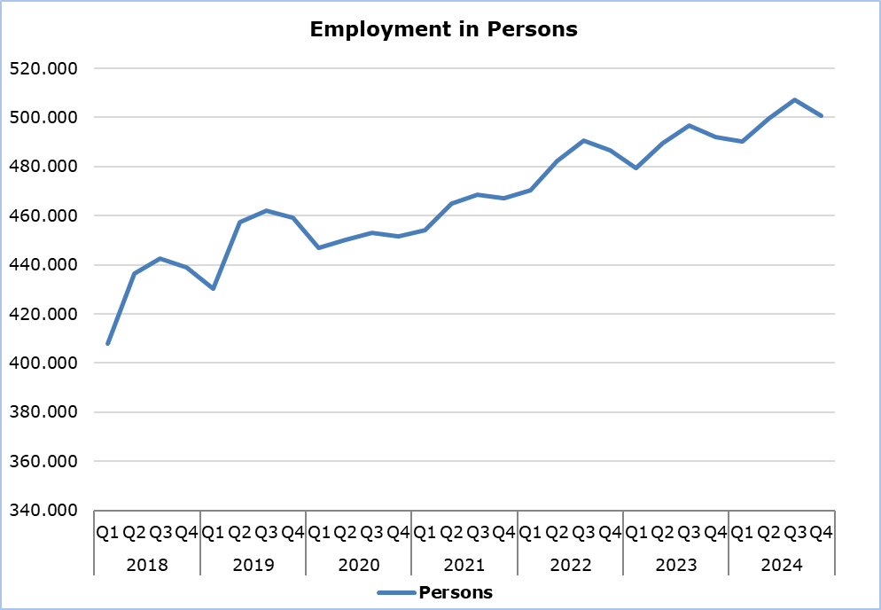

**Hours Worked**

Actual hours worked for the 4th quarter of 2024 are estimated at 233.566 thousand; an increase of 1,7% compared to the corresponding quarter of 2023. The most significant percentage increases were observed in the economic activities of Arts, Entertainment and Recreation (NACE R), Accommodation and Food Service Activities (NACE I) and Information and communication (NACE J). The Construction activities (NACE F) recorded a decrease in hours worked.

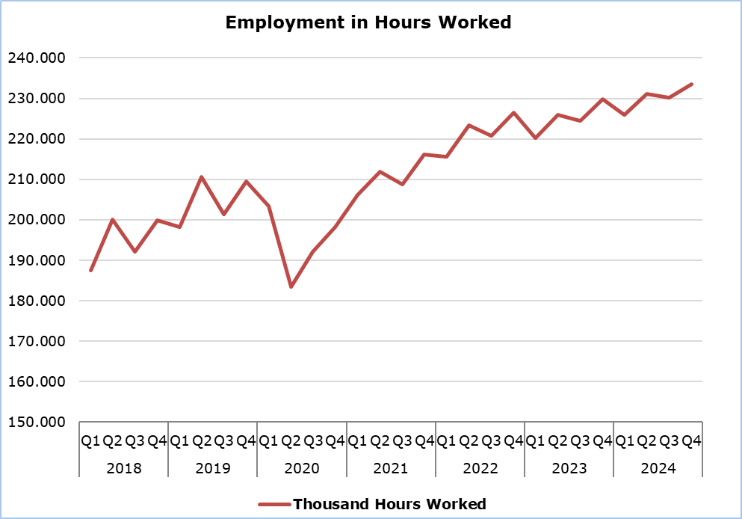

**METHODOLOGICAL NOTES**

**Data Coverage and Methodology**

Information is provided for the number of persons employed and hours worked by economic activity and professional status (self-employed and employees).

The statistical data for the number of persons employed and hours worked are given by economic activity and professional status (self-employed and employees), based on NACE Rev.2 Classification System and according to the methodology for the estimation of national accounts employment based on the European System of Accounts 2010 (ESA 2010).

**Source of Data**

In order to derive the data, the following data sources are used:

- Employment and Job Vacancies Survey,

- Labor Force Survey,

- Employment (in persons) from the Social Insurance Register,

- Treasury of the Republic of Cyprus.

***For more information:***

CYSTAT Portal, subtheme [National Accounts](https://www.cystat.gov.cy/en/SubthemeStatistics?s=45)

[CYSTAT-DB](https://cystatdb.cystat.gov.cy/pxweb/en/8.CYSTAT-DB/8.CYSTAT-DB__National%20Accounts__) (Online Database)

[Predefined Tables](https://www.cystat.gov.cy/en/KeyFiguresList?s=45) (Excel)

[Methodological Information](https://www.cystat.gov.cy/en/MethodologicalDetails?m=2150)

**The data included in the Predefined Tables in Excel format are available up to 4th Quarter 2021. Data from the 1st Quarter 2022 onwards are available only in the CYSTAT-DB Online Database.**

*Contact*

Demetriou Stavroula: Τel: +35722602205, Email: [sdemetriou@cystat.mof.gov.cy](mailto:sdemetriou@cystat.mof.gov.cy)