6 March, 2026

PRESS RELEASE

EMPLOYMENT - NATIONAL ACCOUNTS: 4th QUARTER 2025 (Provisional Estimate)

Annual Change +2,0% in Persons and +3,3% in Hours Worked

Persons

Total Employment for the 4th quarter of 2025 is estimated at 519.116 persons, of which 466.265 are employees and 52.851 are self-employed.

Compared to the corresponding quarter of 2024, total employment increased by 2,0% for the 4th quarter of 2025. The most significant percentage increases were observed in the economic activities of Wholesale and retail trade; repair of motor vehicles and motorcycles (NACE G), Construction (NACE F) and Manufacturing (NACE C).

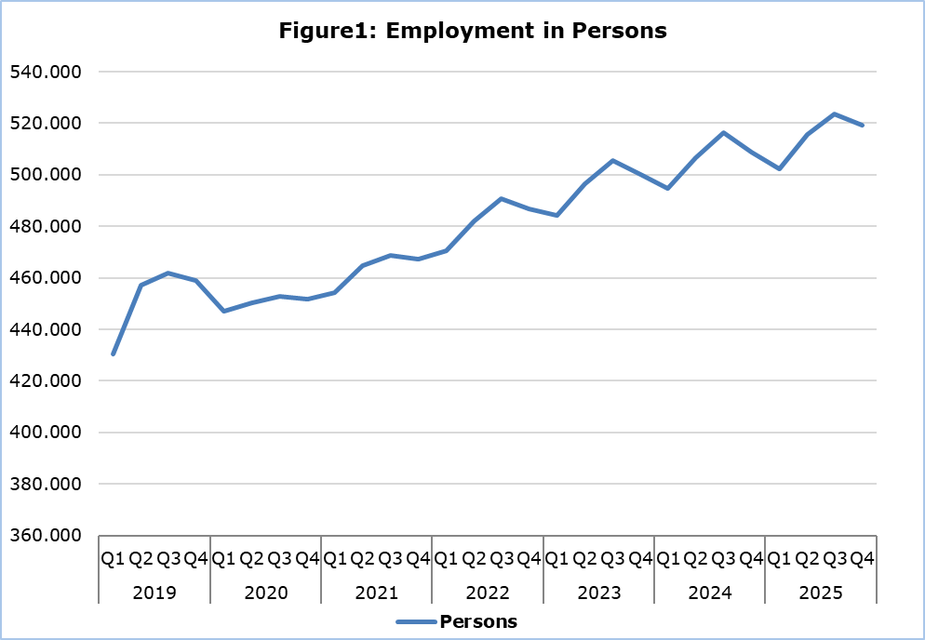

Hours Worked

Actual hours worked for the 4th quarter of 2025 are estimated at 244.170 thousand; an increase of 3,3% compared to the corresponding quarter of 2024. The most significant percentage increases were observed in the economic activities Wholesale and retail trade; repair of motor vehicles and motorcycles (NACE G), Construction (NACE F) and Manufacturing (NACE C).

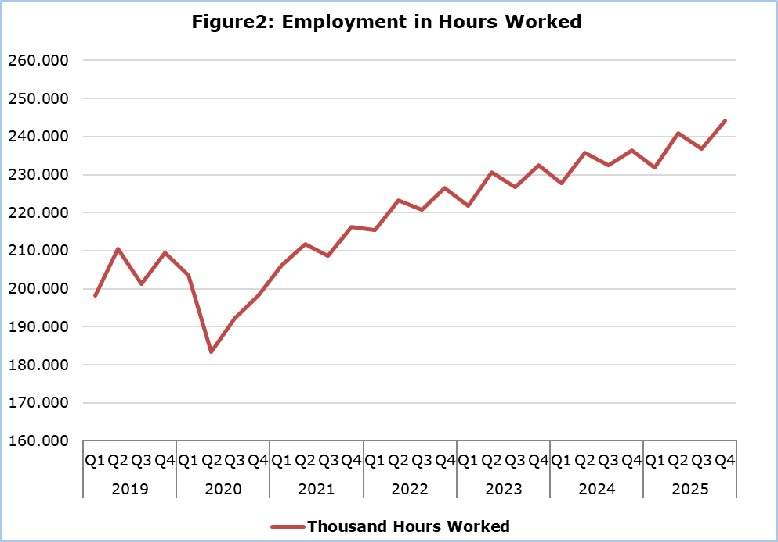

METHODOLOGICAL NOTES

Data Coverage and Methodology

Information is provided for the number of persons employed and hours worked by economic activity and professional status (self-employed and employees).

The statistical data for the number of persons employed and hours worked are given by economic activity and professional status (self-employed and employees), based on NACE Rev.2 Classification System and according to the methodology for the estimation of national accounts employment based on the European System of Accounts 2010 (ESA 2010).

Source of Data

In order to derive the data, the following data sources are used:
- Employment and Job Vacancies Survey,
- Labor Force Survey,
- Employment (in persons) from the Social Insurance Register,
- Treasury of the Republic of Cyprus.

For more information:
CYSTAT Portal, subtheme National Accounts
CYSTAT-DB (Online Database)
Methodological Information

Contact
Demetriou Stavroula: Τel: +35722602205, Email: sdemetriou@cystat.mof.gov.cy

