12 March 2024

PRESS RELEASE

ENVIRONMENTAL PROTECTION EXPENDITURES IN INDUSTRIAL ENTERPRISES: 2021

Environmental Expenditures in Industry at 0,15% of the GDP

On the basis of the results of a survey carried out by the Statistical Service, the total expenditure for environmental protection activities in industry in 2021 is estimated at €36,9 million which corresponds to 0,15% of the Gross Domestic Product, compared to €33,6 million or 0,15% of the GDP in 2020.

By sector of economic activity, the manufacturing industries reported expenditures of €32,2 million, the mining and quarrying industries and electricity supply €4,4 million and the water treatment and supply enterprises €0,2 million. In the manufacturing sector, environmental protection activities in the manufacturing of other non-metallic mineral products accounted for €13,1 million, the manufacture of food products for €11,5 million, the manufacturing of pharmaceutical products and preparations for €1,6 million and the manufacturing of chemicals and chemical products for €1,5 million.

By environmental domain, expenditure related to the reduction of air emissions accounted for €15,3 million, for the monitoring, treatment and disposal of waste €12,6 million, for the treatment of waste water €6,9 million and for other actions such as the abatement of noise and vibrations, the protection of soil and ground water and the protection of natural resources and biodiversity €2,2 million.

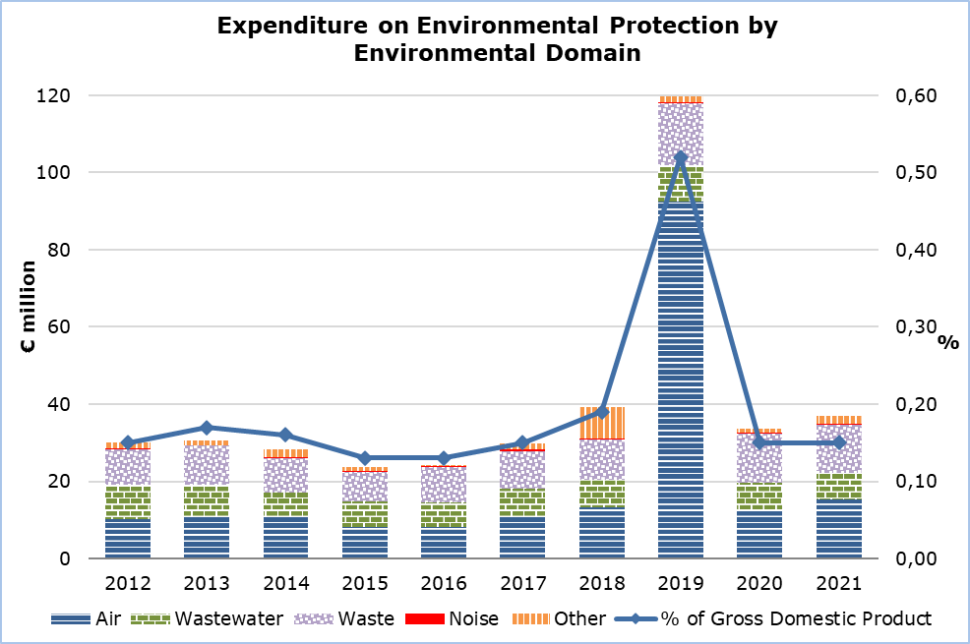

Table
Indicator | Unit | 2014 | 2015 | 2016 | 2017 | 2018 | 2019 | 2020 | 2021
Expenditure for Environmental Protection | €000’s | 28.359 | 23.670 | 24.238 | 29.789 | 39.279 | 119.595 | 33.615 | 36.900
As percentage of GDP | % | 0,16 | 0,13 | 0,13 | 0,15 | 0,18 | 0,52 | 0,15 | 0,15
Air | €000’s | 10.646 | 8.261 | 8.165 | 10.940 | 13.314 | 92.553 | 12.254 | 15.280
Wastewater | " | 6.426 | 6.468 | 6.289 | 7.082 | 6.999 | 9.318 | 7.454 | 6.898
Waste | " | 9.029 | 7.725 | 9.278 | 9.886 | 10.440 | 16.181 | 12.771 | 12.550
Noise | " | 148 | 109 | 148 | 278 | 297 | 203 | 208 | 183
Other | " | 2.109 | 1.107 | 358 | 1.603 | 8.230 | 1.340 | 927 | 1.989

METHODOLOGICAL INFORMATION

Definitions

Environmental protection: is defined as any action or activity whose main purpose is the collection, treatment, reduction, prevention or elimination of pollution and pollutants or any other degradation of the environment resulting from the operating activity of an enterprise.

All actions and activities where the primary function is environmental protection are included, regardless of whether they are undertaken in response to environmental legislation, to meet demands of customers, to improve company image, etc. However, actions and activities that are beneficial to the environment but whose main purpose is not environmental protection and have been taken regardless of environmental protection considerations are excluded.

Examples of such activities are: treatment of waste and waste water, elimination or reduction of emissions of air pollutants, protection of soils and ground water, abatement or reduction of noise and vibration, protection of natural resources and biodiversity, as well as the monitoring of the quality of the environment and the control of waste production etc.

Environmental protection expenditure: is the sum of capital investments and current expenditures for the undertaking of environmental protection activities.

For more information:
CYSTAT Portal, subtheme Environment
Predefined Tables (Excel)
Methodological Information

Contact
Marilena Kythreotou: Tel.: +357 22602137, Email: mkythreotou@cystat.mof.gov.cy
Nafsika Apostolou: Tel.: +357 22602199, Email: napostolou@cystat.mof.gov.cy

