31 October, 2025

PRESS RELEASE

ANNUAL FINANCIAL ACCOUNTS (STOCKS) BY INSTITUTIONAL SECTOR: 2024

Annual Financial Net Worth -€29.269,3 mn

Total Economy
The total assets of the economy in financial instruments amounted to €795.274,6 mn at the end of December 2024, of which 50,3% relates to equities and shares, 17,2% to currency and deposits and 18,8% to loans.

The total liabilities of the economy in financial instruments amounted to €824.543,9 mn at the end of December 2024, of which 50,8% relates to equities and shares, 25,0% to loans and 12,1% to currency and deposits.

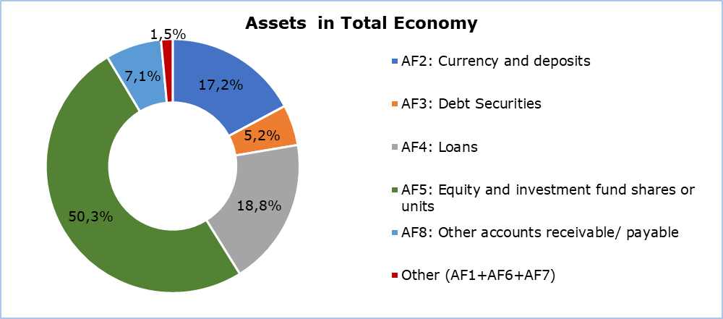

Households and Non-financial Corporations
The assets of households in financial instruments amounted to €61.340,8 mn at the end of December 2024, of which 53,0% consists of currency and deposits, 0,8% in loans, 3,6% in debt securities and 24,8% in equities. The amount of loans for this sector reached 19.871,2 mn, at the end of December 2024, with a debt-to-Gross Domestic Product (GDP) ratio of 57,2%.

The corresponding assets of non-financial corporations amounted to €70.484,5 mn, with 20,6% in cash and deposits, 6,9% in loans, 0,7% in debt securities, 37,7% in equities and 32,6% in other financial instruments. The amount of loans for this sector at the end of December 2024 reached €41.577,8 mn, with a debt-to-GDP ratio of 119,6%.

Table
Financial Instruments (Stocks) | Institutional Sectors 2024 (€mn)
Financial Instruments (Stocks) | Total Economy | Non-Financial Corporations | Financial Corporations | General Government | Households | Non-profit institutions | Rest of the word
Financial assets | 795.274,6 | 70.484,5 | 630.414,9 | 32.308,1 | 61.340,8 | 726,4 | 592.751,7
AF1 | 1.659,6 | n.a | 1.659,6 | 0,0 | n.a | n.a | 1.659,6
AF2 | 136.632,1 | 14.553,2 | 68.885,7 | 20.181,2 | 32.512,0 | 500,2 | 49.546,9
AF3 | 41.053,9 | 478,4 | 38.194,0 | 142,2 | 2.221,5 | 17,8 | 31.931,5
AF4 | 149.492,7 | 4.877,0 | 139.288,9 | 4.794,8 | 516,0 | 16,0 | 109.189,0
AF5 | 399.667,9 | 27.255,6 | 353.184,4 | 3.835,9 | 15.240,0 | 152,0 | 368.078,5
AF6 | 9.230,5 | 328,5 | 855,2 | 0,0 | 8.046,8 | 0,0 | 379,2
AF7 | 824,1 | 13,9 | 810,2 | 0,0 | 0,0 | 0,0 | 773,1
AF8 | 56.713,7 | 22.977,9 | 27.536,8 | 3.354,0 | 2.804,6 | 40,4 | 31.193,9
Financial liabilities | 824.543,9 | 125.559,3 | 633.676,4 | 40.588,2 | 24.623,0 | 97,0 | 622.021,0
AF1 | 532,0 | n.a | 532,0 | n.a | n.a | n.a | 532,0
AF2 | 99.609,8 | n.a | 85.142,8 | 14.467,0 | n.a | n.a | 12.524,6
AF3 | 25.941,0 | 90,0 | 13.460,4 | 12.390,6 | 0,0 | 0,0 | 16.818,6
AF4 | 206.111,2 | 41.577,8 | 135.413,7 | 9.151,5 | 19.871,2 | 97,0 | 165.807,5
AF5 | 418.464,7 | 63.765,6 | 354.690,2 | 8,9 | 0,0 | 0,0 | 386.875,3
AF6 | 9.442,9 | 405,0 | 8.536,8 | 501,1 | 0,0 | 0,0 | 591,6
AF7 | 710,2 | 0,6 | 709,6 | 0,0 | 0,0 | 0,0 | 659,2
AF8 | 63.732,0 | 19.720,3 | 35.190,9 | 4.069,0 | 4.751,8 | 0,0 | 38.212,2
Financial net worth | -29.269,3 | -55.074,8 | -3.261,5 | -8.280,1 | 36.717,8 | 629,4 | 29.269,3
n.a.: Not applicable
Financial Instruments:
AF1: Monetary gold and special drawing rights
AF2: Currency and deposits
AF3: Debt Securities
AF4: Loans
AF5: Equity and investment fund shares or units
AF6: Insurance, pension and standardized guarantee schemes
AF7: Financial Derivatives and employee stock options
AF8: Other accounts receivable/ payable

METHODOLOGICAL INFORMATION

Scope Description

The Annual Financial Accounts (AFA) record financial positions and transactions that involve financial assets and liabilities that have taken place between residents and non-residents. Cross-border financial transactions and positions are further classified by type of instrument and institutional sector.

Method

The compilation of AFA relies on the following primary sources which are fully compliant with European System of Accounts (ESA 2010) and produced on the basis of European Central Bank:

1. MFI Balance Sheets statistics
2. Investment Fund Balance sheet statistics
3. Insurance statistics
4. Pension Fund Statistics
5. Securities issues statistics
6. Securities Holdings statistics (SHS)
7. Quarterly Financial Accounts of General Government
8. International Investment Position and Balance of Payments

Also, financial statements are collected from entities that are included in the OFI (Other Financial Institutions) sector. For the Non-financial sector, information is derived from annual financial statements and mapped to the ESA 2010 instruments, to the best possible extent. For Household some instruments are compiled mainly on a residual basis.

Data Coverage

Inclusion of all financial and non-financial corporations, investment funds, insurance companies, pension funds and organizations that are included in the OFI sector. Also, the inclusion of General Government Sector divided to its subsectors.

For more information:
CYSTAT Portal, subtheme National Accounts
CYSTAT-DB (Online Database)
Methodological Information

Contact
Sofia Panagidou: Tel:+ 35722605119, Email.: spanayidou@cystat.mof.gov.cy
Katerina Kyriakou: Tel:+ 35722602202, Email.: kkyriakou@cystat.mof.gov.cy

