8 October, 2024

PRESS RELEASE

FISCAL ACCOUNTS OF GENERAL GOVERNMENT: JAN-AUG 2024

Surplus €1.368,4 mn

The preliminary General Government fiscal results, which are prepared by the Statistical Service of Cyprus (CYSTAT) indicate a surplus of €1.368,4 mn (4,3% of GDP) for the period of January-August 2024, as compared to a surplus of €898,5 mn (3,0% of GDP) that was recorded during the period of January-August 2023.

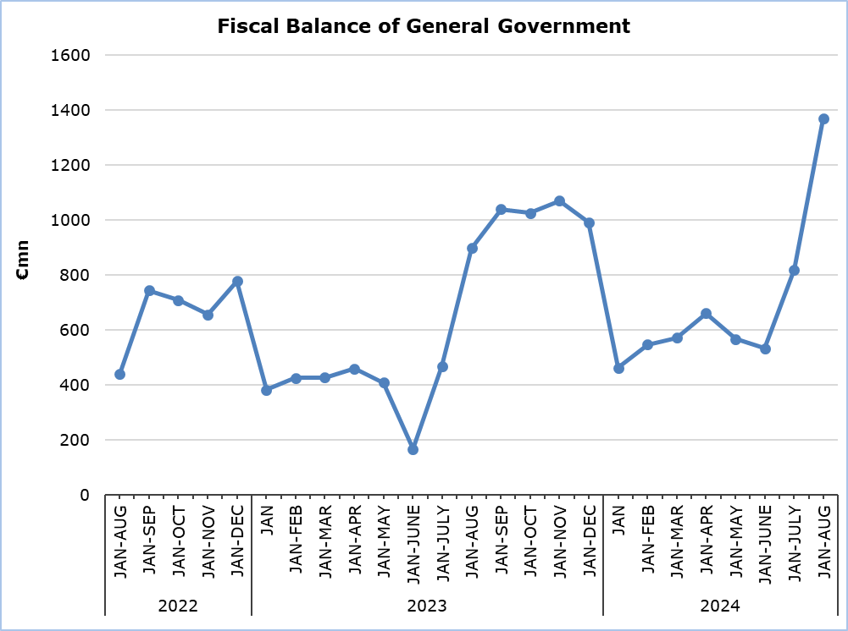

Revenue

During the period of January-August 2024, total revenue increased by €1.073,4 mn (+13,0%) and amounted to €9.298,9 mn, compared to €8.225,5 mn in the corresponding period of 2023.

In detail, taxes on production and imports increased by €275,4 mn (+9,8%) and amounted to €3.073,3 mn, compared to €2.797,9 mn in 2023, of which net VAT revenue increased by €247,2 mn (+13,6%) and amounted to €2.070,1 mn, compared to €1.822,9 mn in 2023. Revenue from taxes on income and wealth increased by €371,7 mn (+17,3%) and amounted to €2.517,7 mn, compared to €2.146,0 mn in 2023. Social contributions increased by €365,7 mn (+15,7%) and amounted to €2.694,1 mn, compared to €2.328,4 mn in 2023. Property income increased by €21,4 mn (+31,1%) and amounted to €90,3 mn, compared to €68,9 mn in 2023. Revenue from the sale of goods and services increased by €143,4 mn (+30,2%) and amounted to €618,4 mn, compared to €475,0 mn in 2023.

On the contrary, current transfers decreased by €71,4 mn (-23,5%) to €232,9 mn, from €304,3 mn in 2023. Capital transfers decreased by €32,8 mn (-31,2%) to €72,2 mn, from €105,0 mn in 2023.

Expenditure

During the period of January-August 2024, total expenditure increased by €603,5 mn (+8,2%) and amounted to €7.930,5 mn, compared to €7.327,0 mn in the corresponding period of 2023.

In detail, intermediate consumption increased by €49,9 mn (+6,5%) and amounted to €818,2 mn, compared to €768,3 mn in 2023. Compensation of employees (including imputed social contributions and pensions of civil servants) increased by €262,4 mn (+12,0%) and amounted to €2.454,1 mn, compared to €2.191,7 mn in 2023. Social benefits increased by €242,3 mn (+8,4%) and amounted to €3.132,1 mn, compared to €2.889,8 mn in 2023. Current transfers increased by €117,3 mn (+23,6%) and amounted to €614,9 mn, compared to €497,6 mn in 2023. Interest payable increased by €37,0 mn (+14,2%) and amounted to €298,6 mn, compared to €261,6 mn in 2023.

The capital account decreased by €74,3 mn (-12,4%) to €526,0 mn, from €600,3 mn in 2023, of which gross capital formation decreased by €69,4 mn (-13,9%) to €429,3 mn, from €498,7 mn in 2023 and other capital expenditure decreased by €4,9 mn (-4,8%) to €96,7 mn, from €101,6 mn in 2023.

On the contrary, subsidies decreased by €31,2 mn (-26,5%) to €86,6 mn, from €117,8 mn in 2023.

Table
Macroeconomic Aggregates of General Government | Euro (million) |  |  |  |  |  |  | Change
Macroeconomic Aggregates of General Government | Fiscal Results |  |  | Difference |  |  |  | (%)
Macroeconomic Aggregates of General Government | Jan-Aug 2023 | Jan- Aug 2024 |  | Jan- Aug 2024/23 |  |  |  | Jan- Aug 2024/23
Total Revenue | 8.225,5 | 9.298,9 |  |  | 1.073,4 |  |  |  | 13,0%
Taxes on Production and Imports | 2.797,9 | 3.073,3 |  |  | 275,4 |  |  |  | 9,8%
of which VAT | 1.822,9 | 2.070,1 |  |  | 247,2 |  |  |  | 13,6%
Current Taxes on Income and Wealth, etc | 2.146,0 | 2.517,7 |  |  | 371,7 |  |  |  | 17,3%
Social Contributions | 2.328,4 | 2.694,1 |  |  | 365,7 |  |  |  | 15,7%
Other Current Resources | 848,2 | 941,6 |  |  | 93,4 |  |  |  | 11,0%
Interest receivable | 68,9 | 90,3 |  |  | 21,4 |  |  |  | 31,1%
Current transfers | 304,3 | 232,9 |  |  | -71,4 |  |  |  | -23,5%
Sales | 475,0 | 618,4 |  |  | 143,4 |  |  |  | 30,2%
Capital Transfers Received | 105,0 | 72,2 |  |  | -32,8 |  |  |  | -31,2%
Total Expenditure | 7.327,0 | 7.930,5 |  |  | 603,5 |  |  |  | 8,2%
Total Current Expenditure | 6.726,7 | 7.404,5 |  |  | 677,8 |  |  |  | 10,1%
Intermediate consumption | 768,3 | 818,2 |  |  | 49,9 |  |  |  | 6,5%
Compensation of employees | 2.191,7 | 2.454,1 |  |  | 262,4 |  |  |  | 12,0%
Social transfers | 2.889,8 | 3.132,1 |  |  | 242,3 |  |  |  | 8,4%
Interest | 261,6 | 298,6 |  |  | 37,0 |  |  |  | 14,2%
Subsidies | 117,8 | 86,6 |  |  | -31,2 |  |  |  | -26,5%
Other current expenditure | 497,6 | 614,9 |  |  | 117,3 |  |  |  | 23,6%
Total Capital Expenditure | 600,3 | 526,0 |  |  | -74,3 |  |  |  | -12,4%
Gross capital formation | 498,7 | 429,3 |  |  | -69,4 |  |  |  | -13,9%
Gross capital formation excluding land annexations | 489,9 | 411,2 |  |  | -78,7 |  |  |  | -16,1%
Other capital expenditure | 101,6 | 96,7 |  |  | -4,9 |  |  |  | -4,8%
Net Lending (+)/ Borrowing (-) | 898,5 | 1.368,4 |  |  | 469,9
% of GDP | 3,0% | 4,3%

METHODOLOGICAL INFORMATION

Data Coverage and Methodology

Information is provided for the whole sequence of accounts for the General Government sector. The revenue and expenditure are analyzed by category and these are classified between current and capital, respectively.

The categories of revenue and expenditure for General Government cover all the subsectors of the General Government based on the European System of Accounts 2010 (ESA 2010).

Source of Data

The data is collected from:
- Financial Information Management Automation System (FIMAS) for Central Government, Extra Budgetary Funds and Social Security Funds,
- Budget execution of Municipalities and Communities,
- Budget execution of Semi-Government Organizations.

For the completion of the estimates, any methodological adjustments or corrections based on the European System of Accounts 2010 (ESA 2010) are taken into account.

For more information:
CYSTAT Portal, subtheme Public Finance
Predefined Tables (Excel)

Contact
Michael Panayiota: Τel: +35722602186, Email: pmichael@cystat.mof.gov.cy

