10 October, 2025

**PRESS RELEASE**

FISCAL ACCOUNTS OF GENERAL GOVERNMENT: **JAN-AUG 2025**

**Surplus €1.395,7 mn**

The preliminary General Government fiscal results, which are prepared by the Statistical Service of Cyprus (CYSTAT) indicate a surplus of €1.395,7 mn (4,0% of GDP) for the period of January-August 2025, as compared to a surplus of €1.328,9 mn (4,0% of GDP) that was recorded during the period of January-August 2024.

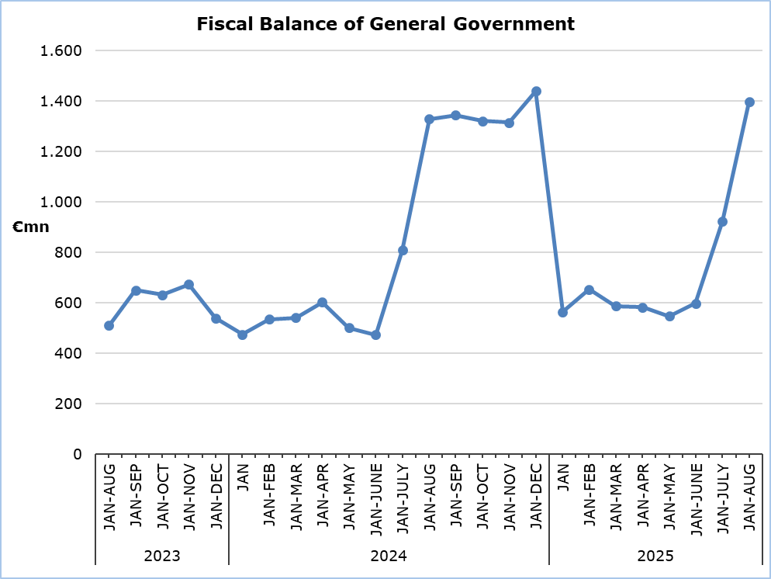

**Revenue**

During the period of January-August 2025, total revenue increased by €641,1 mn (+6,8%) and amounted to €10.102,3 mn, compared to €9.461,2 mn in the corresponding period of 2024.

In detail, revenue from taxes on income and wealth increased by €178,3 mn (+7,1%) and amounted to €2.696,0 mn, compared to €2.517,7 mn in 2024. Social contributions increased by €243,8 mn (+8,4%) and amounted to €3.136,5 mn, compared to €2.892,7 mn in 2024. Property income increased by €57,4 mn and amounted to €121,8 mn, compared to €64,4 mn in 2024. Taxes on production and imports increased by €41,0 mn (+1,3%) and amounted to €3.148,2 mn, compared to €3.107,2 mn in 2024, of which net VAT revenue increased by €47,7 mn (+2,3%) and amounted to €2.117,8 mn, compared to €2.070,1 mn in 2024. Revenue from the sale of goods and services increased by €97,8 mn (+17,7%) and amounted to €651,6 mn, compared to €553,8 mn in 2024. Capital transfers increased by €45,8 mn (+65,7%) and amounted to €115,5 mn, compared to €69,7 mn in 2024.

On the contrary, current transfers decreased by €22,9 mn (-9,0%) to €232,7 mn, from €255,6 mn in 2024.

**Expenditure**

During the period of January-August 2025, total expenditure increased by €574,3 mn (+7,1%) and amounted to €8.706,6 mn, compared to €8.132,3 mn in the corresponding period of 2024.

In detail, compensation of employees (including imputed social contributions and pensions of civil servants) increased by €149,3 mn (+6,2%) and amounted to €2.544,0 mn, compared to €2.394,7 mn in 2024. Social benefits increased by €231,1 mn (+6,8%) and amounted to €3.622,8 mn, compared to €3.391,7 mn in 2024. Intermediate consumption increased by €84,6 mn (+10,1%) and amounted to €920,1 mn, compared to €835,5 mn in 2024.

The capital account increased by €131,8 mn (+22,9%) and amounted to €707,0 mn, compared to €575,2 mn in 2024, of which gross capital formation increased by €92,9 mn (+19,2%) and amounted to €576,7 mn, compared to €483,8 mn in 2024 and other capital expenditure increased by €38,9 mn (+42,6%) and amounted to €130,3 mn, compared to €91,4 mn in 2024.

On the contrary, interest payable decreased by €2,9 mn (-1,0%) to €287,7 mn, from €290,6 mn in 2024. Current transfers decreased by €16,6 mn (-3,1%) to €527,0 mn, from €543,6 mn in 2024. Subsidies decreased by €3,0 mn (-3,0%) to €98,0 mn, from €101,0 mn in 2024.

**Important Notice**

It is emphasized that for a number of entities of the General Government and specifically for the Local Government Subsector, estimates have been produced by the Statistical Service, due to non-submission of sufficient data by the competent authorities.

|  |  |  |  |  |  |  |  |  |  |  |
| --- | --- | --- | --- | --- | --- | --- | --- | --- | --- | --- |
| **Table 1** | |  |  |  |  | |  | |  | |
| **Macroeconomic Aggregates of General Government** | | **Euro (million)** | | | | |  | | **Change** | |
| **Fiscal Results** | |  | **Difference** | |  | | **(%)** | |
| **Jan-Aug**  **2024** | **Jan-Aug 2025** |  | **Jan-Aug 2025/24** | |  | | **Jan-Aug 2025/24** | |
| **Total Revenue** | **9.461,2** | | **10.102,3** |  | | **641,1** | |  | | **6,8** | |
| Taxes on Production and Imports | 3.107,2 | | 3.148,2 |  | | 41,0 | |  | | 1,3 | |
| *of which VAT* | 2.070,1 | | 2.117,8 |  | | 47,7 | |  | | 2,3 | |
| Current Taxes on Income and Wealth, etc | 2.517,7 | | 2.696,0 |  | | 178,3 | |  | | 7,1 | |
| Social Contributions | 2.892,7 | | 3.136,5 |  | | 243,8 | |  | | 8,4 | |
| Other Current Resources | 873,9 | | 1.006,1 |  | | 132,2 | |  | | 15,1 | |
| Property income | 64,4 | | 121,8 |  | | 57,4 | |  | | 89,1 | |
| Current transfers | 255,6 | | 232,7 |  | | -22,9 | |  | | -9,0 | |
| Sales | 553,8 | | 651,6 |  | | 97,8 | |  | | 17,7 | |
| Capital Transfers Received | 69,7 | | 115,5 |  | | 45,8 | |  | | 65,7 | |
| **Total Expenditure** | **8.132,3** | | **8.706,6** |  | | **574,3** | |  | | **7,1** | |
| Total Current Expenditure | 7.557,1 | | 7.999,6 |  | | 442,5 | |  | | 5,9 | |
| Intermediate consumption | 835,5 | | 920,1 |  | | 84,6 | |  | | 10,1 | |
| Compensation of employees | 2.394,7 | | 2.544,0 |  | | 149,3 | |  | | 6,2 | |
| Social transfers | 3.391,7 | | 3.622,8 |  | | 231,1 | |  | | 6,8 | |
| Interest | 290,6 | | 287,7 |  | | -2,9 | |  | | -1,0 | |
| Subsidies | 101,0 | | 98,0 |  | | -3,0 | |  | | -3,0 | |
| Other current expenditure | 543,6 | | 527,0 |  | | -16,6 | |  | | -3,1 | |
| Total Capital Expenditure | 575,2 | | 707,0 |  | | 131,8 | |  | | 22,9 | |
| Gross capital formation | 483,8 | | 576,7 |  | | 92,9 | |  | | 19,2 | |
| *Gross capital formation* *excluding land annexations* | 465,8 | | 560,9 |  | | 95,1 | |  | | 20,4 | |
| Other capital expenditure | 91,4 | | 130,3 |  | | 38,9 | |  | | 42,6 | |
| **Net Lending (+)/ Borrowing (-)** | | **1.328,9** | **1.395,7** |  | | **66,8** | |  | |  | |
| % of GDP | | *4,0%* | *4,0%* |  | |  | |  | |  | |

The Net Lending/Borrowing of the General Government for the period of January-August 2025 and 2024, respectively, which is presented above, is analysed as follows:

|  |  |  |
| --- | --- | --- |
| **Table 2** |  |  |
| **Net Lending (+)/ Borrowing (-) by Subsector of the General Government** | **Jan-Aug 2024**  **(€ mn)** | **Jan-Aug 2025**  **(€ mn)** |
| Central Government | 432,3 | 622,0 |
| Local Government | 14,6 | -32,7 |
| Social Security Funds | 881,9 | 806,4 |
| **General Government** | **1.328,9** | **1.395,7** |

**METHODOLOGICAL INFORMATION**

**Data Coverage and Methodology**

Information is provided for the whole sequence of accounts for the General Government sector. The revenue and expenditure are analyzed by category and these are classified between current and capital, respectively.

The categories of revenue and expenditure for General Government cover all the subsectors of the General Government based on the European System of Accounts 2010 (ESA 2010).

**Source of Data**

The data is collected from:

- Financial Information Management Automation System (FIMAS) for Central Government, Extra Budgetary Funds and Social Security Funds,

- Budget execution of Municipalities and Communities,

- Budget execution of Semi-Government Organizations.

For the completion of the estimates, any methodological adjustments or corrections based on the European System of Accounts 2010 (ESA 2010) are taken into account.

***For more information:***

CYSTAT Portal, subtheme [Public Finance](https://www.cystat.gov.cy/en/SubthemeStatistics?id=48)

[Predefined Tables](https://www.cystat.gov.cy/en/KeyFiguresList?s=48) (Excel)

*Contact*

Pantziaras Michalis: Τel: +35722605127, Email: [MPantziaras@cystat.mof.gov.cy](mailto:MPantziaras@cystat.mof.gov.cy)