4 March, 2025

**PRESS RELEASE**

FISCAL ACCOUNTS OF GENERAL GOVERNMENT: **JAN-DEC 2024**

**Surplus €1.507,8 mn**

The preliminary General Government fiscal results, which are prepared by the Statistical Service of Cyprus (CYSTAT) indicate a surplus of €1.507,8 mn (4,5% of GDP) for the period of January-December 2024, as compared to a surplus of €631,5 mn (2,0% of GDP) that was recorded during the period of January-December 2023.

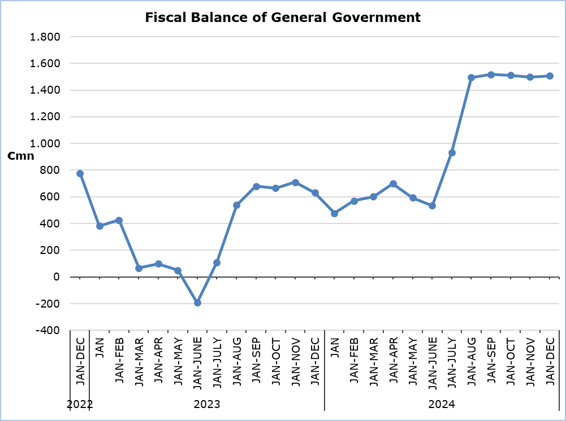

**Revenue**

During the period of January-December 2024, total revenue increased by €1.073,7 mn (+7,8%) and amounted to €14.835,5 mn, compared to €13.761,8 mn in the corresponding period of 2023.

In detail, taxes on production and imports increased by €244,4 mn (+5,5%) and amounted to €4.686,8 mn, compared to €4.442,4 mn in 2023, of which net VAT revenue increased by €166,2 mn (+5,6%) and amounted to €3.145,0 mn, compared to €2.978,8 mn in 2023. Revenue from taxes on income and wealth increased by €545,2 mn (+16,7%) and amounted to €3.810,1 mn, compared to €3.264,9 mn in 2023. Property income increased by €6,1 mn (+4,4%) and amounted to €143,6 mn, compared to €137,5 mn in 2023. Revenue from the sale of goods and services increased by 240,0 mn (+28,1%) and amounted to €1.093,4 mn, compared to €853,4 mn in 2023. Social contributions increased by €119,5 mn (+2,7%) and amounted to €4.500,0 mn, compared to €4.380,5 mn in 2023. Current transfers increased by €56,0 mn (+17,2%) and amounted to €381,2 mn, compared to €325,2 mn in 2023.

On the contrary, capital transfers decreased by €137,5 mn (-38,4%) to €220,4 mn, from €357,9 mn in 2023.

**Expenditure**

During the period of January-December 2024, total expenditure increased by €197,4 mn (+1,5%) and amounted to €13.327,6 mn, compared to €13.130,2 mn in the corresponding period of 2023.

In detail, intermediate consumption increased by €205,6 mn (+15,8%) and amounted to €1.507,3 mn, compared to €1.301,7 mn in 2023. Compensation of employees (including imputed social contributions and pensions of civil servants) increased by €269,4 mn (+7,5%) and amounted to €3.861,3 mn, compared to €3.591,9 mn in 2023. Social benefits increased by €366,2 mn (+7,4%) and amounted to €5.307,5 mn, compared to €4.941,3 mn in 2023. Interest payable increased by €25,7 mn (+6,3%) and amounted to €433,9 mn, compared to €408,2 mn in 2023.

On the contrary, subsidies decreased by €5,7 mn (-3,6%) to €153,4 mn, from €159,1 mn in 2023. Current transfers decreased by €282,7 mn (-24,2%) to €887,7 mn, from €1.170,4 mn in 2023.

The capital account decreased by €381,2 mn (-24,5%) to €1.176,5 mn, from €1.557,7 mn in 2023, of which gross capital formation decreased by €1,6 mn (-0,2%) to €983,0 mn, from €984,6 mn in 2023 and other capital expenditure decreased by €379,6 mn (-66,2%) to €193,5 mn, from €573,1 mn in 2023.

**Important Notice**

It is emphasized that for the Local Government Subsector, estimates have been produced by the Statistical Service, due to non-submission of sufficient data by the competent authorities for the District Self-Government Organizations of Famagusta and Pafos (activities related to drainage, water supply, licensing and waste management).

|  |  |  |  |  |  |  |  |  |  |  |
| --- | --- | --- | --- | --- | --- | --- | --- | --- | --- | --- |
| **Table 1** | |  |  |  |  | |  | |  | |
| **Macroeconomic Aggregates of General Government** | | **Euro (million)** | | | | |  | | **Change** | |
| **Fiscal Results** | |  | **Difference** | |  | | **(%)** | |
| **Jan-Dec 2023** | **Jan-Dec 2024** |  | **Jan-Dec 2024/23** | |  | | **Jan-Dec 2024/23** | |
| **Total Revenue** | **13.761,8** | | **14.835,5** |  | | **1.073,7** | |  | | **7,8%** | |
| Taxes on Production and Imports | 4.442,4 | | 4.686,8 |  | | 244,4 | |  | | 5,5% | |
| *of which VAT* | 2.978,8 | | 3.145,0 |  | | 166,2 | |  | | 5,6% | |
| Current Taxes on Income and Wealth, etc | 3.264,9 | | 3.810,1 |  | | 545,2 | |  | | 16,7% | |
| Social Contributions | 4.380,5 | | 4.500,0 |  | | 119,5 | |  | | 2,7% | |
| Other Current Resources | 1.316,1 | | 1.618,2 |  | | 302,1 | |  | | 23,0% | |
| Interest receivable | 137,5 | | 143,6 |  | | 6,1 | |  | | 4,4% | |
| Current transfers | 325,2 | | 381,2 |  | | 56,0 | |  | | 17,2% | |
| Sales | 853,4 | | 1.093,4 |  | | 240,0 | |  | | 28,1% | |
| Capital Transfers Received | 357,9 | | 220,4 |  | | -137,5 | |  | | -38,4% | |
| **Total Expenditure** | **13.130,2** | | **13.327,6** |  | | **197,4** | |  | | **1,5%** | |
| Total Current Expenditure | 11.572,5 | | 12.151,1 |  | | 578,6 | |  | | 5,0% | |
| Intermediate consumption | 1.301,7 | | 1.507,3 |  | | 205,6 | |  | | 15,8% | |
| Compensation of employees | 3.591,9 | | 3.861,3 |  | | 269,4 | |  | | 7,5% | |
| Social transfers | 4.941,3 | | 5.307,5 |  | | 366,2 | |  | | 7,4% | |
| Interest | 408,2 | | 433,9 |  | | 25,7 | |  | | 6,3% | |
| Subsidies | 159,1 | | 153,4 |  | | -5,7 | |  | | -3,6% | |
| Other current expenditure | 1.170,4 | | 887,7 |  | | -282,7 | |  | | -24,2% | |
| Total Capital Expenditure | 1.557,7 | | 1.176,5 |  | | -381,2 | |  | | -24,5% | |
| Gross capital formation | 984,6 | | 983,0 |  | | -1,6 | |  | | -0,2% | |
| *Gross capital formation* *excluding land annexations* | 954,9 | | 944,7 |  | | -10,2 | |  | | -1,1% | |
| Other capital expenditure | 573,1 | | 193,5 |  | | -379,6 | |  | | -66,2% | |
| **Net Lending (+)/ Borrowing (-)** | | **631,5** | **1.507,8** |  | | **876,3** | |  | |  | |
| % of GDP | | *2,0%* | *4,5%* |  | |  | |  | |  | |

The Net Lending/Borrowing of the General Government for the period of January-December 2024 presented above is analysed as follows:

|  |  |
| --- | --- |
| **Table 2** |  |
| **Net Lending (+)/ Borrowing (-) by subsector of the General Government** | **Jan-Dec 2024**  **(€ mn)** |
| Central Government | 68,3 |
| Local Government | 22,3 |
| Social Security Funds | 1.417,2 |
| **General Government** | **1.507,8** |

**METHODOLOGICAL INFORMATION**

**Data Coverage and Methodology**

Information is provided for the whole sequence of accounts for the General Government sector. The revenue and expenditure are analyzed by category and these are classified between current and capital, respectively.

The categories of revenue and expenditure for General Government cover all the subsectors of the General Government based on the European System of Accounts 2010 (ESA 2010).

**Source of Data**

The data is collected from:

- Financial Information Management Automation System (FIMAS) for Central Government, Extra Budgetary Funds and Social Security Funds,

- Budget execution of Municipalities and Communities,

- Budget execution of Semi-Government Organizations.

For the completion of the estimates, any methodological adjustments or corrections based on the European System of Accounts 2010 (ESA 2010) are taken into account.

***For more information:***

CYSTAT Portal, subtheme [Public Finance](https://www.cystat.gov.cy/en/SubthemeStatistics?id=48)

[Predefined Tables](https://www.cystat.gov.cy/en/KeyFiguresList?s=48) (Excel)

*Contact*

Michael Panayiota: Τel: +35722602186, Email: [pmichael@cystat.mof.gov.cy](mailto:pmichael@cystat.mof.gov.cy)